
Participant Information Sheet
Study title: An interview study exploring the experience of pain during routine breast screening
Queen Mary Ethics of Research Committee (QMREC) Number: QME26.2213

You are being invited to take part in an interview study because you have felt pain during routine breast screening.

Before you decide whether you wish to take part in this study, please take time to read this information sheet carefully and talk about it with others if you want to. This information sheet will explain why the study is being done and what taking part in the study will involve. Please feel free to ask questions if anything is not clear or if you would like more information.

What is the purpose of the study?

We know that breast screening can sometimes be painful. We want to hear your experience of pain during breast screening. Your experiences will help us understand more about pain during breast screening and may help us to find ways to make breast screening more comfortable in the future.

What will I be asked to do if I take part?
If you want to take part, the researcher will contact you to see if you are able to take part. The researcher will ask a small number of questions about yourself and your experience of breast screening. We ask these questions to make sure we include a range of different people in the study. The researcher may ask you these questions directly or may ask you to complete a short online survey hosted by JISC online surveys.
If you are eligible and agree to take part, the researcher will arrange a one-off interview which will last up to one hour. The interview can be carried out by telephone, by Microsoft Teams or can be carried out in person at our university campus in Whitechapel or at a local community centre. You can decide how and where you would like to do the interview.
The researcher will contact or meet you at the arranged time and date for the interview.
During the interview the researcher will ask you to talk about your experiences of breast screening and breast screening pain. The interview will be recorded using a voice recorder.

Why am I being invited?

You are being invited to take part in this research study because you are aged 50 years or over and have found routine breast screening painful.

You should not take part if you have not experienced pain during routine breast screening.

Do I have to take part?

No, you do not have to take part in this study. The information on this sheet has been written to help you decide if you would like to take part. It is up to you whether you take part. You do not have to give a reason for not taking part.

You are free to withdraw from the study at any time up to three weeks after the interview without needing to provide a reason.

During the interview, you can choose not to answer any individual question and move on to the next without giving any reasons.

Whether or not you decide to take part, this will not affect your rights to any screening or health checks, and you are also free to continue to take part in any other study.

What are the possible benefits of taking part?

You have the chance to share your experiences about breast screening and breast screening pain which will help to improve understanding of what it is like to have breast screening. This may help to make breast screening more comfortable in the future.

What are the possible disadvantages and risks of taking part?

There is a small risk that taking part in the interview may be upsetting. This is because we will be asking you to talk about your experience of pain during breast screening. For some people, this may be difficult to talk about and may bring up upsetting memories or feelings.

We are providing information in this sheet about the topic of the interviews so that you can decide whether you feel comfortable to share your experiences.

You do not have to answer any questions you do not want to or that make you feel uncomfortable. You can stop the interview at any time, and you do not have to give a reason.

If you find the interview upsetting, we will advise you to speak to your GP or to telephone the Samaritans (116 123) or the Breast Cancer Now helpline (0808 800 6000) for support.

Should you need more information or wish to talk about this more, you can also contact the Chief Investigator, Judith Offman by email (j.m.offman@qmul.ac.uk)

Expenses and payments

If you decide to take part in the interview and attend the interview in person, we will repay you for any travel expenses. You will need to keep receipts of any travel costs. We will then be able to pay you back through a bank transfer.
Everyone who takes part in the interview study will get a £25 Vex shopping voucher. This voucher can be used online or in store at a large range of different supermarkets. This will be given, emailed or posted to you after the interview.

What information about me will you be collecting?

We will ask some questions about you. This is so we can make sure we are including a mix of different people in our study. This helps to make sure that our study includes experiences from different groups.
There are some questions we will ask that we need you to answer to be able to take part in the interview. These include:
- Your name
- Your contact details (telephone number and/or email address so we can contact you and arrange the interview)
- Your age and ethnicity (this is to make sure we are speaking to a mix of different people)
- Your preferred language (so we know whether we can offer an interview in your native language)

There are other questions that we will ask but you do not have to answer if you do not want to and you can still take part in the interview without answering them. These questions help us to make sure that we talk to lots of different people with different backgrounds and experiences.

- Your gender
- Whether or not you have a disability (we will not ask for details of any disability)
- What your religion is
- Whether or not you are working, and how much you work (we will not ask for any details about your work, for example, what you do for work or where you work)
- What your highest level of education is (you do not need to share details of qualifications)
- The borough where you live (we do not need your address unless you want us to send information by post)

How will my data be stored and who will have access to it?

We will keep all information about you safe and secure. Your personal data will remain confidential. The researcher will securely share the recording of your interview with a typing company who will type up (and translate if necessary) your interview. Only the research team and the person typing up your interview will have access to the recording of your interview. The recording of you interview will be labelled with a code and not your name.
All your personal information and your typed up interview will be stored in de-identified format. This means that your name will be replaced by a unique code to label your typed up interview and your personal information (for example, your age). The unique code linked to your real identity will be stored separately from the research data in a password protected database on a secure drive and will only be accessible to the immediate research team.
We will also remove any other information that may identify you. For example, if you talk to us about a specific breast screening service, we will remove the name of the breast screening service.

Members of the research team including Public and Patient Involvement members (members of the community who help us to do research studies) may help us to check that translations are correct by listening to your interview alongside the typed up and translated version. This will only be done in a private meeting with the researcher present.

The typed-up interview and any files containing your personal details will be stored in an encrypted and restricted access data safe haven.

All investigators and research team comply with the requirements of the General Data Protection Regulation (GDPR 2018) and the Data Protection Act (DPA 2018) with regards to the storage, processing, handling and destroying the information you give us.

You can find further details of QMUL’s data protection privacy notice for research participants in http://www.arcs.qmul.ac.uk/media/arcs/policyzone/Privacy-Notice-for-Research-Participants.pdf, which includes access to QMUL’s record retention schedule.

When and how will my data be destroyed?

Once your interview recording has been typed up and checked, it will be deleted by the research team and the transcription company.
All other data collected about you (typed up interview, personal details and contact details) will be stored securely for 5 years after the study ends in line with the UK Policy Framework for Health and Social Care Research policy for retaining records. They will then be deleted.

How will my data be used and shared?

Our procedures for storing, processing, handling, and destroying the information you give us adhere to the Data Protection Act and the General Data Protection Regulation. We hope to report anonymous findings in academic journals and present them at scientific meetings and conferences. This may include the use of anonymised quotes from the interviews. You will not be identified in any reports or publications from the study. We may share information collected from you in this study to support other research in the future and it may be shared in anonymised form with other researchers or regulatory authorities.

Under what legal basis are you collecting this information?

Queen Mary University of London processes personal data for research purposes in accordance with the lawful basis of ‘public task’.

Please read Queen Mary’s privacy notice for research participants containing important information about your personal data and your rights in this respect.
If you have any questions relating to data protection, please contact Queen Mary’s Data Protection Officer, Queens’ Building, Mile End Road, London, E1 4NS or data-protection@qmul.ac.uk or 020 7882 7596.

What will happen if I want to withdraw from this study?

You can withdraw from the study at any time up until three weeks after the interview without providing a reason, and with no impact on your rights. We will then confidentially destroy all the data we have collected about you. To withdraw, please email: g.hutton@qmul.ac.uk
Three weeks after the interview, you will not be able to withdraw the information you have shared with us.
If you decide to withdraw from this study, this will not have any impact on your rights to any healthcare or breast screening.

What should I do if I have concerns about this study?

If you have any concerns about the way the study was conducted, in the first instance, please contact the researcher responsible for the study, Dr Judith Offman (j.m.offman@qmul.ac.uk) .
If you have a complaint which you feel you cannot discuss with the researchers, then you should contact the Research Ethics Facilitators. When contacting the Research Ethics Facilitators at research-ethics@qmul.ac.uk, please provide details of the study title, description of the study and QMERC reference number (where possible), the researcher (s) involved, and details of the complaint you wish to make.

Who can I contact if I have any questions about this study?
If you would like to talk about the study in more detail or have any questions, please contact one of the following research team members.
Chief Investigator: Dr Judith Offman, j.m.offman@qmul.ac.uk
Researcher: Dr Gemma Hutton, g.hutton@qmul.ac.uk or call 020 7882 3495

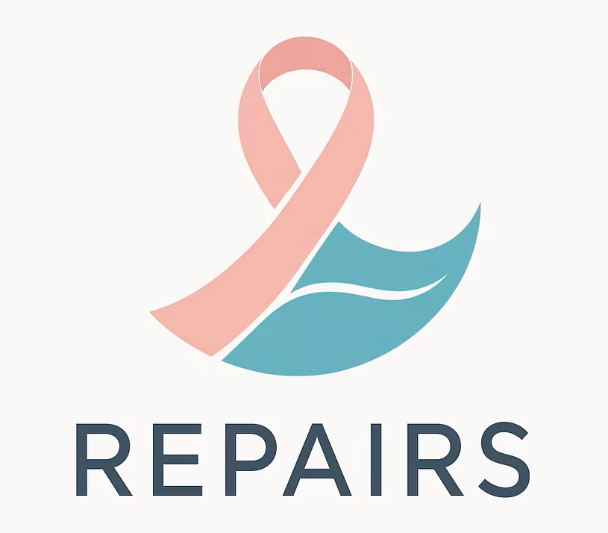
REPAIRS (Reducing Pain in Breast Screening Project), Centre for Cancer Screening, Prevention and Early Diagnosis, Wolfson Institute of Population Health, Queen Mary University of London, Charterhouse Square, London EC1M 6BQ, United Kingdom.

