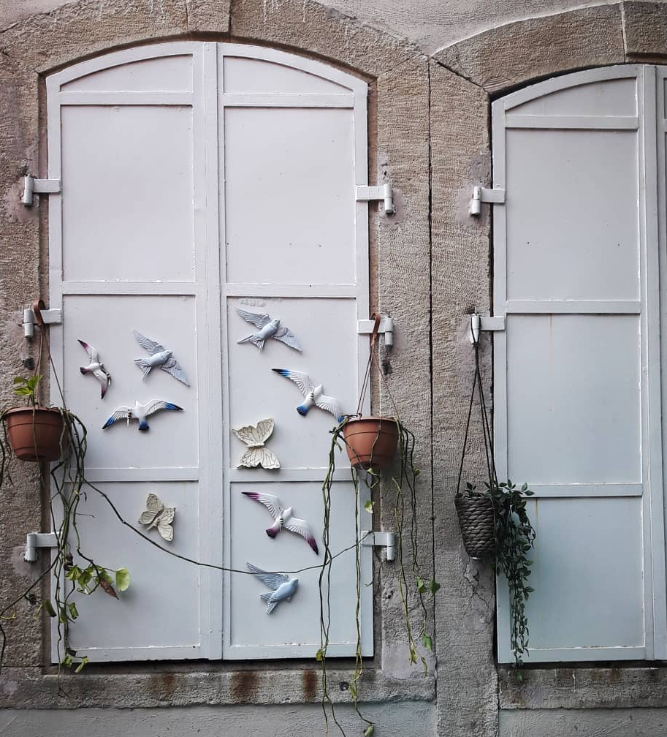
“Strengths for the journey”
Resilience – Building Intervention Manual
S. Foka, PhD.
C. Sergianni, PhD.
Queen Mary University of London
2022

Table of Contents

General instructions 3
Day 1: Introduction to intervention 4
Activity 1.1: “What is your name?” 4
Activity 1.2: “Unique and Shared” 6
Activity 1.3: “The happiness jar” 8
Day 2: Positive emotions 10
Warm-up activity: “4up” 10
Activity 2.1: “Flower of positive emotions” 11
Activity 2.2: “Positive activities notes” 13
Day 3: Optimistic thinking & Hope 16
Warm-up activity: “Blowing bubbles” 16
Activity 3.1: “My best possible self” 17
Activity 3.2: “Collage” 18
Day 4: Character strengths 21
Warm-up activity: “Marshmallow challenge” 21
Activity 4.1: “Discover your strengths” 22
Activity 4.2: “Strengths pebbles” 24
Activity 4.3: “Soar” 25
Day 5: Positive relationships 27
Warm-up activity: “Is nothing something?” 27
Activity 5.1: “Tying friendship knots” 29
Activity 5.2: “Random acts of kindness poster” 31
Activity 5.3: “Gratitude Tree” 32
Day 6: Mindfulness 34
Warm-up activity: “Let’s make a Mind jar” 34
Activity 6.1: “Active meditation: Create your own mandala” 36
Activity 6.2: “Spiderman senses” 38
Day 7: “Time to say goodbye” 41
Warm-up activity: “Food contemplations” 41
Activity 7.1: “Planting Seeds” 42
Activity 7.2: “Ball of Yarn” 44
Activity 7.3: “Opening the Happiness jar” 45
References 47
Appendix A 49
1. Key active listening techniques 49
2. Examples of giving positive feedback and encouragement for effort, thinking, and problem solving 50
Appendix B 51
Troubleshooting – “What if…” 51
Appendix C 53
Printable leaves template to use for “the gratitude tree”. 53
Appendix D 54
Food contemplation poster 54

General instructions
- Show unconditional positive regard.
You need to appreciate each group member without (even in your own mind) judging them. You can use non-violent communication when a difficult situation arises (i.e. Make an observation, mention feelings, mention needs, make a request. This can be about your own views, feelings etc. but also an empathic exploration of the inner world of one of the group members if this appears helpful)

- Listen carefully.
Don't just pretend to listen to what someone in the group is saying. People can tell. Listen at a slight distance, using “soft eyes and soft ears” – this means listening without judgment, visibly conveying warmth and compassion. Listen closely to understand a point someone is making and check back if you are summarizing, always asking the person if you understood their idea correctly (go to Appendix A for more information about Active Listening Techniques).

- Comfort with silence.
Slow down, allowing more space between thoughts, especially when much emotion is present. Be intentional about pauses or even saying, “Let’s take a moment to think about this…”

- Watch the group’s body language.
Are participant’s shifting in their seats? Are they bored? Tired? Looking confused? If they seem restless or in a haze, you may need to take a break, or speed up or slow down the pace of the meeting. And if you see confused looks on too many faces, you may need to stop and check in with the group, to make sure that everyone knows where you are in the agenda and that the group is with you.

- Be aware of your own behaviour.
Take a break to calm down if you feel nervous or are losing control. Watch that you're not repeating yourself, saying "ah" between each word, or speaking too fast. How you act makes an impact on how participants feel. Watch your voice and physical manner (e.g. Are you making eye contact so people feel engaged?).

- Step in and mediate immediately if there are obvious personal attacks.
Effective facilitators look for the least intrusive intervention first, so reminding everyone of the ground rules is often a good place to start. Whatever the issue, you cannot allow bad behavior to continue so be prepared to take the steps necessary to stop attacks.

- Keep a close eye on the timing.
Be flexible and balance the need for participation with the need to keep things running efficiently.

Day 1: Introduction to intervention

Objectives
- Introduction to the intervention programme
- Establishment of supportive group environment

Time
2 hours (18:00 – 20:00)

- Welcome participants to the group.
- Brief description of what we are going to do during this week.
- Show picture of the training group.

Activity 1.1: “What is your name?”

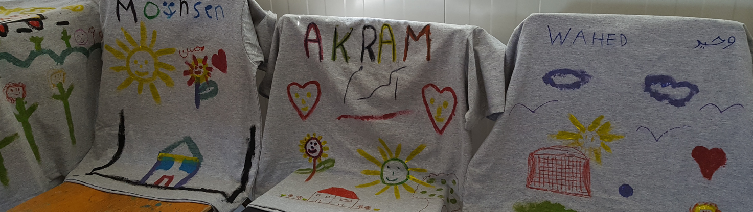
Objectives
- Get to know each other’s names
- Warm up before we move on to other activities

Time
35 minutes
Materials
- T-shirts
- Fabric crayons in different colors
- Paper
Method
- Give each participant one t-shirt of the right size, paper and crayons.
- Ask them to use the crayons to write their names on the piece of paper in Latin letters.
- Check the names on the papers and then ask them to copy their names on their t-shirts.
- Do the same with your own t-shirt.
- Put your t-shirt on (“I will put my name on my t-shirt so that all of you can all read my name”)
- Ask participants to do the same (“I would like to ask you to do the same so that we can all read each other’s name and be easier for us all to refer to each other”).
- Check if any of them needs your help and offer your assistance.
- As soon as everyone has put their t-shirts on, comment on what you see: e.g. “Now that we all have our t-shirts on, we look like football players. They all wear the same t-shirts because they are all part of the same team. But instead of playing sports together, we will work together as a team in order to learn new ways to feel, think, and act.”

Group rules
- One person talks at a time
- We support each other by listening to each other
- Give everyone a chance to talk
- Participate actively
- Stay with the group

Confidentiality
Review the concept of confidentiality and describe that things that are talked about in the group should be kept private so that everyone can feel comfortable sharing. Give a couple of examples of what this might mean.

“One thing that will be important in this group is to make sure that everyone feels like it is safe to share things and talk about themselves. That means that what other participants share with us within this group, we would not share with other people outside this group”.
NB. Make sure you clarify that a group member can talk about their own experience, thoughts, ideas etc. with whoever they trust to talk to (e.g. a parent, another trusted adult or a close friend). They just shouldn’t talk about other participants of the group.

Activity 1.2: “Unique and Shared”

Objectives
Unique and Shared is a get-to-know-you game as well as a team-building activity. The game helps people see that they have more in common with their peers than they might initially realize, while highlighting their own individual strengths that they can contribute to the group.
Time
20 minutes
Materials
- Paper
- Pens and pencils

Method
- Ask participants to form groups of five people with the people around them.
- Pass out sheets of paper and writing utensil. The first half of the activity is the shared part.
- Instruct a note taker for each group to create a list of many common traits or qualities that members of the group have in common. “Avoid writing things that are immediately obvious (e.g. Don’t write down something like “we all speak the same language” or “we are all girls”. The goal is for everyone to dig deeper than the superficial” (5-6 mins).
- Have a spokesperson from each subgroup read their list.
- The second half is the unique part. Keep the same groups or, optionally, you can ask everyone to rearrange themselves into new groups.
- On a second sheet of paper have them record unique traits and qualities; that is, items that only apply to one person in the group.
- Instruct the group to find at least two unique qualities and strengths per person. Again, strive for qualities and strengths beyond the superficial and past the obvious things anyone can readily see (5-6 mins).
- When time is up, share the unique qualities in one of the following ways: (a) each person can share one of their unique qualities themselves; (b) have each person read the qualities of the person to their right; or (c) have a spokesperson read a quality one at a time, and have the others guess who it was.

Activity 1.3: “The happiness jar”

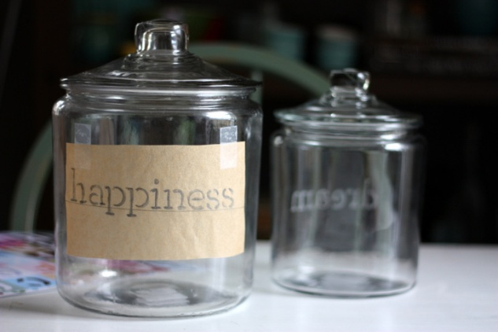

Objectives
- Focus on positive events, experiences, moments, etc.
- End each day with a positive thought (These positive thoughts follow participants out the door and the rest of their day).
Time
5 minutes
Materials
- A jar
- Colored post-it notes (or any other colored small pieces of paper)
Method
- We introduce the “happiness jar” to the group.
- We describe what we are going to do with it.
- “This is OUR jar, so WE make the rules. There are lots of things we could include depending on what seems most fitting that day: e.g. our happiest moment that day, things that we are grateful for, positive thoughts that come up, good group (or individual) moments”.
- “Whatever it is, write it down, put a date on it, and toss it in the jar”.

Closure
Time
10 minutes
Method
- Review what you did on that day.
- Thank everyone for being there and participating in the process.
- Let participants know that you will be waiting for them at the same place and on the same time the next day.
- Emphasize the importance of being on time and trying not to be absent so that they do not miss anything in the group.
- Ask participants to put all the materials they used on that day back in the boxes available so that you can all use them on the next day.

Day 2: Positive emotions

Warm-up activity: “Blowing bubbles”

Objectives
- Induction of positive emotions
- Introduction to mindfulness

Materials
- Bubble liquid and wands
Time
15 minutes
Method
- Distribute bubble liquid to all the participants.
- Blow some bubbles as a demonstration and as you do give the following instructions: “Practice focusing on your bubbles: Where they go, what they look like, what is their size, shape, number, color. I f you get distracted by someone else’s bubbles, it’s ok. Bring yourself back to watching your bubbles without judging yourself for being distracted”.
- “Connect bubble blowing with a sense of letting go of stressful or other negative thoughts.” (2-3 mins).
- Allow participants to practice while you give them the instructions (3-4 mins).
- After they finish, encourage participants to talk about their experience.
“What did we learn during this activity? (a) Focusing; staying focused even with distractions, is good practice for figuring out options in tough situations- helps get what you want and need in the moment (b) Redirecting; distractions are everywhere, getting distracted is a part of life - when that happens, just bring yourself back to the task at hand (c) Doing things non-judgmentally: notice when you judge, don't judge your judging” (8-10 mins).

Bridge (15 mins)
You are now going to talk with participants about how they felt while playing this game. What you are looking for is positive emotions. Each time a positive emotion is mentioned, you can write it on the flip chart.
- “How did you feel while playing this game?”
- “Was it fun for you?” (You are looking for amusement to write on the flip chart)
- “Did you feel joy?” (You can name some positive emotions yourself and write them on the flip chart)
- “Did you feel proud when you made it?”
- …
- “Did you notice that while playing the game and enjoying it, you wanted to play more and maybe in a more enthusiastic way?” (Here you can describe something that you might had noticed during the game).
- “These emotions are called positive emotions. Let’s talk a little bit about positive emotions, i.e. which are the basic positive emotions and why they are important for us”.

Activity 2.1: “Flower of positive emotions”

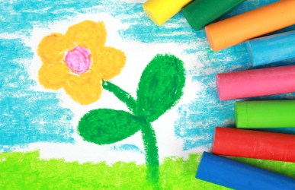
Objectives
- Talk to participants about positive emotions

Time
30 minutes
Materials
- 10 pieces of colored paper cut in flower petals shape
- Adhesive tape
- Colored markers
Method
- Introduce the 10 representative positive emotions one-by-one.
- After the introduction of each emotion, ask participants to write the emotion on one of the petals.
- After having all 10 petals ready, ask participants to arrange them in a way to form a flower and use the adhesive tape in order to keep the shape.
- “Just like flowers, humans can flourish and the frequent experience of positive emotions makes a significant contribution to human flourishing”.
- Talk a little bit about what happens when we experience positive emotions.

- “Despicable Me 2” movie clip

Bridge
“Each of us experiences each of these emotions in different settings. Therefore, different activities that each of us engages in bring about feelings of joy, contentment, serenity, etc.” (Move on to activity 2.2).

Activity 2.2: “Positive activities notes”

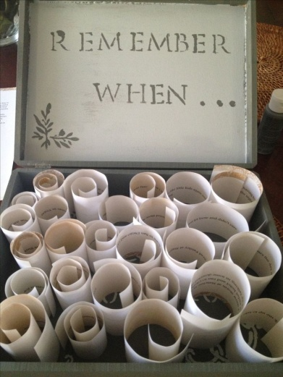
Objectives
- Have participants think about the experience of positive emotions in their everyday living.

Time
15-20 minutes
Materials
- A small box or bag
- Small pieces of paper
- Pens, pencils, colored crayons
Method
- Ask participants write on small pieces of paper different things that make them experience any of the positive emotions described to them (e.g. going for a walk, playing with a dog, drawing, singing, playing football, etc) and place each activity in a small box.
- When they have a hard day and need a “pick me up,” they are encouraged to pick one of the papers and complete the “surprise” activity. (Note: make sure these are things that are relatively easy to do).
- Let them know that while an activity can be substituted for another activity, this can be discouraging if routinely exchanged and can cause further emotional defeat.
Closure
Time
10 minutes
Method
- Review what you did on that day.
- Thank everyone for being there and participating in the process.
- Let participants know that you will be waiting for them at the same place and on the same time the next day.
- Emphasize the importance of being on time and trying not to be absent so that they do not miss anything in the group.
- Ask participants to put all the materials they used on that day back in the boxes available so that you can all use them on the next day.

Day 3: Optimistic thinking & Hope

Warm-up activity: “Let’s make a Mind jar”

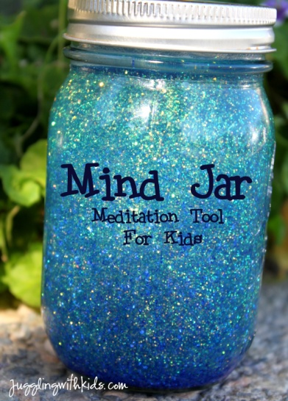
Objectives
- Demonstrate the connection between thoughts, feelings and behaviors
- To teach deep breathing relaxation
Time
20 minutes
Materials
- A mason jar (or a plastic bottle)
- Glitter in different colors
- Water
Method
(Script adapted from Willard, C. (2016). Growing up mindful: Essential Practices to Help Children, Teens, and Families Find Balance, Calm, and Resilience. Sounds True).
- “The jar is like our mind and the glitter represents all the thoughts, emotions and urges to do things in our minds.
- Let’s put in red for thoughts, gold for feelings, and silver for urges to do things. (Pour in a little bit of glitter with each comment).
- Now we seal up the jar (Put the lid on the jar and seal it.) Then we start our day.
- We wake up, and things are pretty settled. We can see that clearly (Show how all the glitter has settled on the bottom of the jar).
- But pretty soon, things start swirling around. Maybe we are running late (swirl the jar). Someone does something annoying, and it leads to a fight (shake the jar). We hear some good news. We get to school, and find out we aced a test (shake the jar).
- Now it’s only a few minutes into the school day, and we can’t see clearly because all of our thoughts and feelings and urges are getting in the way.
- So what is the one thing we can do to get the glitter to settle and see clearly again?
- Be still! And what happens when we are still? We can see clearly again. There is also no way to rush being still. We can’t push all the glitter down to the bottom. We just have to watch and wait. No amount of effort will make it settle sooner.
- When things become clear, we’ll know the wise next thing to do. In fact, that’s one definition of wisdom: seeing things as they are and choosing how to act.
- While we wait, does the glitter go away? No, it stays at the bottom. Our thoughts and feelings and urges are still in our minds, but they are no longer in our way, clouding our vision”.

Activity 3.1: “My best possible self”

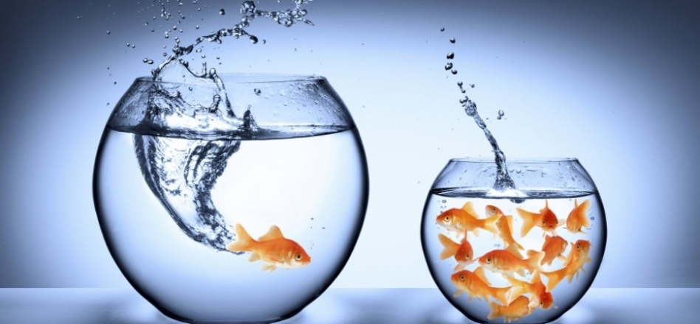

Objectives
- Enhance a sense of control and a forward looking (goal-setting) mindset
- Enhance targeted and positive daydreaming
- Empower children by helping them to believe in the possibility of a happy future full of accomplishment and satisfaction.
- Cultivate positive emotions.

Materials
- Pen
- Pencils
- Colored crayons
- Plain paper cut in a footstep shape
- Floor Mat Puzzle (optional)
Time
45 minutes
Method
- Script adapted from King, L. (2001). The Health Benefits of Writing about Life Goals. Personality & Social Psychology Bulletin, 27(7), 798-807.
“Think about your life in the future (say in 5 years from now). Imagine that everything has gone as well as it possibly could. You have worked hard and succeeded at accomplishing all of your life goals. Think of this as the realization of all of your life dreams. Now, write about what you imagined. Be as creative and imaginative as you want, and don’t worry about grammar or spelling”. (20 mins)

Activity 3.2: “Collage”

Collage allows a group to express itself visually. By using the stimulus of images and words created by others, the activity avoids the need for the group or individuals to have any artistic ability.
Collage works particularly well where a group cannot express itself adequately in words, and therefore needs some stimulation. It is therefore particularly useful to allow a group to express feelings, and views of the future, and is often used in team building situations.
Objectives
- To help a group to express its feelings about an issue or situation
- To visualize the future of a situation (i.e. How the group would like something to be)

Materials

- A good and varied supply of magazines, journals and newspapers
- Scissors (one pair for each member of the group)
- Glue
- Adhesive tape
- Flipchart or similar sized paper
- Coloured markers.

Time
45 minutes
Method
- Find a large working area. Tape together a number of flipchart-size pieces of paper to make a reasonable-sized area for the group while allowing a large area of free space in the room (Allow up to one piece of flip­ chart paper for each person).
2. Explain that the task is to create a picture depicting the problem, issue, situation or environment under consideration (for example, the desired future situation).
3. Provide the magazines, newspapers and journals as a resource, and suggest that everyone take a selection at random, and look through them for images, headlines, pictures, words, cartoons, etc. which they are attracted to in the context of the situation they are trying to describe. At this stage, it is best for individuals to choose their own pictures rather than discussing them within the group. When each person has collected a number of pictures, they need to start creating a group collage by sticking them on to the background, thus involving participation and discussion with other group members.
(30 mins)
- When the collage has been completed, allow the group time to look at it in detail, and discuss the meanings of the various parts and the whole with each other. Discuss any themes or observations that are important to the problem, issue or situation under consideration.
(15 mins)

Day 4: Character strengths

Warm up Activity “Active meditation: Create your own design of harmony”

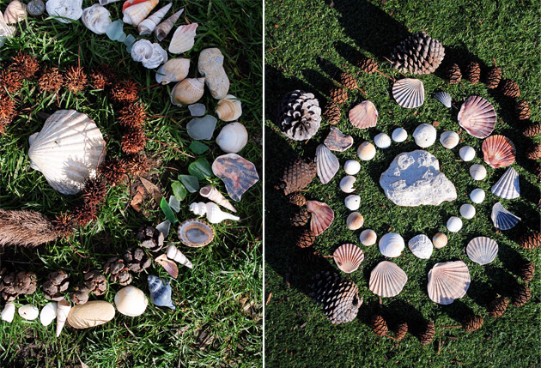

Objectives
- To make an induction to mindfulness
- To teach participants a way to calm the mind and body
- To help participants uncover their creativity

Time
60 minutes
Materials
Could be any of the following:
- Old magazines or colorful ads and newspapers,
- Tissue paper in a variety of colors,
- Poster board (20’’x20’’ is a great size),
- Colorful fabrics and paints,
- Flower petals,
- Stick-on cutouts
Or
- Objects found in nature (e.g. shells, pine cones, driftwood, pebbles)

Additionally,
- Scissors,
- glue sticks
- double sided tape.

Method
- “Meditation comes in many different modes. This time we will talk about Active Meditations. Anything that helps you stay focused and calm while doing something meaningful is Active Meditation. Making a Mandala is a perfect way to do that!”
- “Creating mandalas is a delightful, beautiful and easy activity which you can do almost anywhere and at anytime. All you need is a small collection of materials. Could be objects found in the nature such as shells, pine cones, driftwood etc.”
- “Start your circle in an area which will allow your art work to grow, such as a a poster board or a space on the floor”.
- “Once you have determined your area, gather your materials nearby so you have them in an easily assessable space”.
- “Choose the central piece for your art work and place it in the center of your working area. Try to select a large item or an item you will only use once”.
- “Choose another collection and form a ring around the central piece much like a tree ring”.
- “Continue this pattern adding new circles made out of different items until you believe your piece is complete. (A minimum of 5 rings is usually required for visual impact)”.
- “Take a photo so that participants can remember their mandala”.

Activity 4.1: “Discover your strengths”
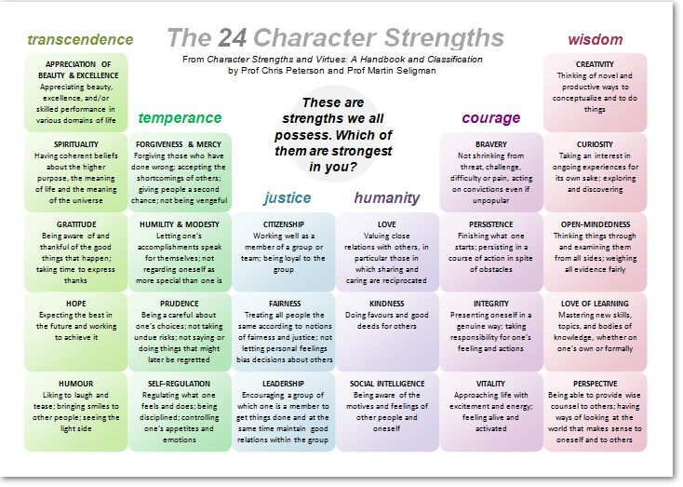
Objectives
- Developing a character strengths language and lens
- Recognizing and thinking about one’s own strengths
- Recognizing and thinking about strengths in others
- Identifying group strengths.
Time
50 minutes

Materials
- Copies of the list of the 24 character strengths
- Flip chart
- Coloured crayons
- Pens
- Pencils
Method
- Distribute the list of the 24 character strengths to all participants.
- Talk a little bit about character strengths.
- Sample script:
“These character strengths influence our values and beliefs, our thinking and learning, and how we relate to others in our social world. Our character strengths decide the choices we make about how we like to spend our time”.
“When we are actively using our signature strengths (i.e. those character strengths that are most essential to who we are), it energizes us and absorbs our attention. When we are using our strengths, our effort, our attention, our thinking, and our physical energy are all fully engaged”.
“You can think of strengths as an inner compass that guides us through life”.
“It is important to know that strengths are dynamic and will grow the more we make use of them”.
“So what we need to do is first identify our signature strengths and then increase the use of these strengths in our everyday life”.
- Ask participants to read carefully the list of strengths and decide what their top 3 is (10-12 mins).
- Ask participants to form pairs and share with each other which their strengths are. Ask them to tell each other about a time when they employed one (or more) of their strengths (12-15 mins).
- Ask participants to share some of their stories with whole group (10-15 mins).
- Ask each participant to write his/her own character strengths on the flip chart and create a map of the strengths in the group (5 mins).

Activity 4.2: “Strengths pebbles”

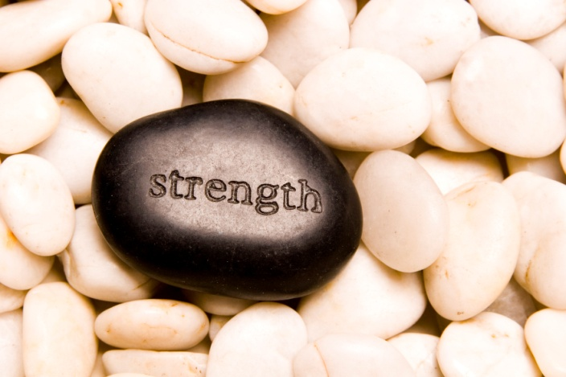

Objectives
- Developing a character strengths language and lens
- Recognizing and thinking about one’s own strengths
Time
15-20 minutes
Materials
- 6 medium-sized pebbles for each participant
- Water colors
- Brushes
- Paint markers
- Glitter glue
Method
- Ask participants to take a look at the 24 character strengths list and choose the three strengths that they wish to develop.
- As soon as they are done, ask them to take their pebbles and write on each one of them their 3 character strengths as well as the 3 strengths they wish to develop.
- Ask them to use their creativity during the process in order to personalize their pebbles.

Activity 4.3: “Soar”
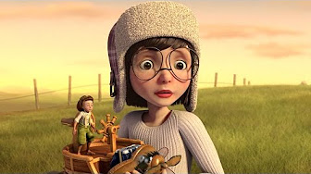

Objectives
- Developing a character strengths language and lens
- Recognizing and thinking about strengths in others
Time
15-20 minutes
Materials
- Animated Short Film “Soar”

Method
- Before starting to watch the film, ask participants to have the following questions in mind:
- “Which do you think are the film characters’ signature strengths?”

Closure
Time
10 minutes
Method
- Review what you did on that day.
- Thank everyone for being there and participating in the process.
- Let participants know that you will be waiting for them at the same place and on the same time the next day.
- Emphasize the importance of being on time and trying not to be absent so that they do not miss anything in the group.
- Ask participants to put all the materials they used on that day back in the boxes available so that you can all use them on the next day.

Day 5: Positive relationships

Warm-up activity: “Is nothing something?”

Objectives
- To demonstrate the importance of developing and maintaining positive relationships between team members.
- To induce positive emotions to the group members

Materials
- No specific materials needed
Time
- 25 minutes
Method
- Talk a little bit about the idea of positive relationships (5 mins)
- Divide the students into groups of 2.
- Each group will try to answer the questions below (10-12mins)

- What qualities do you think make a true friend?
- How can I show a friend I care?
- What should I do if someone feels bad and I want to comfort that person and make him or her feel better?
- How can I love someone who likes different things than me?
- Ask the children to share their answers. Then talk to them about some of the ideas outlined below.

(Script adapted from Hanh, T. (2014). Is Nothing Something? Plum Blossom Books).
- What should you do if someone feels bad and you want to comfort that person and make him or her feel better?
“One of the simplest and most loving things you can do for someone who feels bad is just to be with them and breathe with them. You can say, “I am here for you.” You are offering your presence, which is the most wonderful gift you can offer another person”.
- How can I love someone who likes different things than me?
“To love is to discover. If you keep on loving another person, you will keep discovering wonderful things about that person. You can enjoy the differences because it would be boring if everyone were the same. Even if the other person has a quality that doesn’t seem lovable, you can practice loving that person anyway, just as they are, and not how you wish they were.”
- Come together as a group and ask for students to share what they discussed. Write key words on the flip chart (12-15 mins).

Activity 5.1: “Tying friendship knots”

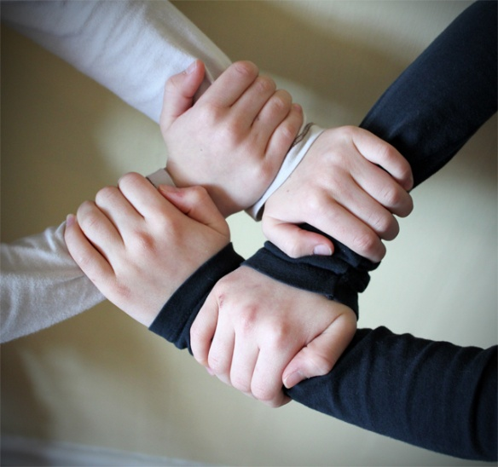

Objectives
- Enhance relationship building skills.
- Create a sense of connectedness among children.

Time
10 minutes
Materials
- One relatively long piece of string for each participant

Method
- Ask participants to hold their pieces of string and tie them together once.
- Sample script:
“Notice that when tied once, the two strings are only weakly held together and can very easily become untied” (Show them how it is done while you talk).
- “This shows how a relationship, when starting out, is quite easy to pull apart. If we let little things bother us, we will never create a strong relationship”.
- “However when we tie twice, three times, and more, the knot gets stronger”.
Talk about how these knots are like experiences we have with friends, e.g. things we do together, jokes we share, games we play, experiences we share, and problems we work out.
- “When we tie a knot purposefully, we can make a very strong friendship where both sides are being used fairly. However sometimes a knot can be tied in the *wrong* place (like using up all of one belt and not much of the other), and this is like disagreements we have, hard feelings we hold against each other, jealousy, or competition. These knots can actually harm our friendship and not make either person feel very good”.
- “However sometimes a knot can be tied in the *wrong* place (like using up all of one string and not much of the other), and this is like disagreements we have, hard feelings we hold against each other, jealousy, or competition. These knots can actually harm our friendship and not make either person feel very good”.
- “In this case, we need to be patient and untie the knot. It may take time and it may be hard, but we can undo the knot. Then we can tie it better, in another place! This will help make friendship stronger again”.
- “And when our knot is really strong, it can hold and support us and our friends in case we might lose our balance and we are about to fall” (Show them us you talk).
- “Now let’s see how we can make strong knots between us using our hands”.
- Jorge Bucay closure activity

Activity 5.2: “Random acts of kindness poster”

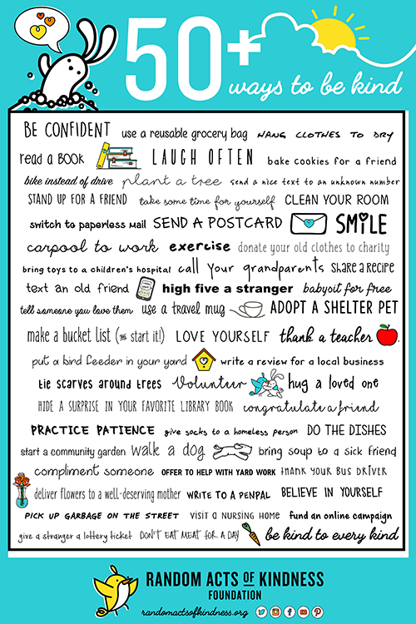

Objectives
- Introduction to the acts of kindness concept
- Provide inspiration to participants to explore various concepts of kindness
- Empower participants to assess how they can be kind to their everyday lives
- Encourage participants to act
- Share and reflect on acts of kindness
Time
20 minutes
Materials
- Paper
- Pens
- Pencils
- Flip chart
- Colored crayons

Method
- Briefly talk about kindness
“Kindness as a natural quality of the heart, expressed through an act of good will and reflecting care for self and others. Kindness means being friendly, generous or considerate to ourselves and others through our thoughts, words and actions”.
- Divide participants in groups of 2 and ask them to think and write down ways in which they would be able to practice kindness in their everyday lives.
- Ask participants to share their ideas with the whole group.
- After all ideas have been shared, ask participants to create a poster with those ideas in order for everyone to be reminded and inspired about everyday acts of kindness.

Bridge
Discuss the relationship between random acts of kindness and gratitude.

Activity 5.3: “Gratitude Tree”

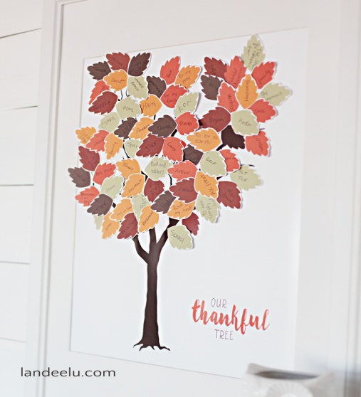

Objectives
- Identify emotions related to positive relationships such as gratitude.
- Create a sense of connectedness among children.
- Familiarise participants with gratitude practice.
Time
40 minutes
Materials
- Coloured paper to cut out leaves (double sided)
- String or ribbon to hang the leaves on the tree branches
- Scissors
- Twigs or tree branches
- Rocks to add stability to the tree
- Vase
- Grateful hearts
- Follow the instructions below
Method
- Make a short introduction about gratitude (5 mins).
(Script adapted from Emmons, R., & McCullough, M. (2003). Counting Blessings versus burdens: An experimental investigation of gratitude and subjective wellbeing in daily life. Journal of Personality and Social Psychology, 84, 377-389).
‘‘Cultivate a sense of gratitude’’ means that you make an effort to think about the many things in your life, both large and small, that you have to be grateful about. These might include anything, really: The roof over your head. Your senses. The beauty of an evening sky. The bird song you heard today. The scent of flowers. The warmth you feel inside your thick sweater, the sun on your face.
- Make a leaf cut out (or few for variety) to use as a template. Ask children to follow your instructions and to cut their own leaves (use PDF template in Appendix C).
- Ask children to punch a hole at the top of each leaf and to loop a piece of string through each.
- Ask children to put stones in a vase and stick the tree branch there.
- Ask children to draw or write about things they are grateful for on the leaves.
- Try to make a few leaves of your own to model the concept and provide the children with ideas:
Ideas of Things to be grateful for
- Family
- Friends
- A quality about your self
- A talent
- Something in nature
- Something you love to do
- Something you love to eat
- Something you have earned
Every child who writes something on the leaves then hang the leaves from the branches (45 mins).

Activity 5.4 (Optional): “Active meditation: Create your own design of harmony”
Objectives
- To make an induction to mindfulness
- To teach participants a way to calm the mind and body
- To help participants uncover their creativity

Time
60 minutes
Materials
Could be any of the following:
- Old magazines or colorful ads and newspapers,
- Tissue paper in a variety of colors,
- Poster board (20’’x20’’ is a great size),
- Colorful fabrics and paints,
- Flower petals,
- Stick-on cutouts
Or
- Objects found in nature (e.g. shells, pine cones, driftwood, pebbles)
Additionally,
- Scissors,
- glue sticks
- double sided tape.

Method
“Meditation comes in many different modes. This time we will talk about Active Meditations. Anything that helps you stay focused and calm while doing something meaningful is Active Meditation. Making a Mandala is a perfect way to do that!”
“Creating mandalas is a delightful, beautiful and easy activity which you can do almost anywhere and at anytime. All you need is a small collection of materials. Could be objects found in the nature such as shells, pine cones, driftwood etc.”

“Start your circle in an area which will allow your art work to grow, such as a poster board or a space on the floor”.
“Once you have determined your area, gather your materials nearby so you have them in an easily assessable space”.
“Choose the central piece for your art work and place it in the center of your working area. Try to select a large item or an item you will only use once”.
“Choose another collection and form a ring around the central piece much like a tree ring”.
“Continue this pattern adding new circles made out of different items until you believe your piece is complete. (A minimum of 5 rings is usually required for visual impact)”.
“Take a photo so that participants can remember their design”.
Closure
Time
10 minutes
Method
- Review what you did on that day.
- Thank everyone for being there and participating in the process.
- Let participants know that you will be waiting for them at the same place and on the same time the next day.
- Emphasize the importance of being on time and trying not to be absent so that they do not miss anything in the group.
- Ask participants to put all the materials they used on that day back in the boxes available so that you can all use them on the next day.

Day 6: “Time to say goodbye”

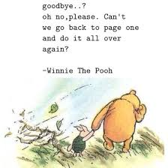

Warm-up activity: “Animals and Senses Exercise”

Objectives
- Teach participants an easy to understand and practice meditation ritual
Time
15 minutes
Materials
- A bell
- A flower
- A small chocolate

Method
- Start reading the script and guide participants through the exercise:
- “One of our powers is the ability to tune into our senses. When we pay very close attention, we are able to calm our mind and let go of all the noisy thoughts in our heads that can be distracting. With practice, we can improve our focus and help ourselves relax wherever we are”.
- “So now we are going to learn how to activate our powers to tune into our senses”.
- “Owls can hear very tiny noises. They are able to pay very close attention to the noises. I would like you to close your eyes and place your hands on your knees. I am going to ring a bell. When you hear the bell, pay attention to the ring until you can no longer hear the ringing sound and then clasp your hands together in your lap (Repeat 3 times).”
- “Like Owls, we have activated your super power of ultra hearing! Well done!”
- “Next we are going to activate our powers of ultra seeing. I’m going to give each of you a flower. Hold your flower gently in your hand.
- “Now, I want you to look very closely at the flower. Pay attention to the lines on the petals. What does the center of the flower look like? Is it bumpy? Smooth? Soft looking? Wet looking? Is there powdery pollen in the center? See what details you can notice in the flower, what little shapes, what lines, what circles, if any”.
- “Now you have activated all of the owls Senses! Remember that when you get very quiet and focus, your body and mind are able to relax and take a break from the day’s busy activities. You have the power to activate your Spiderman Super Senses whenever you want to calm down and focus for a moment”.
The Senses Exercise can be conducted somewhere close to nature (e.g. a beach)

Activity 6.1:: “Food contemplations”

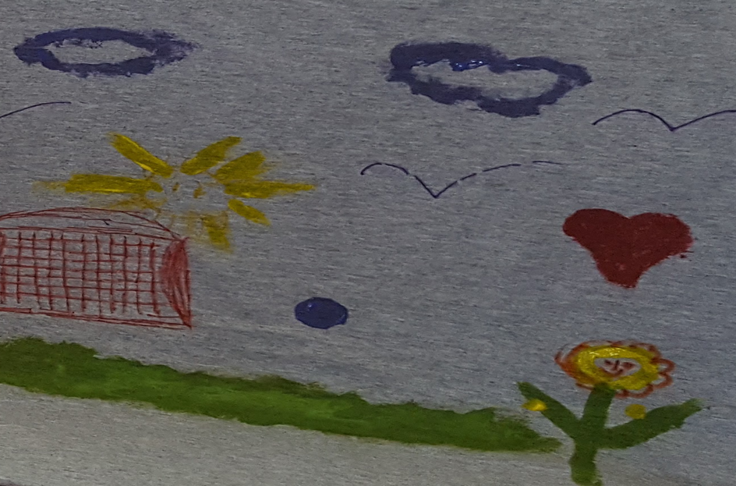
Thich Nhat Hanh, “Planting Seeds – Practicing Mindfulness with Children” 2011
Objectives
- Teach skills of savoring
- Stimulate discussion about protecting the environment and animals
- Enhance positive emotions such as joy, harmony, gratitude
Time
10 minutes (We allow about 3-4 mins for instructions and eating & 6-7 mins to discussion).
Materials
- Fruits (apples, oranges, apricots etc.)
- An A3 poster to include the food contemplations

Method
- Ask children to sit around in a circle.
- Discuss briefly about eating and drinking

“Eating and drinking are very important in our lives. We can eat in such a way to that we nurture our compassion and understanding and only bring to our body what is nourishing”.

- Put in front of the children a big bowl of different kinds of fruits and vegetables and ask the children to take the food they like.
- Then ask them the origin of that food – whether growing that food destroyed any living beings, whether the way of growing the food creates harmony and compassion (see Appendix D for Food Contemplations)

Activity 6.2: “Planting Seeds”

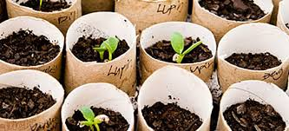
Thich Nhat Hanh, “Planting Seeds – Practicing Mindfulness with Children” 2011
Objectives
- Teach participants how to plant seeds
- Relate participants to nature

Time
45 minutes
Materials
- Bean seeds soaked overnight (to be arranged the day before)
- Toothpicks
- Hand lens
- Newsprint and markers
- Seeds (You can use packaged seeds or dried ones similar to those used for the dissection activity. Dried seeds need to be soaked overnight.)
- Paper cups and lids for each student or pair of students
- Newspaper (to protect the desks from any soil that spills)
- Pencils
- Soil

Method

Ask children to discuss what living things need to live and thrive.
- Begin by asking children what they need to live and grow.
- Make a list of their ideas on a sheet of newsprint.
Suggestions include:
- Food
- Water
- A place to live
- Ways to stay warm when the weather is cold and cool when the weather is hot
- People to help and protect them

- Then ask children to think about what animals, including pets such as dogs, cats, and fish, need to live and grow.
- Write these suggestions on the same sheet of newsprint. Children will notice that the needs of animals are similar to the needs of human beings.
- Go through the same discussion with plants. Here, too, children will notice that plants need similar things: food, water, and a place to live, such as a pot with the right kind of soil containing the proper nutrients, or space in a garden.

Plants have another important need: They must be near light. In fact, light is so important to plants that they will grow toward it!

“Planting seeds” procedure

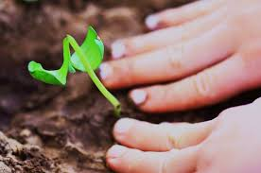

- Hand out one bean seed that has been soaked overnight, a couple of toothpicks, and a hand lens to each pair.
- Ask participants to gently lift off the outside layer of the seed.
- Make available to each participant a cup, a plastic lid, and soil.
- Ask them to poke a hole in the bottom of the cup with a pencil.
- Add soil to the cup.

- Participants should place one or two seeds in the hole and cover them with soil.
- Advise participants to water the soil when it looks dry.
- They can tell when the growing plants need water by sticking their fingers one inch into the soil. If it feels dry, then watering is necessary.
- Tell participants that when they water the plant, they should add enough water so that it starts to come out of the hole at the bottom of the cup.
- Advise participants to watch every day their plants grow.

Bridge
“Time to say goodbye”

Activity 6.3: “Ball of Yarn”

Objectives
- Enhance positive emotions of togetherness, joy, thankfulness, serenity.
- To make children understand the meaning of bonding and closeness.
- Learn to say good-bye in a non-hurtful way
Materials
- Ball of yarn
Time
25 minutes
Method
- Participants sit in a circle.
- “Holding the ball of yarn, share one important thing about your time together during this week. Then throw the ball to someone else while you hold on to your bit of string. The person you’ve thrown it to then shares”.
- In the end, when everyone is holding their part of their string, the facilitator can say something like:
“Even though we are all going back to our families, we remain connected just like this string connects us now. We bring our time together back to our homes and our schools and we take each other with us as well. Then we each create our own web of practice back at home. So, from this larger web, many smaller webs grow out from each one of us.”
For the good bye session try to use the following expressions:
- Something joyful I experienced was …………
- I remember when …………………………………...
- I am thankful for………………………………………

Activity 6.4: “Opening the Happiness jar”
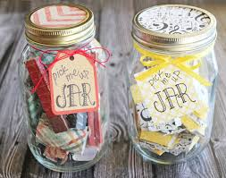
Objectives
- Enhance positive emotions
- Retrieve positive emotions from last week

Materials
- Happiness jar
Time
25 minutes
Method
- Ask participants to sit around in a circle.
- We take the happiness jar and every participant opens takes out a positive note.
- Then each participant reads loud the positive notes and we retrieve memories, emotions and experiences from the week before.
Closure
Time
10 minutes
Method
Children prepare their personal took lit and place inside all the things they have created during the week (i.e. drawings, stones, positive activity notes etc.)

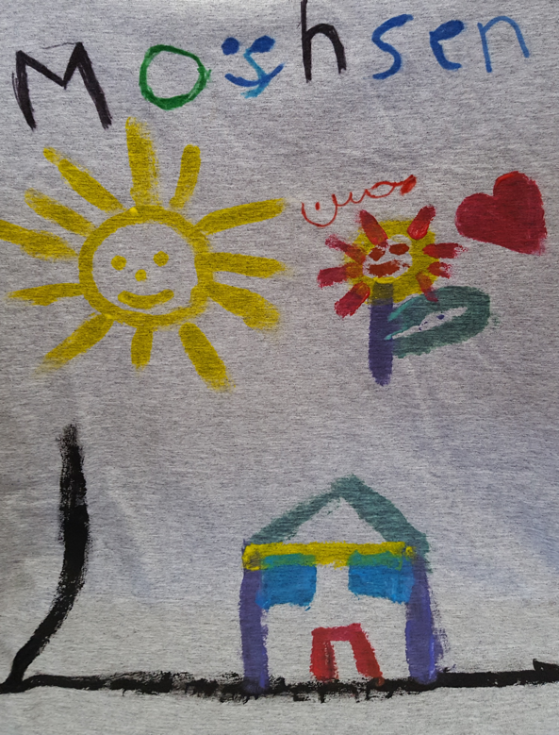

References

Cox, G., Dufault, C., and Hopkins, W. (1992). Fifty Activities on Creativity and Problem Solving. Amherst, Mass.: HRD Press.
Dovidio, J.F., Isen, A.M., Guerra, P., Gaertner, S.L. and Rust, M. (1998). Positive affect, cognition, and the reduction of intergroup bias. In: Sedikides, C., (Ed.), Intergroup cognition and intergroup behaviour (pp. 337–366). Erlbaum; Mahwah, NJ.
Emmons, R., and McCullough, M. (2003). Counting Blessings versus burdens: An experimental investigation of gratitude and subjective wellbeing in daily life. Journal of Personality and Social Psychology, 84, 377-389.
Fredrickson, B. L. (1998a). What good are positive emotions? Review of General Psychology, 2(3), 300–319.
Fredrickson, B. L. (1998b). The role of positive emotions in positive psychology: The broaden-and-build theory of positive emotions. American Psychologist, 56, 218–226.
Fredrickson, B. L. (2013). Positive emotions broaden and build. In P. Devine & A. Plant (Eds.), Advances in Experimental Social Psychology, Vol. 47, (pp. 1-53). Burlington: Academic Press.
Fredrickson, B. L. and Branigan, C. (2005). Positive emotions broaden the scope of attention and thought-action repertoires. Cognition and Emotion, 19, 313–332.
Hooper, J. (2012). What Children Need to Be Happy, Confident and Successful: Step by Step Positive Psychology to Help Children Flourish. London: J. Kingsley Publishers.
Isen, A.M., Niedenthal, P. and Cantor, N. (1992). The influence of positive affect on social categorization. Motivation and Emotion, 16, 65–78.
Ivtzan, I. and Lomas, T. (2016). Mindfulness in Positive Psychology: The Science of Meditation and Wellbeing. Routledge.
King, L. (2001). The Health Benefits of Writing about Life Goals. Personality & Social Psychology Bulletin, 27(7), 798-807.
Kok, B. E., Coffey, K. A., Cohn, M. A., Catalino, L. I., Vacharkulksemsuk, T., Algoe, S. B., Brantley, M. and Fredrickson, B.L. (2013). How positive emotions build physical health: Perceived positive social connections account for the upward spiral between positive emotions and vagal tone. Psychological Science, 24(7), 1123-1132.
Morris, I. (2009). Teaching Happiness and Well-Being in Schools. London: Continuum Books.
Niemiec, R. M. (2014). Mindfulness and character strengths: A practical guide to flourishing. Cambridge, MA: Hogrefe.
Proctor, C. (2017). Positive Psychology Interventions in Practice. Springer International Publishing.
Seligman, M. (2002). Authentic Happiness: Using the New Positive Psychology to Realize Your Potential for Lasting Fulfillment. New York: Free Press.
Seligman, M. (2011). Flourish: A Visionary New Understanding of Happiness and Well-being. New York: Free Press.
Willard, C. (2016). Growing up mindful: Essential Practices to Help Children, Teens, and Families Find Balance, Calm, and Resilience. Sounds True.

Appendix A

Key active listening techniques

TECHNIQUES | Purpose | Approach | Language
ENCOURAGING | - To convey interest  - To keep the person talking | - Don’t agree or disagree with speaker.  - Use noncommittal words with positive tone of voice. | - I see… ƒ  - That’s interesting…  - Tell us more about… ƒ  - Go on…
RESTATING | - To show that you are listening and understandin  - To help speaker grasp the facts | - Restate the speakers’ basic ideas.  - Put in your own words. | - If I understand, you are saying that  - In other words, you say that...
REFLECTING | - To show you are listening and understanding  - To let speaker know you understand how he/she feels. | - Reflect the speakers’ basic feelings. ƒ  - Put in your own words. | - You feel that…  - You were pretty disturbed about that… ƒ  - You believe that…
SUMMARIZING | - To pull important ideas, facts, etc. together. ƒ  - To establish a basis for further discussion ƒ  - To review progress | - Restate, reflect, and summarize major ideas and feelings. | - These seem to be the key ideas you expressed… ƒ  - If I understand you, you feel this way about this situation.

Examples of giving positive feedback and encouragement for effort, thinking, and problem solving

- “Excellent idea for…”
- “You’ve done a wonderful job at…”
- “See how _______has improved in…”
- “Look how well s/he did at…”
- “What a fabulous job you’ve done of…”
- “That’s a cool way to …”
- “You put a lot of work in to make that picture the way you wanted…”
- “Brilliant thinking for…”
- “You must feel proud of yourself for…”
- “Tell me what you like best about your creation.”
- “I really appreciate the way all of you have your eye on the story and are listening so carefully so you don’t miss any part of the story.”

Appendix B

Troubleshooting – “What if…”

What if one (or more) of the children:
- Does not want to talk in an activity or all activities?
________________________________________________________________________________________________________________________________________________________________________________________________________________________________________________________________________________________________________________________________________________________________________________________________________________________________________________________________________
- Interrupts the process?
________________________________________________________________________________________________________________________________________________________________________________________________________________________________________________________________________________________________________________________________________________________________________________________________________________________________________________________________________
- Engages in an annoying behaviour?
________________________________________________________________________________________________________________________________________________________________________________________________________________________________________________________________________________________________________________________________________________________________________________________________________________________________________________________________________
- Makes a rude comment to another participant?
________________________________________________________________________________________________________________________________________________________________________________________________________________________________________________________________________________________________________________________________________________________________________________________________________________________________________________________________________

- Relates an activity or a comment in the discussions with a negative memory?
________________________________________________________________________________________________________________________________________________________________________________________________________________________________________________________________________________________________________________________________________________________________________________________________________________________________________________________________________

Appendix C

Printable leaves template to use for “the gratitude tree”.

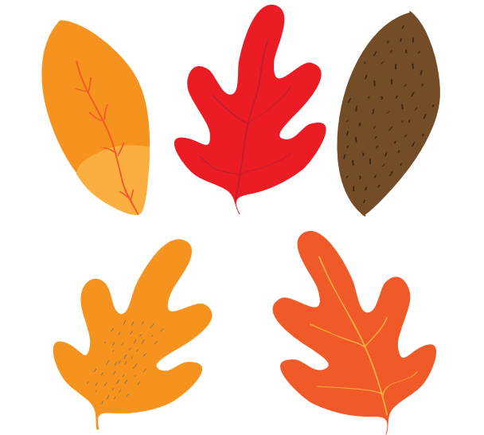

Appendix D

Food contemplation poster
Thich Nhat Hanh, “Planting Seeds – Practicing Mindfulness with Children” 2011
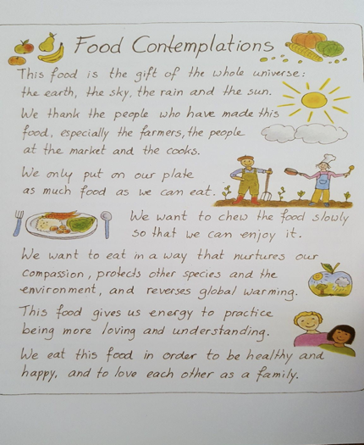

If we decide to collect objects found in nature, we can combine the process of collecting our materials with a mindful walk.
If we decide to collect objects found in nature, we can combine the process of collecting our materials with a mindful walk.

