New Guidelines and SOP’s for in Working JP
Introduction
The purpose of this document is to highlight the new working practices required to get the Joseph Priestley research laboratories up and running as release from the government lockdown progresses. All Mile End campus must be a COVID 19 safe environment. To this end we have proposed a series of measures which combine government guidelines with current H&S requirements and adapted them to the JP building. The proposals are general and details can be applied once the rapidly developing situation becomes clearer, however we will consider who is returning and where they will work taking social distancing as a primary driver. It must be emphasised that this is not a comprehensive plan for all JP but the bare requirements to restart research and open office space. Furthermore we wish to stress the onus on individual responsibility to safe working during the current COVID19 pandemic.
Work Schedule
The JP research labs and offices will be open for all SBCS staff/students that need to work on campus either undertaking practical work or preparing/delivering teaching material.
For more detailed government guidelines on working safely during COVID-19 in labs and research facilities please use the following link.
https://assets.publishing.service.gov.uk/media/5eb9752086650c2799a57ac5/working-safely-during-covid-19-labs-research-facilities-240520.pdf

General Considerations
Personal Health
Just to be clear, return to the university is not compulsory but voluntary so if you have any signs of COVID 19 symptoms stay at home for the required quarantine period. Please do a self-assessment and only return to JP if fit and well with no underlying health issues.
Personal hygiene is extremely important and we must stress the need for regular and efficient hand washing including the use of hand sanitisers when available between all activities and movement around the building. This is especially important when arriving / leaving JP and working in communal areas such as NMR, Analytical services and using keyboards.
Travel to and from campus
Fortuitously most workers can walk or cycle to campus; however in certain cases critical managers must use public transport. On an individual basis we propose flexible hours as much as possible to facilitate these journeys combined with working from home if feasible.
The approach to JP must follow any one way systems as determined by central QM planning committee and signposted by estates. More detail can be found at http://qm-web.estates.qmul.ac.uk/covid-19/
Please use the link below for more details on university HR policy concerning return to campus.
http://hr.qmul.ac.uk/temporary-remote-working/returning-to-campus/

Areas of JP to Open
Ground, 1st floor, third floor research labs, plus ground floor undergraduate lab and Nanoforce will be open; however SBCS second floor teaching lab will be prepared to welcome students. In addition offices and the computational lab can be used following the relevant guidelines described below.
Only people doing practical work or teaching will be admitted and those performing data analysis or writing up are expected to work from home.
Revised JP opening hours is 8 am to 8 pm Monday to Sunday. It will be left to individuals to ensure they leave the building before the dead line. Security will make periodic checks and anyone found after the cut off will have their access removed for 3 months.
New COSHH forms are to be submitted by all researchers. All chemical reactions are to be performed between core hours 9 am to 6 pm with dangerous experiments avoided in the first few weeks. PI and technical staff will be around to check overnight cards are in place and up to date.
Instrument rooms adjacent to the main laboratory area will operate as single occupancy on a one in one out system. While there is limited demand a booking system will not be in operation but this will be reviewed periodically.
Entering JP
The latest procedures necessary to access the JP building can be found on the return to work webpage via the link below.
https://www.qmul.ac.uk/sbcs/internal/information_staff/staff-returning-to-work/
Once you have read and understood the new online induction material (a SOP word document with slides) plus the building Risk Assessment you must sign the COVID return to work agreement by inserting an electronic signature and emailing copies to both p.duncanson@qmul.ac.uk and hs-jp@qmul.ac.uk. In addition you must fill out the security protocols. The QM card should work as before lockdown but due to reader system upheavals there may be glitches so once your agreement has been received, if necessary, I will alert security to reinstate previous access. Additional information from security (as of June 2nd) can be obtained from the link http://qm-web.estates.qmul.ac.uk/media/estates-and-facilities-intranet/directorate-support/Return-to-Campus-Security-Arrangements.pdf
For staff already registered at QM if you plan to work out of core hours then strict access is controlled by a Chip and Pin system via a keypad situated close to the front doors. Your card will need to be registered with security and you will need a PIN number.
Everybody must swipe out at the end of the day to ensure that occupancy of a building is able to be confirmed at all times

Once inside JP there is a basic movement plan around the building
Main door : entry only
Main staircase : upward travel only (Signed with directional arrows and “Up Only”)
Back staircase: downward travel only (Signed with directional arrows and “Down Only”)
Back door : exit only (except for liq N2 and goods deliveries into the building)

Lift out of action except for deliveries/movement of equipment around the building

Building Preparation

The building will be in a safe state but before practical work commences some basic precautions and maintenance must be followed.
1. The water supply has been signed off by estates and is now usable. On return to JP a flushing rota will be introduced and ALL will contribute. The number of taps remains the same but personal has decreased so be prepared to do extra flushing.
2. Extraction system checked for correct flow rate and Firetrace should be visually checked to be in the green.
3. Annual PAT testing is not a legal requirement so on return to JP electrical equipment can be used with the following guidance.
User checks
All staff should undertake a basic check of electrical equipment before use, where any defects are noted the equipment should be removed and either repaired and tested by a competent person, or disposed of.
- Damage to the lead including fraying, cuts or heavy scuffing, e.g. from floor box
- covers;
- Damage to the plug, e.g. to the cover or bent pins;
- Tape applied to the lead to join leads together;
- Coloured wires visible where the lead joins the plug (the cable is not being gripped where it enters the plug);
- Damage to the outer cover of the equipment itself, including loose parts or screws;
- Signs of overheating, such as burn marks or staining on the plug, lead or piece of equipment;
- Equipment that has been used or stored in unsuitable conditions, such as wet or dusty environments or where water spills are possible;
- Cables trapped under furniture or in floor boxes.
Regularly used kit such as heater stirrers/hot air guns should be included in a maintenance plan taking into account that a chemistry laboratory is a harsh environment exacting increased wear and tear.
The building will be prepared for returnees. The space management group will work out the maximum number of workers per lab/room and we can fit our staff in accordingly to minimise disruption. A local flow plan has been implemented with appropriate signage, stickers and non-accessible areas cordoned off. All signage has been supplied by estates to maintain continuity across campus and not confuse visitors.
We have relevant stock supplies of PPE. All incoming workers will have their individual PPE (lab coat, glasses, etc) and this essentially needs to be kept isolated. We will get all unused lab coats laundered so that a three lab coat system can be introduced. This entails wearing one coat, having a spare and one in the wash
Most importantly everyone will undergo a new induction which can be viewed as online to explain the new working practices. Returning workers will also sign a return to work agreement form stating they understand the new working practices and agree to abide by them.
Space Allocation and SOP Working Practices

We have a basic movement flow around the building (see above) but if numbers increase it may have to be expanded to include local spaces around the labs.

1. Ground Floor

Labs G23, (Wet Chemistry), G35 (Biochemistry,), G15 (NMR,) G12 (teaching), G 34 ( cryoTEM), G33 (EPR) and G28 (computational lab) will be opened.

In G23a the proposed working locations are highlighted in red and blue on the space allocation below. At the time of writing QM policy is that the 2M rule is in operation for research laboratories and incoming workers must organise themselves to obey this rule.
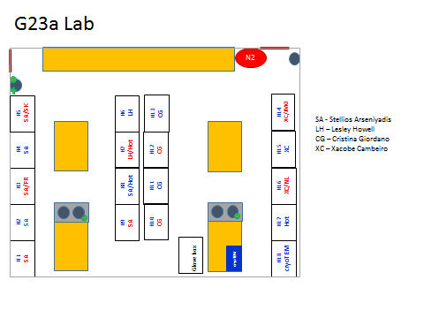
The seating locations are highlighted on the space allocation below with black indicating unoccupied desks. The will be NO HOT DESKING. It is recommended that each desk is sterilised before work on Monday morning and disinfected when leaving after your weekly attendance.

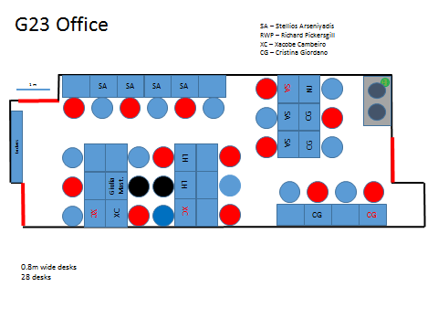

G 35 lab/office: Biochemistry

Working hours

Working hours are 8am – 7.45 pm (leaving building by 8pm) from Monday –Sunday

Hygiene and disinfection:

General:

When you enter or leave the building, please clean your hands with soap or sanitiser. The sanitiser dispenser is located in the foyer and the back entrance.

Laboratory:

- Shared equipment should be cleaned with disinfectant every time after use. Pour the disinfectant on dry paper and clean the equipment surface. Do not apply the disinfectant directly to the equipment surface. 70% ethanol or Chemgene High Level Disinfectant 1:10 dilutions are available in the lab to clean your bench space and equipment. Each work bench should be cleaned when you finished all work on that day.

- Cling film is available for covering keyboards of shared equipment.
Please use cling film to cover the keyboard when you use it and dispose the cling film after use.

- Individual users should have a set of PPE (labcoat and safety spec) to avoid sharing. Visitor lab coats are no longer available. All the lab coats should be hanged on the lab coat hooks with one or two hook spaces between the lab coats. There are two sets of lab coat hooks in the lab, so if a hook near the lab entrance from office is not available use the other one. Lab coats should be labelled with a sticker at the back collar to make clear that the lab coat is in use.

- Face masks/coverings will be required for working in some communal parts of the building such as corridors , they do have some benefit in reducing the spread of the virus.
-We encourage you to make use of face masks/coverings if you have them and they do not interfere with your other PPE or introduce additional risk.
-If you have a reusable, fabric mask you should wash this after every use.

Office:
- All users who used an office desk should clean it with disinfectant (70% ethanol or Chemgene High Level Disinfectant 1:10 dilution) every day before and after use. Disinfectant and blue/white roll will be provided by lab manager.

Social distancing:

The 2M rule is in operation for all QM research laboratories and office areas so incoming workers must organise themselves to follow this rule.

Maximum capacity of Lab and office:

In order to maintain 2m social distance between end users in the lab and office area, we have had to put caps on the number of people permitted to be present at any one time. This number varies depending on the size of the room.

You should only come to the building to do lab work and any office work should be done from home.

- A maximum of 6 people (5 G35 lab based users + 1 lab manager/extra) are allowed to be in the G35 lab/office at the same time. Extra person can be in the communal area when the person use only shared equipment (not office space) and should contact lab manager before using the facility in G35.

- There are 5 bookable Benchs (Bench 0, 1, 2, 3 and 4 where your workbench located. When you use the lab, you must book the bench. Please note that no hot desking of your allocated bench or office desk.

- G35 Communal areas (Cold room, Bench 5, Bench 6 and Bench 7), Autoclave room in JP building and Crystal room in FB building are single occupancy area.
Users will wait their turn in their working bay until the area is unoccupied.
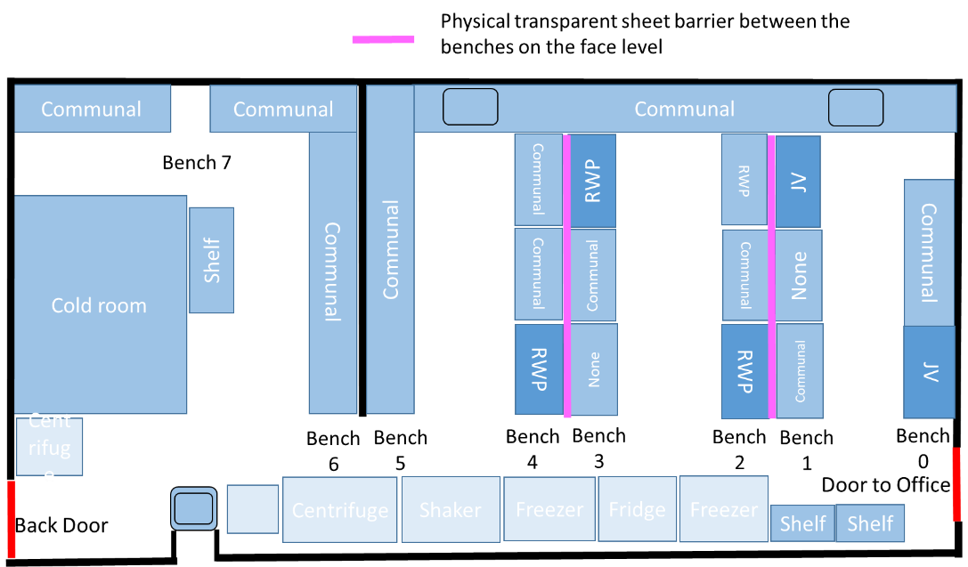

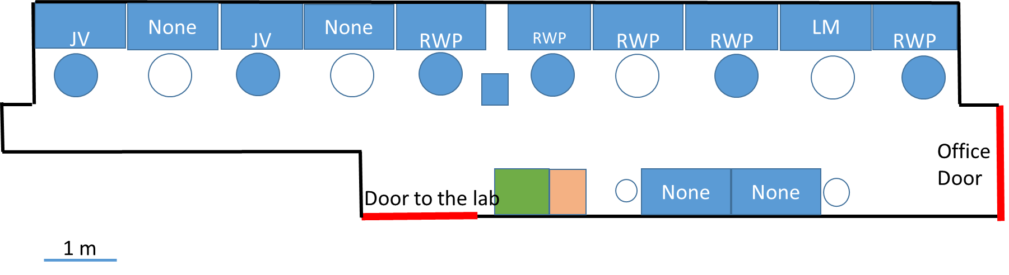

JV(John Viles group), RWP (Richard Pickersgill group)
Online booking system-Booking benches, equipment, autoclave room and crystal room

All laboratory work should be planned with bench space/instruments booked beforehand so you can use your time in the building efficiently.

- Your work Benches (Bench 0, Bench 1, Bench 2, Bench 3 and Bench 4), shared equipment, autoclave room and crystal room should be booked via the online booking system-http://iodine.chem.qmul.ac.uk/scheduler before you access to the Joseph Priestly/Francis Bancroft building. There will be no booking for office as this space will be occupied by the lab users, who have booked the bench.

The booking system will be used to ensure the number of people does not exceeded SD guidelines and be used to monitor the occupancy. In case of anyone showing symptoms, lab managers are expected to be able to identify who was spending time in a particular area.
The duration of your booking of bench (and use of office desk) must include the time you need to get into and out of the building – to avoid people meeting at changeovers. This means that even if you just come in to check some plates or do some other very small task in the lab, you will need to use a 1-hour slot.
If you need more than 1 hour you can book multiple slots but please be considerate of others and only book what you will actually use. Academics will be responsible for ensuring that their group members are being reasonable.

Lab managers will query bookings in the event that the occupancy of the floor is approaching maximum numbers and where social distancing cannot be safely maintained. This means users may be required to be flexible about moving booking slots to other days if possible.

- Be mindful of bottle-necks in the lab, give people time and space

- Crystal room in Francis Bancroft building only bookable during weekday 8am-6pm with no weekend work.

Weekend Working

Weekend work is allowed if:

- All relevant documentation should be completed before weekend work commence.
-Lone working/out of work hour’s form
-Weekend work agreement form to be signed by end users and supervisor
-COSHH form
- Completed Weekend work agreement form signed and should be sent back to lab manager.
- Only experiments which have COSHH forms completed and are non-hazardous can be undertaken.
- New experiments that require training must be avoided.
- Use of liquid nitrogen is forbidden
- Make sure you notify your group that you are in the lab and when you leave. .
- Book the space and equipment in advance similar to weekday work.
- Notify lab managers in advance when you plan to work over the weekend at least a few days in advance-not the day before-with the schedule how long you are in the building. So that we can arrange the security to open the back gate for your exit. The back gate is only open during prearranged times so please finish work within your allotted time.
- Please note you cannot just turn up and leave when you feel like it. In case if you stuck at the back yard, please call security 020 7882 5000

As before, MSc/project students are not allow to work alone and out of work hours in the lab/building.

Please note that the number of people on campus and especially the JP building (e.g. security/first aides/fire marshal) will be low at the weekend so in case of an accident make sure you are aware how to summon help. For instance, know the emergency contact number (Emergency number ex 3333 from land line or 0207 882 3333 from your mobile phone.)

Equipment training/Safety induction for users

- Joseph Priestley building G35, G16 : One to one training is not available for any users at present however we are moving towards to introducing instrument training and HS/Building inductions.

- Francis Bancroft building Crystal room: Mosquito training will be available under the following conditions. Please contact lab manager.

  - Keep duration of 'physical' part of training as short as possible typically 15mins periods- deliver all 'theoretical' aspects online when need it.
  - Keep as much distance from each other as reasonably practicable
  - Avoid face to face, try to work side to side
  - Wash hands before and after training. Clean surfaces and equipment using 70% ethanol, provided by the equipment.
  - For the duration of the 1-1 training the maximum number of occupants per room can be +1
  - Both persons are wearing face coverings i.e. safety spec, masks or visors.
  - Open the crystal room door slightly to get ventilation during induction.

G28 Computational Laboratory
University policy is still 2m SD so in the short term till results from ventilation rate tests are available occupancy will be limited to a maximum of 8 people. The room has been marked out so please note the presence of yellow/black tape means you cannot work in this space. The previous space allocation is no longer operating and new seating arrangements are in force. Presently, numbers fall below this level but as term approaches this is liable to change.
If there is increased need then other spaces can be released and either a booking system or rota introduced. There will be NO hot desking as this will mean regular deep cleaning which is currently unavailable. Communal facilities such as fridges are not to be used.
Usage will be reviewed frequently.

G15 NMR services
The service is essentially good to go - all instruments have been successfully maintained during lock down and the following working protocols will be started.
1) Face covering optional.
2) Hand sanitiser to be used on entry to prevent infection from computer keyboards, sample holders, the sample depth gauges and the HD 400 sample changer touch screen.
3) Only three people in the room at any one time:
- The NMR Manager
- One person using the AVANCE NEO 600
- One person using either the AVANCE III 400 or the AVANCE III HD 400

A booking system for submitting samples on the 400s isn't really viable as the time taken (a few minutes) is so short. The spectrometers are both clearly visible from the door so I suggest people simply do not enter if there is someone already in the room. At this time of year, without under-graduates, there is unlikely to be much of a queue outside the room.
4) Maximum of two people to queue in the corridor. Queueing priority given to researchers from other buildings since Joseph Priestley based staff can more conveniently go back to their offices and come back later.
5) Samples should be collected from the sample changers as soon as they have run, or as soon as possible on the following day for overnight samples.
6) 2m social distancing between the three people in the room to be observed at all times.
7) Samples may not be submitted when the 400 MHz magnets are being filled with nitrogen... usually done on Thursday afternoons.
8) All data processing to be done on users own computers and not on the workstation in the NMR room (to allow for sample submission).

Confocal And TEM microscope facility:
All sessions must be booked at least one day in advance
Only one person is permitted in the Confocal microscope facility room per session
There must be an hour break between any sessions within one day
Users must use their personal safety specs and personal lab coats while working in the facility
Users must turn on the red warning sign above the doors outside the facility while in the room to indicate their presence
While entering and exiting the facility a social distancing of 2 meters must be observed

For a more detailed SOP and introduction to the booking system please contact Michaela Egertova.

Teaching Lab
Presently unused but has massive potential for overspill from wet chemistry and an influx of new researchers.
X-Ray Facilities Bancroft G30
Lab G30 contains the College X-ray facility an office for the research officer and a separate crystal growth room. Even before the lockdown samples were run almost exclusively by the facility’s research officer Richard Whitely, with only limited access to the lab for students and staff. The following restrictions are proposed.
(1) Access to the laboratory will be strictly limited to a maximum of three persons, including a maximum of one person in the crystal growth room and one in the staff office at any one time. Appropriate signage will be placed on the doors to the lab and on internal doors.
(2) All X-ray instruments will be operated only by the research officer Dr Whitely (SEMS), the Facility director Dr Abrahams (SBCS) or Dr Anthony Phillips (SPA).
(2) A box will be available for users to deposit samples along with submission forms outside the laboratory. Users wishing to collect samples will need to ring the bell and wait at the door for the samples to be recovered and returned. Users without access to the Bancroft building will be advised to contact the service for samples to be picked up outside the building
(3) All samples will be handled using gloves.
(4) If required, the service can be operated in alternate weeks by Dr Richard Whitely (SEMS) and Dr Isaac Abrahams (5 + 9 day model) to provide a continuous service.
(5) Work surfaces will be cleaned daily. Prior to reopening the service Dr Whitely and/or Dr Abrahams will need about a week to recommission the X-ray generators.

Toilets

1 person ONLY
Unoccupied/Occupied flip sign on each door (red/green text as appropriate – please turn over accordingly

2. First Floor
Most of the first floor will be opened as many rooms contain instruments vital for research to proceed. They will essentially work on a ‘one in one out’ policy. These spaces are open and it is easy to see if they are occupied. A general policy is to leave most returnees in their original FC to minimise disruption and relocations. Working arrangements are shown in the space allocation below.
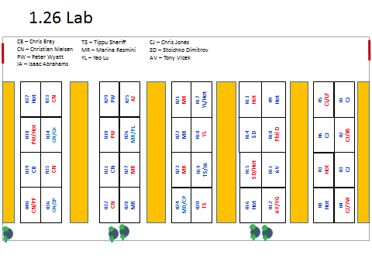
Segregation for 1.27 is shown below. .
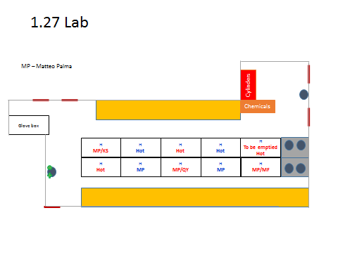
Potentially the most problematic space is the write up area and allocated spaces for occupation are highlighted below. It must be emphasised that a minimum time only should be spent in the write up area. It is recommended that desks are disinfected regularly. NO Hot Desking.
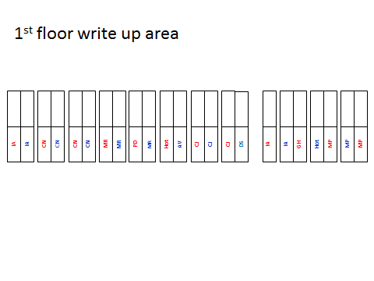
Analytical Services
All services were shut down prior to lock down but are now back up and running normally The following protocols are in force.
1. Face masks are mandatory in the lab along with eye protection.
2. No sample prep in the MS lab (allowed only for users of MALDI-Tof so far)
3. I will run MALDI-Tof analyses upon sample submission form.
4. There is an instrument’s booking system in place, but I will extend it to the users of GCMS and LCMS
5. Three people max in the lab using different instruments and not forming a group. Social distancing will be enforced.
6. Users will have to reserve their time on the instrument to acquire and also to analyse data. They will be instructed to use only the time for which they signed in.
7. Instrument reservations one day in advance. NO walk-ins. (I will set up the booking system with an approval feature from me)
8. 30 mins gap between two users who signed in.
9. The Mass Spec Lab will be closed to all except for the users who signed in to use a particular instrument.
10. I will meet visitors and researchers in a public space maintaining a 2 meter distance, and not in my office.
12. I will post a sign on the door reminding people NOT to access the lab unless they have signed in for a particular instrument during the time of the visit. NO walk-ins allowed.
13. During instrument service or preventative maintenance, I will close the lab for that time period as we will have engineers in the lab.

Kitchen Area

In the first instance no communal fridges/microwaves are to be used as these are and prime areas for virus transmission. The water fountain/ sinks can be kept open as it is possible to dispense liquid with minimal contact and provide extra washing facilities. The use of this area will be reviewed after 3-4 weeks.

Stores

Jay is to continue working from home.
Face covering when approaching counter and /or remain behind the plastic panel
Only the storeman is allowed in the stores. NO WALK IN
Items will be passed over the counter maintaining 2m social distancing.
Store opening hours 10 am to 12am and 2 pm to 4 pm except when Agha is sorting out the solvent deliveries
Approach to the stores will follow the movement plan above.

Visitors from other departments must make a list and send it to Agha before making an appointment to pick up their items (which can be left close to the lift). If you miss the appointment time – no stock collection will take place.

JP 3.03
Covid-19 Secure – Operating Procedure

JP3.03 is a laboratory on the roof of the Joseph Priestley (JP) Building and is accessed by staff and students carrying out work involving high temperature synthesis. Currently the room is used by the research groups of Dr Giordano and Dr Abrahams. The laboratory has electronic card access control and all users of the laboratory must have undergone a safety induction to the laboratory in addition to the that undertaken by users of the other research labs in JP, before being granted access.
Since the laboratory is situated away from other research labs, it is important that the presence of users in the laboratory is known to the staff responsible. Prior to the lockdown a new access policy was implemented, whereby users of the laboratory sign in and out on a whiteboard situated next to the lift on the first floor of JP. This allows for staff to determine, at a glance, whether anyone is present in the lab.
The following operating practices for JP 3.03 including the ancillary rooms (3.04, 3.05, 3.07) will apply:
- Access to the laboratory will be strictly limited to a maximum of four persons, including a maximum of one person in each of the ancillary rooms. Appropriate signage will be placed on the doors to the lab and on internal doors.
- To preserve the one-way system on the back stairs of JP, users of Lab 3.03 will be permitted to use the lift to access the laboratory.
- All users of the laboratory must sign in and out on the whiteboard on the first floor of JP and make their presence known to the technical staff and/or PI on duty.
- A minimum of two people must be present in the laboratory, before ANY practical work can be carried out.
- Users should maintain social distancing whilst working in the laboratory.
- Personal lab coats and safety spectacles will be issued to users and should not be shared between individuals.
- Users must not enter the laboratory if the air depletion alarm is sounding. If the alarm activates while a user is in the laboratory, they must leave immediately. In both cases, security, technical staff and PI on duty should be informed immediately.
- SOPs for the use of furnaces must be followed.
- The following must NEVER be left unattended:
- Naked flames (i.e. Bunsen burner or gas torch)
- Distilled water still whilst running
- Unsecured reflux apparatus
- In the case of experiments being left to run overnight or over the weekend, these must be checked and an overnight card signed off by a staff member.
- All experiments to be carried out in the laboratory must be approved by the supervisor and a risk assessment carried out.

Miscellaneous

Deliveries
All deliveries will be made to the back door of JP.
There is already a bell installed to stores to alert stores staff to deliveries. Both front and back doors of JP will be signed with delivery instructions and map. The storeman is to be given a phone so delivery drivers can contact him if necessary

Please note the back exit of JP is for exit only – except deliveries and liq N2 dewer movement.

Fire Evacuations

In the event of a fire alarm everyone must leave the building by the nearest exit as instructed in their building induction. Implementation of the team system means that workers will be well separated around the building which brings all three fire exits into use so the evacuation can continue to follow social distancing. However if one exit is preferred increasing numbers may be slightly awkward but given a choice of dying/burning in a chemical fireball or approaching others when at the time of writing COVID19 infection is 1 in 400 (office ONS) then we can allow a 1 metre rule. It should be noted that major crowding only usually occurs during fire evacuations when both teaching labs are in operation.

We will have two fire marshals in the building Agha Shah (1st floor) and Yumiko Tashiro (ground floor).

First Aid Cover and H&S Courses

Before returning to JP and commencing practical work the following online course ‘First aid for Lab workers’ must be completed.

Details of all H&S courses can be found here: http://www.hsd.qmul.ac.uk/training/online-learning/

First Aid for Lab workers can be found by:

Log into QMPlus and select the Recent Courses menu (top right)
Click on View all courses
Click on Learning & Support
Click on Health & Safety Directorate to access the courses listed below:
- Fire Safety Awareness
- First Aid for Laboratory Workers
- Safe Management of Laboratory Hazardous Waste

In the event of an accident usual procedures outlined in the building induction should be followed which are calling a local first aider, alert security (Ext 3333) and if necessary ring the emergency services (999). During core hours only one first aider (Philip Duncanson) will be present in the building.

Non Building Workers

Initially only access will be given to JP and SBCS staff. Later once conditions have eased researchers from other departments who have undergone a building induction and passed the safety quiz will be allowed back to work. In addition, they must also read the new induction and sign a new Laboratories Agreement assenting to adhere to the new working practices.. Also before work commences either JP Lab manager or Chemistry Research Lab Manager must be informed. There are NO WALK IN’s.

Initially no visiting researchers will be allowed in the first phase of reopening JP. Equipment engineers will have to read the new induction guidelines (either online pdf or slides) and make an appointment before arranging to meet their host in the atrium where if necessary additional safety procedures such as fire regulations can be explained.

Offices

General information for using offices during the Covid 19 pandemic can be found in the link below.

https://www.gov.uk/guidance/working-safely-during-coronavirus-covid-19/offices-and-contact-centres

All academic offices in JP are large spaces and will initially be used for single occupancy however ventilation should be optimised to ensure the maximum fresh air supply is provided.

Offices cannot be used for
1. Research Group seminars
2. Tutorials
3. Meetings
4. Hot desking

Where an office is to be shared by different staff for set periods and who are not present at the same time if no deep cleaning is possible then individual disinfecting substances such as handgel/ spray will be supplied.

