Queen Mary Academy
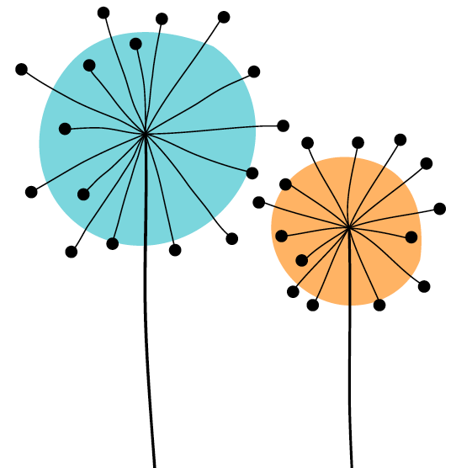 SEED AWARD
Student Enhanced Engagement & Development Award

Student Guidance Document
2026-2027

Dear Students, 
Thank you for your interest in Queen Mary's Student Enhanced Engagement and Development (SEED) Award.
This important award, distinctive to our University, has been developed in recognition of the important role that students can make to enhance their learning experience in partnership with staff. The SEED award is open to all students that have taken part in, and can evidence their contribution to, some form of educational improvement processes at the University. This might include, for example, working together with staff members to make changes to the curriculum, teaching methods, academic support or assessments. In this document you will find guidance on how to prepare your application. I recommend you start by first of all watching the SEED introductory video.
It is essential that you also discuss your application with the staff you have worked closely with, and whom you have chosen to endorse your application.
We have designed this process to be as simple as possible, whilst ensuring that your application is well-evidenced and verifiable.
The full application comprises a Reflective Account and Recommendations of 600 words (+/- 10% and not including references) and an Endorsement from an appropriate member of staff.
The University really appreciates your hard work and innovative ideas to enhance our students' learning, and I wish you the best of luck with your SEED application!

Professor Alastair Robertson
Interim Director
Queen Mary Academy
Queen Mary University of London
*You will be able to let us know about your experience on our evaluation form which you will receive after your application. In the meantime, you can contact us using our email: qma-seed@qmul.ac.uk
What is the SEED Award?
The Student Enhanced Engagement and Development Award – also known as the SEED Award – is a way for Queen Mary to recognise and reward the contributions that you and other students make to improve the educational experience.
The Award is open to all Queen Mary students that have taken part in some form of educational improvement processes, for example by working together with staff members to make changes to the curriculum, teaching methods or assessments.
To get the Award, you need to submit an application, where you explain how you have contributed to educational improvements and reflect on your experience.

Why has Queen Mary introduced the SEED Award?
It’s really important for Queen Mary to get students to help us to make sure our educational offer is as good as it can be, and the SEED Award is here to recognise the achievements of the students that get involved in this.
The SEED Award is also here to help us to achieve the QMUL Strategy 2030, which aims to:
‘ensure that anyone who is able to flourish at Queen Mary can join us, irrespective of their background’ …and that…‘learning is individualised and our pedagogic development meets the needs of our diverse learners’.
The vision is to develop student engagement opportunities with educational developments across Queen Mary which benefit and empower all our students to contribute. These opportunities will enable students to enhance and co-create the educational scene in which they are learning. It is important that students’ contribution is recognised and accredited and that all students can benefit from this commitment by the institution.

What’s in it for you?
We think there are lots of good reasons for you to apply for the SEED Award. Not only will you have the opportunity to make a difference for students, but you’ll also gain lots of experience and skills that can help you in your career. Not convinced yet? Here are all the benefits you get from being involved:
- Gaining experience as an influencer and co-creator in educational practice.
- Gaining exposure to educational development and activity.
- Developing your knowledge and understanding of reflective practice through a range of activities and the application process.
- Improving your critical thinking skills.
- Increasing your understanding of your academic subject are through dialogue and discourse.
- Enhancing your interpersonal skills such as teamwork, dependability, adaptability, and flexibility.
- Gaining recognition for your contribution.
- All of the above improve employability skills and help you to meet employer requirements.

Who can apply for the SEED Award?
You! All students of any level of study at Queen Mary can apply. From Foundation Year to Postgrad Research, the SEED Award is for you. It spans across all academic areas and covers many different types of educational improvements.
If you’re still not sure whether the SEED Award is for you, have a look in appendix 1, where you can find a list of examples of activities that count towards your SEED Award. If you can’t find your activity in the list, contact the SEED Award team on qma-seed@qmul.ac.uk.

How do you apply?
Step 1: Prepare to apply
- Carefully read the Student Guidance Document (this one) and Application Form. These documents will give you all the information you need, so take some time to review them before you start writing your application.
- The application should focus on one activity/ project. Examples of approved activities/case studies and sample applications from previous years can be found on the SEED website. We’ve also collated some top tips you can find below.
Step 2: Write your application
- When you’ve done your prep work, it’s time to start writing. It’s your responsibility to write your application, so make sure to set enough time aside to write the full application.
- Make sure you use the official application form which you can find on SEED page of the QM Academy website. Please complete all the sections of the form.
- The full application comprises a reflective account and recommendations of 600 words (+/- 10% and not including references). Applications exceeding the word limit will not be considered.
Step 3: Get your endorsement
- To complete your application, you need to get an appropriate staff member. Your endorser can be an academic, a professional services staff member, or a Queen Mary Student Union Executive Officer. The important thing is that they must have worked closely with the you during the activity you are describing in your SEED Award application.
- You need to share your application with your endorser and ask for their views before submission. The endorsement needs to be as individualised as possible and be consistent with the information you provide about your role and impact. We recommend around 250 words.
- If your endorser isn’t familiar with the SEED Award, it’s a good idea to tell them to read about the SEED Award on the QM Academy website.
Step 4: Before submitting your application
- Create a pdf file of your form to avoid any formatting issues.
- Proofread your application.
Step 5: Submitting your application
All done! Now you just need to submit your application. Applications are accepted at all times of the year, but the panels that review the applications only take place a few times per year, so we recommend that you check the panel dates in advance, so you can set yourself a realistic deadline.

Are there any top tips?

Yes, we’ve collated a list of tips, based on the questions we’ve received from previous applicants:

- The SEED Award is individual, so we are unable to accept group applications. If you’ve been working with other people on your project, you can still apply, but you must focus on your role in the project.
- The application should focus on one activity and be retrospective, which means that you can only apply based on things you’ve already done.
- You can only apply for recognition once each academic year.
- The activity you describe should be equivalent to 10 hours of work or more.
- It’s essential that you clearly explain what your contribution is. Remember that the panel may not be familiar with the project you’ve been involved in, so the application needs to clearly explain this.
- Avoid acronyms and jargon and links to external sources or websites are not permitted.
- Your application must include a reflection, where you talk about the things you have learned and how you’ve developed as a learner or as an educator and co-creator. This reflection should include the things that went well and those that may not have gone well but made you understand relevant aspects.
- The application must have a summary of recommendations for the curriculum or to educators influencing changed practice because of contribution from the student perspective.
- When writing about impact reflect on what you have done, how you have co-created with educators, what you have learned and the impact of your contribution (has it for example, improved student engagement and/or well-being in a way that can be identified and, ideally, measured? You can add participation stats, data from evaluation surveys, quotes from participants).
- Proofread your application and make sure the form you submit does not have formatting issues. We recommend submitting a pdf file.
- The SEED Award is aligned with the Professional Standards Framework 2023 (AdvanceHE). This means your applications must explicitly cover your contribution to teaching and/or support of student learning in relation to one of the following Areas of Activity (Appendix 3):
A1 Design and plan learning activities and/or programmes
A2 Teach and/or support learning through appropriate approaches and environments
A3 Assess and give feedback for learning
A4 Support and guide learners

All the activities are mapped against Queen Mary’s Graduate Attributes to help you identify the skills you have gained from the co-creative experience:

CLASS  Graduate Attributes  Focus | SEED contribution
- Students co-create with educators, contributing to curriculum enhancement
- Encourages dialogue across power dynamics (co-creation and partnership)
- Requires articulation of ideas through reflection and application
- Encourages socially responsible change within programmes
- Builds confidence, resilience, and agency through recognition
- Develops reflective adaptability (understanding and improving systems)
- Requires deep reflection on personal contribution and growth
- Recognises individual voice, lived experience, and identity
- Builds ethical awareness and academic integrity
- Applies disciplinary knowledge to critique curriculum and learning experiences
- Contributes to pedagogic innovation
- Develops critical and reflective engagement with knowledge

What support is available?
Support from the Queen Mary Academy
If you need any help with your application or have a question, we strongly encourage you to seek support from your academic school or the QM Academy. The QM Academy holds regular surgeries for SEED Award prospective applicants, and these are a great opportunity to ask all your questions. You can see when the next surgery takes place on our website.
Your Faculty, School, Institute or Programme should:
Provide opportunities for student engagement with curriculum enhancement activities. These should, where possible, be at every level e.g. considering documentation, reviewing educational processes, assessment and content, with clear outcomes and impact measures.
Support, involve, invite, and inspire students interested in this work, and guide them as required.
Review written reflection and recommendations and respond with feedback on how educational practices/content have changed as a direct result of student reflection/recommendations.
Provide an endorsement which confirms the student’s individual contribution as outlined in their reflection and recommendations (see above).

How is the SEED application processed?
The Queen Mary Academy (QMA) will:
- Review all SEED applications with a panel of 3 colleagues.
- Provide certification of students who achieve the SEED Award (QMUL certificate).
- Provide students, where they are considered not yet to have met the criteria required for a SEED Award, with feedback on what is required for any re-submission.
- Provide support for submission and re-submission (SEED surgeries with an advisor).
- Communicate the outcome of applications to endorsers and invite their contribution in case of re-submission.
- Send information about the SEED award to be included in the HEAR transcript and Rites of Passage (Medicine).
- Award SEED prizes (each academic year) - more information below.
- Arrange and deliver events which will bring together students (including those achieving the SEED Award) and educators e.g. presentations from both students and educators at the Festival of Education and other QM events as well as celebration events (SEED award and prize ceremony).

How is the SEED Award linked to other improvement initiatives and recognition schemes?
The SEED Award is clearly delineated and aligned with other initiatives across Queen Mary, and the work of the Student Union. This award intersects with other educational development opportunities for students. The significant feature of the SEED Award is that students are formally recognised and accredited for their contribution to educational development activities. If you’re unsure how specific activities and recognition schemes link to the Award, please contact qma-seed@qmul.ac.uk for guidance.

SEED PRIZES
We also have two SEED prizes: one for the students who received the SEED award (3 prize winners each academic year) and one for Educators (3 prize winners each academic year);
Nominations are made by the reviewers and winners are chosen in the Summer Panel.
All Prize winners receive a certificate, and the student SEED prize winners receive support to apply for International recognition (SPIA – Student Partnership Impact Award).

What’s the difference between the SEED Award and the SEED Prize?
Good question – the two might sound similar, but they are, in fact, very different. The SEED Award is the main award, but every year, the SEED Award Panel selects three outstanding SEED Award winners to receive the SEED Prize.
Each academic year, this prize recognises the 3 best reflective applications on: (1) the experience of co-creation, (2) the impact of the project on the student co-creator and (3) contribution of the student work to the enhancement of teaching and learning across Queen Mary.
You don’t need to submit a separate application for the SEED Award Prize – all SEED Award winners will automatically be considered for the SEED Award Prize.
What does the prize for the educator recognise? The SEED prize for the most collaborative project recognises (1) the extent to which the educator has engaged co-creatively with the student and (2) the extent to which the co-creative activities have led to impact.

Appendices:
Appendix 1: Some examples you may wish to draw upon include:
- Presenting to educators about course or faculty development.
- Working on and developing curriculum documents.
- Offering a student’s perspective on a podcast, or through video/other modes of delivery.
- Working with academic and/or professional support staff to develop teaching sessions or programmes.
- Student researchers working on educational research projects or quality improvement initiatives within the University and/or placement.
- Students sitting on steering groups or committees that raise issues with the current teaching environment and propose solutions (such as the Anti-Racism Steering Group or the working group on Clinical Reporting Procedures).
- Students involved in teaching/managing teaching societies which leads to demonstrable change (such as the History Society or Cardiology Society).
- Students involved in buddy and mentoring programmes
- Students who sit on Students’ Union subcommittees (for example, BLSA Board, HSS Board, S&E Board and Postgraduate Board) raising student concerns and campaigning on these.
- Students who take a year out as Sabbatical Officers to represent students working with colleagues across the University.

Appendix 2: Criteria for SEED Award

Criteria | Criteria Met | Criteria Not Yet Met | Criteria Not Met
 | The panel will regard the SEED Award criteria met if: | The panel will regard the SEED Award criteria as not yet met if: | The panel will decide that the SEED Award criteria has not been met if:
Contribution including recommendations | The student has written a statement which explicitly reflects upon their contribution to an educational development activity and has clear recommendations. | The student describes an educational activity but their contribution is unclear and/or their recommendations are not clear. | The student has not demonstrated their contribution or there are no recommendations.  Or the contribution outlined in the application does not relate to the SEED Award
Co-creation | The student demonstrates engagement with others and co-creation in the activity. | The application outlines an appropriate example but their role in co-creation is not discussed or is unclear. | The student has not made links between the activity and the ability to co-create with others.
Reflection | The student’s contribution is integrated into a reflective, critically considered argument, using experiences as evidence. | The student demonstrates limited reflection on the experience or provides limited experiences as evidence. | The student does not provide reflective account of their experiences or there are no experiences used to evidence the claim.
Impact | The student has evidenced a clear and verifiable impact. | The student has evidenced only association with the activity and/or evidences no verifiable impact. | The student does not demonstrate or evidence impact.
Supported and endorsed | The application supports a clear and endorsed claim as to how the student’s engagement and contribution in the activities has led to impact. | There is insufficient endorsement of the experience outlined and the impact claimed in the application. | There is no endorsement of the experience outlined and/or the impact claimed in the application.

Appendix 3: Dimensions of the Professional Standards Framework 2023

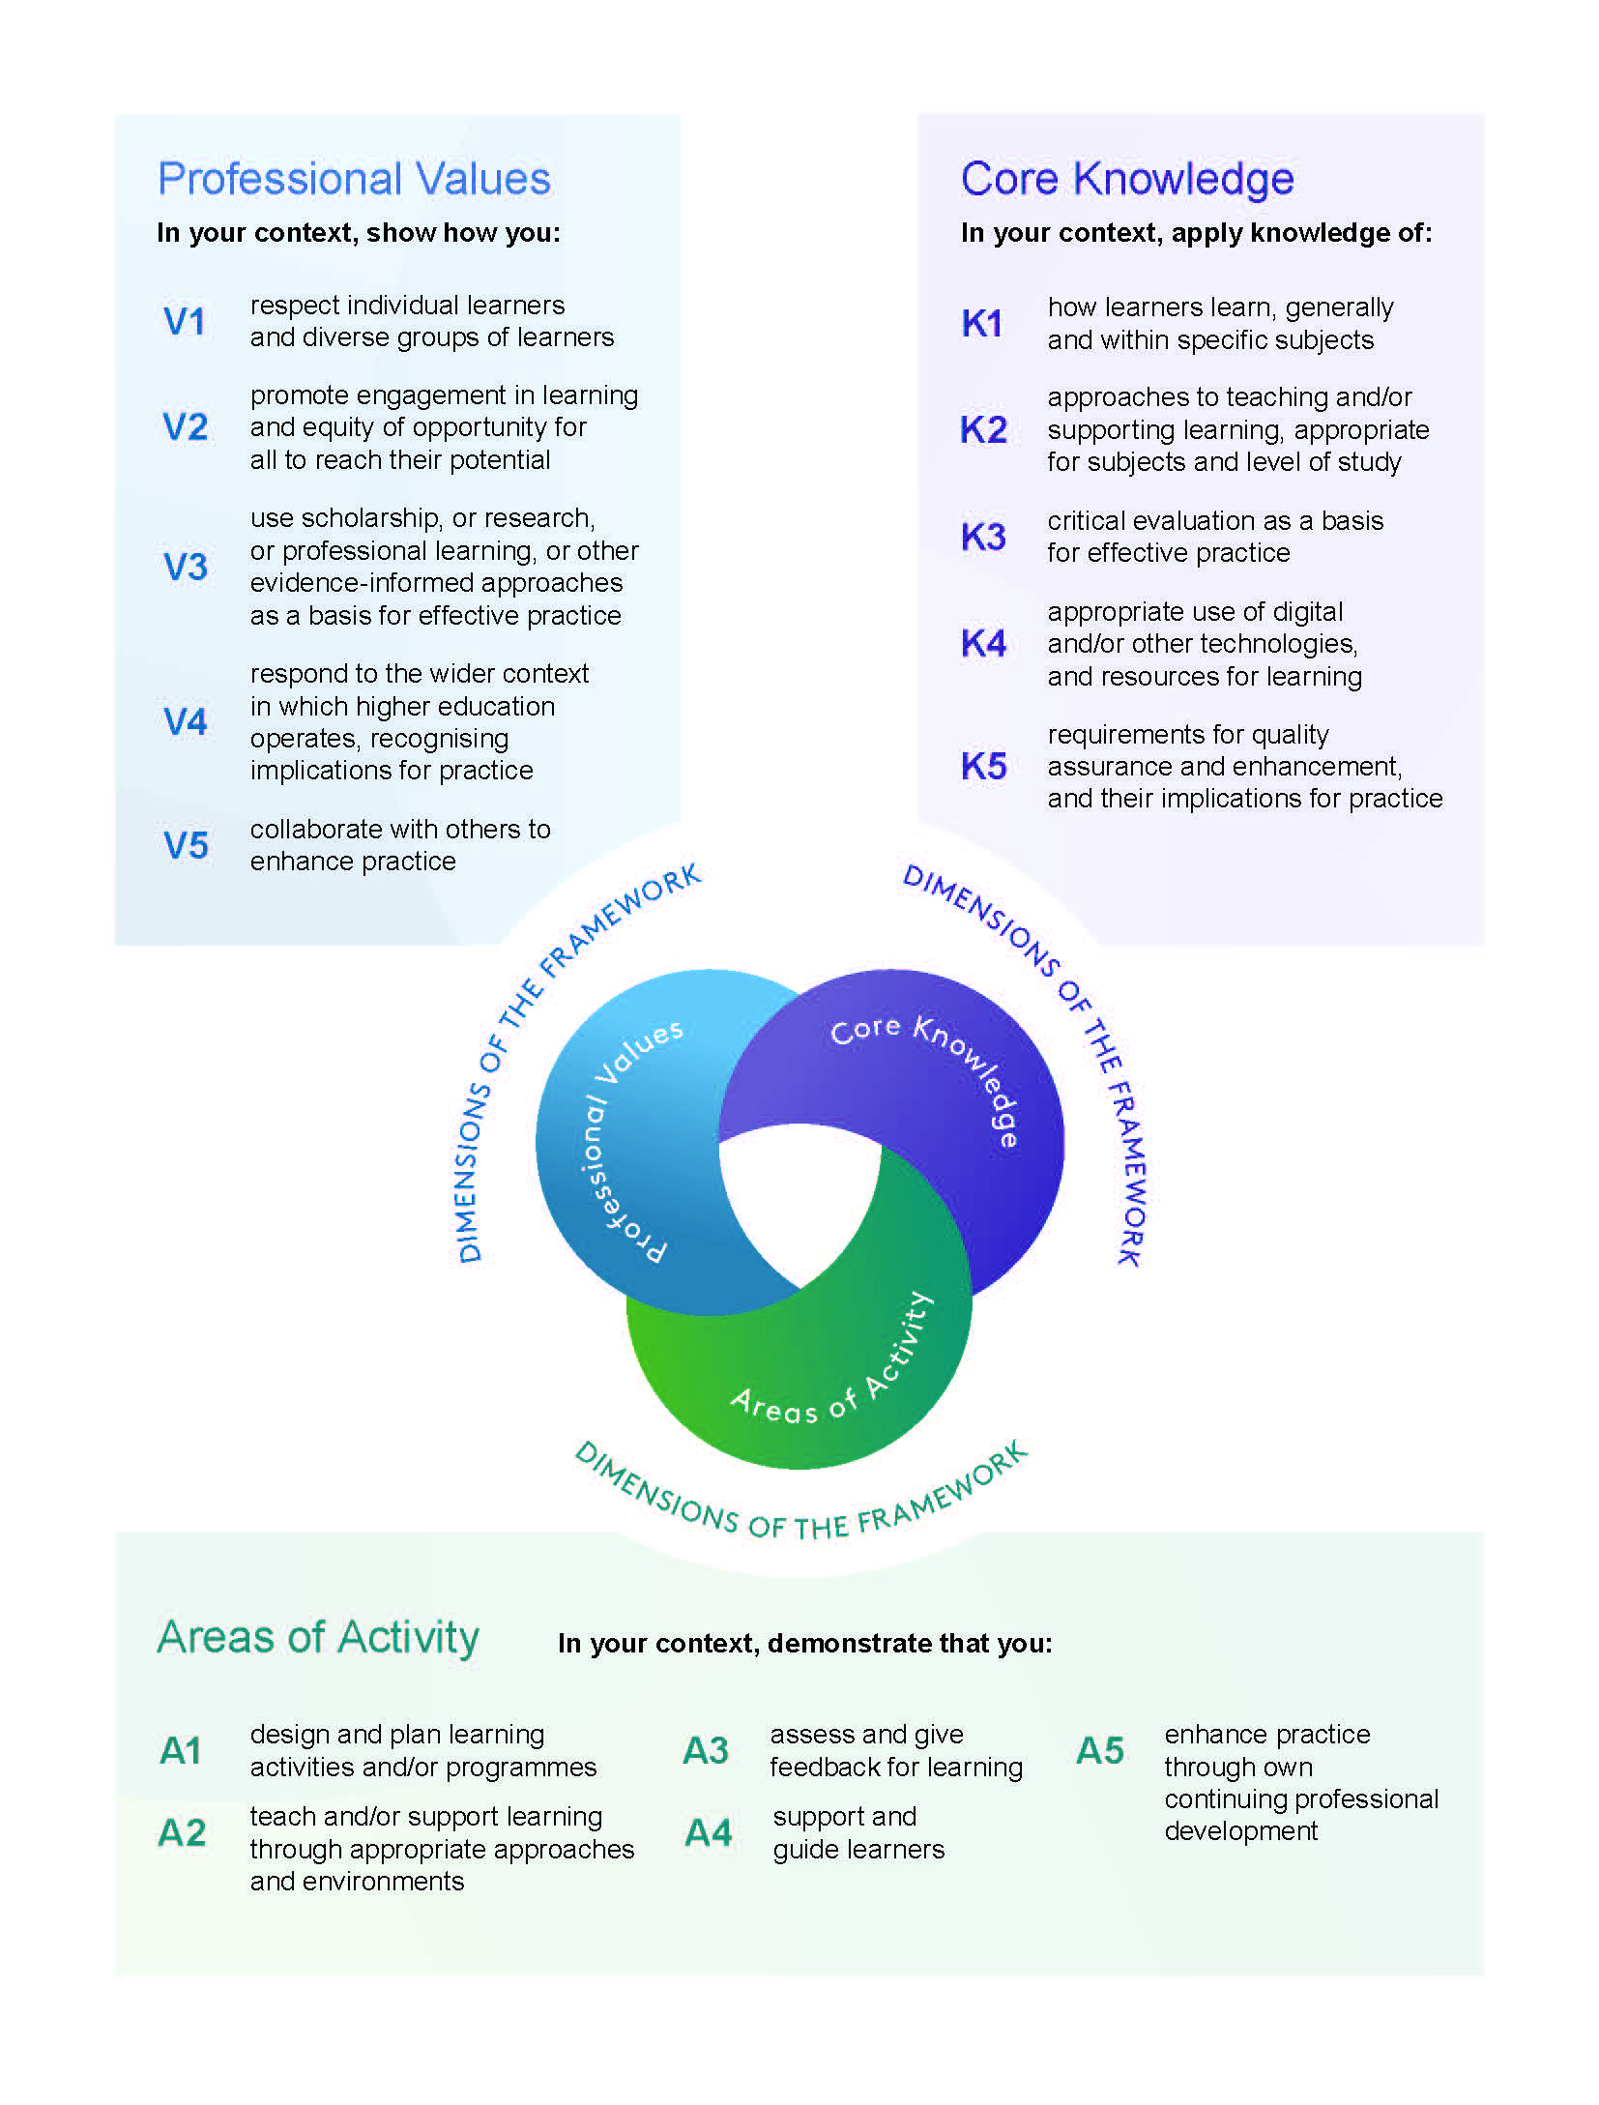

SEED Award Student Guidance
Queen Mary Academy
qma-seed@qmul.ac.uk

qmul.ac.uk/queenmaryacademy

