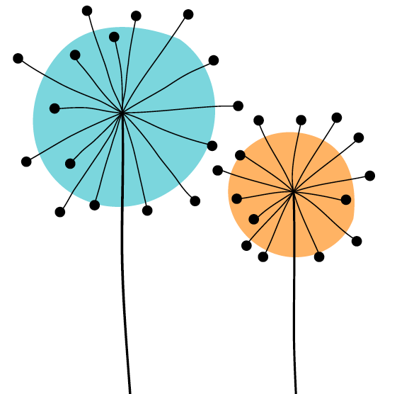

Queen Mary Academy
Student Enhanced Engagement & Development (SEED) Award
Application Form

Before completing this application form, students are reminded to carefully consider the Student Guidance Document and the SEED training video. It is important to remember that in the context of this SEED Award, ‘student engagement’ relates to student partnership with educators aimed at co-creating and enhancing the student learning environment, all of which adds meaningful change to the overall quality of the student learning experience. This aim may be achieved in many different ways, some of which are outlined in more detail in the Student Guidance Document, but they always consider co-creation in terms of collaborative work on the curriculum, course documentation, and the diversity of educational tasks across the discipline areas.

The criteria of the SEED Award are outlined on page 4 (Appendix 1) and the Dimensions of the UK Professional Standards Framework (UKPSF) are outlined on page 5 (Appendix 2).

Application Details

Student name in FULL:
Student ID:
Date SEED Application Form submitted:
Level of study (undergraduate or postgraduate):
Registered course:
Year:
School/Institute:
University username: (e.g. xyz123)
Queen Mary email address: e.g. xyz123@qmul.ac.uk
Please confirm that this application is endorsed. The application is incomplete without this signature of the endorser. | Yes☐ No ☐
Please confirm that the application is within the +/- 10% margin of the 600-word limit. The word limit does not include references. | Yes☐ No ☐
Are you happy for your application to be used as part of training for reviewers, and to help other students understand the requirements of gaining this award? | Yes☐ No ☐

Further guidance on applying for the SEED Award can be obtained on our website (including information on surgeries to support you when writing this application) or by contacting qma-seed@qmul.ac.uk

Evidence for SEED Award (600-word limit)
I. Area of activity:
Identify your main area of activity
A1: Design and plan learning activities and/or programmes of study
A2: Teaching and/or support of learning
A3: Assessment and feedback
A4: Development of effective learning environments

II. Title of your project:
Provide a title that summarises your contribution to the project

III. Reflective Account:

Reflect on what you have done, how you have developed partnerships with educators, what you have learned and the impact of your contribution (has it for example, improved student engagement and/or well-being in a way that can be identified and, ideally, measured? You can add participation stats, data from evaluation surveys, quotes from participants)

IV. Recommendations as a result of the co-creation experience:
Provide a summary of recommendations for the curriculum or to educators

V. References to scholarly literature (if applicable – not included in the word count):

Provide a list of the references you used

Student Signature
Date
VI. Staff endorsement of student’s reflective account and recommendations as outlined in this application
The appropriate member of staff endorsing this application may be an Academic, Professional Support Services colleague, or a Queen Mary Student Union Executive Officer, as long as they have worked closely with the student during the SEED process. (at least 250 words)
Please note: The endorsement should be as personalised as possible and demonstrate how the student's engagement and contribution to the activities has led to impact.

Signature of endorser
Name of endorser
Role
School/Institute/Area
Date

Appendix 1: Criteria of the SEED award
Criteria | Criteria Met | Criteria Not Yet Met | Criteria Not Met
 | The panel will regard the SEED Award criteria met if: | The panel will regard the SEED Award criteria as not yet met if: | The panel will decide that the SEED Award criteria has not been met if:
Contribution including recommendations | The student has written a statement which explicitly reflects upon their contribution to an educational development activity and has clear recommendations. | The student describes an educational activity but their contribution is unclear and/or their recommendations are not clear. | The student has not demonstrated their contribution or there are no recommendations.  Or the contribution outlined in the application does not relate to the SEED Award
Co-creation | The student demonstrates engagement with others and co-creation in the activity. | The application outlines an appropriate example but their role in co-creation is not discussed or is unclear. | The student has not made links between the activity and the ability to co-create with others.
Reflection | The student’s contribution is integrated into a reflective, critically considered argument, using experiences as evidence. | The student demonstrates limited reflection on the experience, or provides limited experiences as evidence. | The student does not provide reflective account of their experiences or there are no experiences used to evidence the claim.
Impact | The student has evidenced a clear and verifiable impact. | The student has evidenced only association with the activity and/or evidences no verifiable impact. | The student does not demonstrate or evidence impact.
Support and endorsement | The application supports a clear and endorsed claim as to how the student’s engagement and contribution in the activities has led to impact. | There is insufficient endorsement of the experience outlined and the impact claimed in the application. | There is no endorsement of the experience outlined and/or the impact claimed in the application.

Appendix 2: Dimensions of the UK Professional Standards Framework (UKPSF)
The application should make explicit reference to your contribution to teaching and/or support of student-learning in relation to one of the following Areas of Activity of the UK Professional Standards Framework

A1: Design and plan learning activities and/or programmes of study.
A2: Teaching and/or support of learning.
A3: Assessment and feedback.
A4: Development of effective learning environments – including virtual platforms – and approaches to student support.

Areas of Activity | Core Knowledge | Professional Values
A1) Design and plan learning activities and/or programmes of study | K1) The subject material | V1) Respect individual learners and diverse learning communities
A2) Teach and/or support learning | K2) Appropriate methods for teaching, learning and assessing in the subject area and at the level of the academic programme | V2) Promote participation in higher education and equality of opportunity for learners
A3) Assess and give feedback to learners | K3) How students learn, both generally and within their subject/ disciplinary area(s) | V3) Use evidence-informed approaches and the outcomes from research, scholarship and continuing professional development
A4) Develop effective learning environments and approaches to student support and guidance | K4) The use and value of appropriate learning technologies | V4) Acknowledge the wider context in which higher education operates recognising the implications for professional practice
A5) Engage in continuing professional development in subjects/disciplines and their pedagogy, incorporating research, scholarship and the evaluation of professional practices | K5) Methods for evaluating the effectiveness of teaching
 | K6) The implications of quality assurance and quality enhancement for academic and professional practice with a particular focus on teaching

