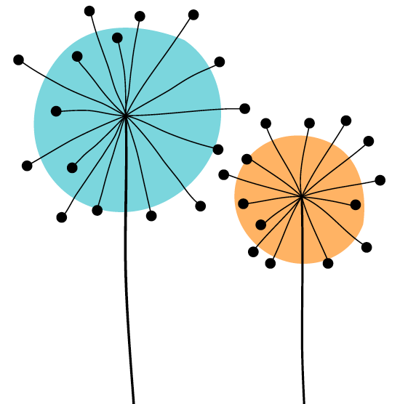

Queen Mary Academy
Student Enhanced Engagement & Development (SEED) Award
Application Form

Before completing this application form, students are reminded to carefully consider the Student Guidance Document.
It is important to remember that in the context of this SEED Award, ‘student engagement’ relates to student partnership with educators aimed at co-creating and enhancing the student learning environment, all of which adds meaningful change to the overall quality of the student learning experience. This aim may be achieved in many different ways, some of which are outlined in more detail in the Student Guidance Document, but they always consider co-creation in terms of collaborative work on the curriculum, course documentation, and the diversity of educational tasks across the discipline areas.

Application Details

Student name in FULL:
Student ID:
Date SEED Application Form submitted:
Level of study (undergraduate or postgraduate):
Registered course:
Year:
School/Institute:
University username: (e.g. xyz123)
Queen Mary email address: e.g. xyz123@qmul.ac.uk
Please confirm that this application is endorsed. The application is incomplete without this signature of the endorser. | Yes☐ No ☐
Please confirm that the application is within the +/- 10% margin of the 600-word limit. The word limit does not include references. | Yes☐ No ☐
Are you happy for your application to be used as part of training for reviewers, and to help other students understand the requirements of gaining this award? | Yes☐ No ☐

Further guidance on applying for the SEED Award can be obtained on our website (including information on surgeries to support you when writing this application) or by contacting qma-seed@qmul.ac.uk

Evidence for SEED Award (600-word limit +/- 10% and not including references)
I. Area of activity:
Identify your main area of activity:
A1: design and plan learning activities and/or programmes
A2: teach and/or support learning through appropriate approaches and environments
A3: assess and give feedback for learning
A4: support and guide learners

II. Title of your project:
Provide a title that summarises your contribution to the project

III. Reflective Account:
Reflect on what you have done, how you have developed partnerships with educators, what you have learned and the impact of your contribution (has it for example, improved student engagement and/or well-being in a way that can be identified and, ideally, measured? You can add participation stats, data from evaluation surveys, quotes from participants)

Reflect on the skills and attributes you developed. Please use the Queen Mary Graduate Attributes:
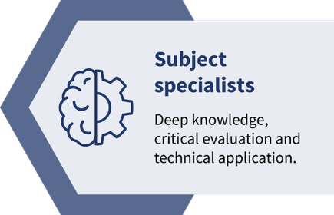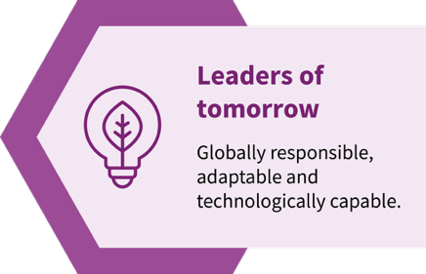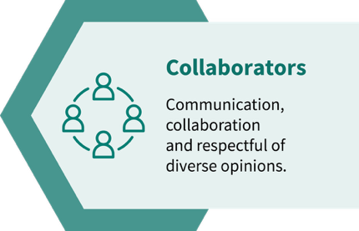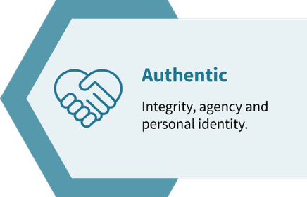

IV. Recommendations as a result of the co-creation experience:
Provide a summary of recommendations for the curriculum or to educators.

V. References to scholarly literature you used or conferences you attended

Student Signature
Date
VI. Staff endorsement of the reflective account and recommendations as outlined in this application
The endorsement should be as personalised as possible (specially if you are endorsing more than one application) and demonstrate :
(1) the extent to which you have engaged co-creatively with the student
(2) how the student's engagement and contribution to the activities have led to impact (350-500 words).

Both the application and your endorsement will be considered for the SEED prizes. Please check our Guidance for more information.
Please read the student's application before writing the endorsement.
☐ I confirm that I have read the application before writing this endorsement – please tick the box
Signature of endorser
Name of endorser
Role
School/Institute/Area
Date

