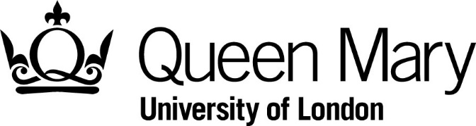

Library Services
Publication permission form for Archives

Please note the following:
- This form should be completed if you wish to publish any material from our collections.
- Complete all sections and sign the declaration.
- It is illegal to publish any material in copyright without the copyright holder’s permission. Copyright in photographs and other artistic works is particularly stringent.
- We do not hold the copyright in all material in our collections, and we may ask you to prove that you have cleared copyright or made best efforts to do so. Please contact us for further details.

Publication Fees
Depending on copyright and ownership status, we may charge publication fees on some material. Publication fees are applied for commercial or non-commercial use. Non-commercial use means an activity where no fee is paid, such as a free lecture or exhibition or an article in a journal for which no fee has been paid. Fees should be paid via the e-shop; a link will be provided by archive staff once costs have been established. If necessary, we can raise an invoice for fees but only if the total is over £50.00. Publication fees are applied per image as follows.

Format | Price
Academic/non-commercial/non-profit books, periodicals, exhibitions, electronic publications and websites | £25.00
Commercial/for profit books, periodicals, exhibitions, electronic publications and websites | £50.00
Covers of books, magazines or other hard copy publications | £70.00
Film (still images up to 10 seconds) | £60.00
Film (still images over 10 seconds) | £100.00
Permission

Last name
First name
Address

Post code
Email
Telephone

Please provide details of each item to be published, including file references and a brief description.

Item reference(s) | Description

If you require copies of the images for publication, please also fill in an Application for Copies form.

Details of publication

Format and price
Publisher/producer
Author/director
Title/web address
Publication/launch date
Print run/duration
Purpose of publication

Conditions of use
If permission to publish is to be granted you will need to:

- Have obtained consent to reproduce the images from the owner of any copyright in the original materials, before an image can be supplied by us.
- Acknowledge ‘Queen Mary University of London’ in the publication and give the reference number of the work, and page numbers where appropriate.
- Use the materials supplied by the Library only as specified in this request.

In addition, for electronic publication you will need to:

- Ensure images cannot be downloaded separately from the text.
- Clearly link a copyright statement to the image.

Permission may be withdrawn if these conditions are abused. You will be liable to indemnify Queen Mary, University of London for any loss due to infringement of these conditions.

Declaration

☐I understand and will abide by the conditions of use detailed above

Name |  | Date
Signature

For office use only
Number of images | Cost | Enquiry reference

