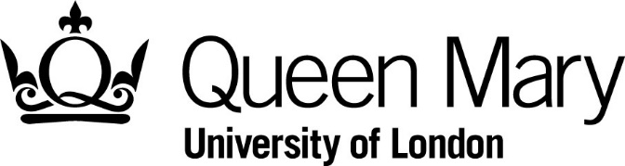

Library Services
Copy request form for Archives

Personal details
Last name
First name
Address

Post code
Email
Telephone

Please provide details of the items to be copied, (continue overleaf if necessary). Where possible please include precise references.

Item reference(s) | Details e.g. resolution required, area of focus etc

Item reference(s) | Details

Please note the following:
- If you wish to order copies of any images (for research or any other purpose), you will need to obtain the copyright holders permission before your order can be processed.
- Items will either be scanned or photographed depending on the nature of the material and its suitability to undergo reprographics. This is decided by archive staff, and we reserve the right to refuse to copy items where the copying process may cause damage.
- Fees for copies should be paid via the e-shop; a link will be provided by archive staff once costs have been established. If necessary, we can raise an invoice for fees but only if the total is over £50.00.
- If you wish to order copies for publication, please complete an application for permission to publish form instead.

Copyright declaration/Conditions of Use
- I have not previously been supplied with a copy of the same material by the Library or any other librarian/archivist.
- I will use the copy for research/private study and non-commercial use only and will not supply a copy of it to any other person.
- To the best of my knowledge, the work has not been published before being deposited at the Library and the owner has not prohibited copying of the work.
- I indemnify Queen Mary, University of London for any loss due to infringement of the conditions above.

Signature |  | Date

For office use only
Scans/photographs | Number of images | Cost | Enquiry reference

