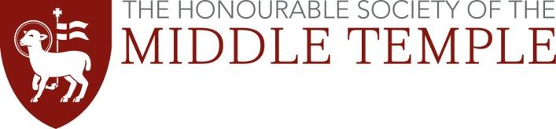
Access to the Bar Awards 2022
Guidance for Students

Background

The Middle Temple Access to the Bar Awards are an example of how we aim to reach able students from backgrounds which do not traditionally encourage aspirations for a career at the Bar and help them to make an informed choice about their opportunities.

Funded by the donations of senior members of the Inn, the scheme provides two funded weeks (£250 per week) of work experience every summer for up to thirty undergraduates from disadvantaged backgrounds. One week is spent marshalling (i.e. shadowing a judge in court) and the other week in Chambers with a barrister.

Where possible Chambers and Courts close to the candidate’s home are selected for the scheme. However where necessary the Inn will provide accommodation to complete the scheme in London. Candidates will also receive invitations to networking events.

Eligibility

The scheme is open to undergraduate and postgraduate students who;

- Are available to participate from Monday 27 June to Friday 8 July 2022 (inclusive).
- are in the second, third or fourth year of a qualifying law degree, or taking the Graduate Diploma in Law or an equivalent conversion course. Postgraduates with a qualifying law degree may also apply.

- have little or no family history of higher or professional education.

- completed secondary education in a state school. (In exceptional circumstances, students who attended secondary education in a fee-paying school may be considered.)

- are not a member of the Honourable Society of Inner Temple, The Honourable Society of Lincoln’s Inn or the Honourable Society of Gray’s Inn.

Please Note: Recipients of the Inner Temple Pegasus Access and Support Scheme will not be eligible to receive an Access to the Bar Award.

Criteria for the making of an award

The criteria for the making of an award are as follows:

- A profile indicating that the student is likely to be awarded a good upper second or first class degree, or has already been awarded one if the student is a graduate undertaking the conversion course; and

- A good performance in mooting or debating activity at university or at school or other evidence of potential to be a successful advocate; and

- Good references as to their academic and intellectual ability and other relevant qualities such as self-confidence, strong communication skills and motivation and determination for a career at the Bar from two of their university tutors.

- Students who have limited experience of the Bar thus far and meet the previous criteria are preferred.

Students should be aware that an unsuccessful application to Access to the Bar is not an indictment of their ability and will not affect their chances of being awarded a Middle Temple BPTC Scholarship - which is awarded on merit alone.

The Application Process

Each university that participates in the scheme will carry out the initial shortlisting and will submit selected applications to the Middle Temple.

Each application must include the following:
- Application form, completed, signed, and dated.
- Transcripts of degree examination results to date
- Two references from university tutors. [It is up to the Department whether referees should be approached by a member of the Faculty or by the student, but either way, they need to be submitted together with the application.]

(* please note that where an institution has multiple study centres, one application will be accepted from each region)

Students should submit their applications to:
Queen Mary University of London School of Law Scholarships and Bursaries Team
Via: law-scholarships-bursaries@qmul.ac.uk
Deadline: Midday Wednesday 9th February 2022

PLEASE NOTE THAT INCOMPLETE APPLICATIONS CANNOT BE CONSIDERED.

Shortlisting and Interview
Applications will be shortlisted by the Inn and a number of applicants will be invited to attend an interview at Middle Temple. Reasonable travel expenses (up to £65) will be reimbursed. If travel is not possible due to coronavirus then the interviews will be conducted online.

Shortlisted applicants will be interviewed by practising members of the Middle Temple in March/April 2022.

