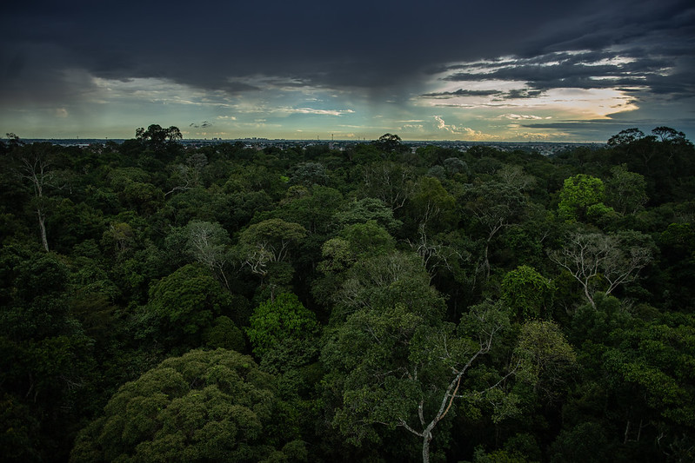Credit: IMF

lost in transition :

Current challenges of the energy transition

  - Conference and podcast launch organized by the
  - IHSS Climate Emergency Working Group (CEWG),
  - Queen Mary University of London

Conveners: Tibisay Morgandi, Caterina Gennaioli & Carlos Bellorin

4 December 2023
IET London: Savoy Place
2 Savoy Place
London
WC2R 0BL

Please sign up on the Eventbrite page to join.

Concept notE
As the world grapples with the imperative shift towards sustainable energy sources, this conference serves as a compass for navigating the complex challenges and opportunities of the ongoing energy transition. Join leading experts from academia and industry as they unravel the intricacies of this monumental paradigm shift.
Delve into critical topics such as the role of oil and gas in the energy transition, examining the industry’s evolution and contribution to achieving net zero. Explore the latest advancements in carbon capture and storage, essential components in mitigating the impact of greenhouse gas emissions. Understand the growing importance of ESG requirements and their influence on decision-making within the energy sector.
Navigate the complex legal landscape surrounding climate litigation, gaining insights into the legal challenges and responsibilities associated with the energy transition. Additionally, explore the intricate dynamics of trade and investment in the energy sector, understanding how the existing legal frameworks alongside global economic forces shape the transition to a more sustainable future.
At the conference we will also launch our brand new podcast 'Climate Game Changers'. The episodes produced cover climate litigation and the role of AI in the climate emergency. The podcasts will be available on Spotify and Apple Music.

Programme
09:00 – 09:30 Registration
09:30 – 09:45 Opening remarks (TBC)

PANEL 1 OIL AND GAS IN THE ENERGY TRANSITION
09:45 – 11:00 Chair: Carlos Bellorin (Queen Mary University of London)
David Manley (Natural Resource Governance Institute)
Beth Mitchell (Independent Consultant)
Peter Roberts (Kosmos Energy & Crosskeys Energy)
Kelly Ripley (Shell)

11:00 – 11:20 Coffee break

LAUNCH PODCAST ‘CLIMATE GAME CHANGERS’
11:20 – 11:35 Tibisay Morgandi and Caterina Gennaioli

PANEL 2 THE TRANSITION THROUGH THE LENS OF ESG
11:35 – 12:50 Chair: Caterina Gennaioli (Queen Mary University of London)
Robyn Klingler-Vidra (King’s College London)
Tibisay Morgandi (Queen Mary University of London)
Kevin Tang (University of Oxford)

12:50 – 14:00 Lunch

PANEL 3 CLIMATE LITIGATION
14:00 – 15:15 Chair: Tibisay Morgandi (Queen Mary University of London)
Payam Akhavan (University of Toronto)
Lesther Ortega (Embassy of Guatemala to the Netherlands)
Aref Shams (University College London)
Tiffanie Chan (London School of Economics)

15:15 – 15:35 Coffee break

PANEL 4 TRADE AND INVESTMENT IN THE ENERGY SECTOR
15:35 – 16:50 Chair: Vicente López-Ibor Mayor (López-Ibor Mayor Abogados & European Federation of Energy Law)
Jean-Paul Dechamps (Dechamps International LLP)
Amir Shafaie (Natural Resource Governance Institute)
Lorand Bartels (University of Cambridge & Freshfields Bruckhaus Deringer LLP)

16:50 – 17:00 Closing remarks

