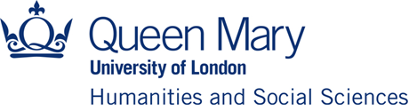

Institute for the Humanities and Social Sciences (IHSS)

IHSS Early Career Workshop Funding Scheme 2022-23

Application deadline: Friday, 11 November 2022 - 12 noon

Applications are invited from Early Career* Researchers, as well as all Post-doctoral Researchers, based in the Faculty of Humanities and Social Sciences at Queen Mary University of London for the above scheme. This is the first tranche of this scheme for this academic year to support activity being planned for the latter part of the year.

*Early Career for the purpose of this scheme is described as researchers who are within five years of gaining their PhD with allowances made for career breaks.

The aim is to provide funding towards the organisation of workshops with a cross-disciplinary dimension. A minimum of two Schools in the Faculty of Humanities and Social Sciences must be involved. Schools/Institutes from other faculties can also be involved. The total sum available will be £10k, with the maximum award being £2k per event. Awards may be supplemented from School funds.

For examples of previously funded workshops, see the IHSS webpage.

Please note that all events should be advertised as activities associated with the IHSS.

How to apply:

Applications for funding should be made using the form available on the IHSS Funding Schemes webpage.

Email address for applications and queries to ihss@qmul.ac.uk.

A brief report on expenditure and outcomes will be required within a month of completion of the workshop(s). It should be sent to ihss@qmul.ac.uk.

