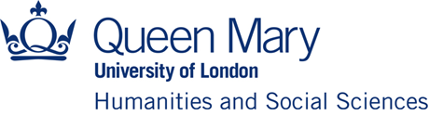

Institute of Humanities and Social Sciences (IHSS)

Early Career Workshop Funding Scheme 2022-23
Application deadline: Friday, 11 November 2022 - 12 noon

Applications are invited from Early Career and Post-doctoral Researchers based in the Faculty of Humanities and Social Sciences at Queen Mary University of London for the above scheme.
The aim is to provide funding towards the organisation of workshops with a cross-disciplinary dimension. A minimum of two Schools in the Faculty of Humanities and Social Sciences must be involved. Schools and Institutes from other Faculties can also be involved. The total sum available will be £10k, with the maximum award being £2k per event, which may be further supplemented from School budgets. For examples of previously funded workshops, please see the IHSS webpage.
Please complete the form below and return it to ihss@qmul.ac.uk.

Section 1: Applicant details:
Applicant(s) Name
School(s)

Section 2: Details of Workshop:
Title
Workshop Summary
Key aims
Specific objectives
Expected outcome
Funds requested- including breakdown of costs
Timescale- when is activity planned?

Section 3: Any other information in support of your application:

Please note that a brief report on expenditure and activity will be required within a month of completion of the workshop(s).

