Research on Display
Collaboration between Academics and Museums on Exhibitions
Geffrye Museum of the Home/ Royal Geographical Society (with IBG)

Free Workshops

Please complete this booking form and return to Laura Humphreys: l.k.humphreys@qmul.ac.uk. Places are limited and will be allocated on a first-come, first- served basis.

I would like to attend the following workshop(s), please tick only one box:
☐ Wednesday 30th April 2014 at the Geffrye Museum (10.00am – 4.30pm)
☐ WAITING LIST ONLY -Tuesday 20th May 2014 at the Royal Geographical Society with IBG (9.30am - 4.30pm)
☐ Both workshop dates

Personal Details

Name

Email address

Institution
Current status | PhD STUDENT / EARLY-CAREER RESEARCHER  (delete as appropriate)
Please inform us of any access requirements
Please inform us of any dietary requirements | (e.g: vegetarian, vegan, gluten-free, diary-free etc.)
Please provide a short biographical note (150 words max)
Please provide some questions or thoughts on collaborative exhibitions you would like addressed in the discussions.
Would you like your e-mail address circulated on delegate list? | YES / NO  (delete as appropriate)

T

Eligibility
In order to attend the event, you must be either:
- A current PhD student
- An Early-Career Researcher (in accordance with the AHRC’s definition of ECRs)

Unfortunately due to limited capacity, this event is not open to Undergraduate or Masters Students. There will be a PDF guide to collaborative exhibitions produced after the event, which will be available as a free download in early summer 2014.

Travel Bursaries

A limited number of travel bursaries of up to £50 are available for PhD students (not ECRs) living outside of the Greater London area. If these bursaries are over-subscribed, they will be allocated based on furthest distance to travel. Successful applicants will be able to claim their Travel Bursaries on the day of the event, on production of valid travel receipts.

If you wish to apply for a travel bursary, please state this in your e-mail.

Please email your completed booking form to Laura Humphreys
l.k.humphreys@qmul.ac.uk

Research on Display
Collaboration between Academics and Museums on Exhibitions
30th April 2014, Geffrye Museum of the Home & 20th May 2014, Royal Geographical Society (with IBG)

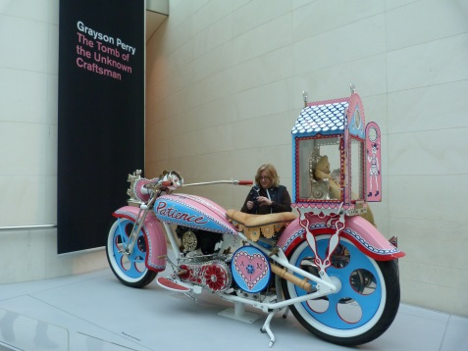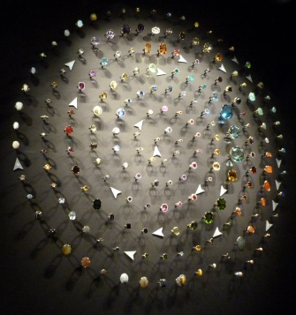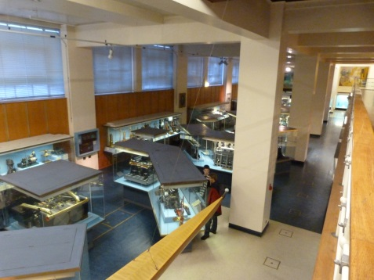

Funded by the AHRC’s Collaborative Skills Development Scheme and with additional funding from The Culture Capital Exchange, the Research on Display workshop aims to provide an introduction to collaborative exhibitions for PhD students and Early-Career Researchers. The Geffrye Museum and The Royal Geographical Society (with IBG) provide apt settings for this topic; both hold regular exhibitions on a variety of contemporary and historical subjects, support collaborative doctoral students, and are committed to collaborative research projects.

The events will include speakers from a variety of backgrounds, and feature talks on online exhibitions, collaborative events, conservation, registry, funding opportunities and a number of case studies from experienced academics and museum professionals. There will also be opportunities for participants to explore current exhibitions at the venues, and participate in a discussion with speakers about potential exhibition ideas.

Contributors and discussions for Wednesday 30 April at the Geffrye Museum include:
- Jane Holmes, Wellcome Collection, on exhibition life cycles.
- Catherine Nash & Caron Lipman, QMUL, on ‘Living with the Past at Home’ exhibition.
- Harry Cliff, Science Museum/ CERN/ Cambridge, on ‘Collider’ exhibition.
- Michael Murray, Heritage Lottery Fund, on funding for exhibitions.
- Helen Watkins, Glasgow Museums, on collaborative exhibitions of varying size.
- Lesley Hoskins and Jane Hamlett, RHUL, on their current work at the Geffrye.
- Exhibitions: permanent period rooms; Useful+Beautiful: contemporary design for the home.
- Roundtable Discussion: Where to get started with collaborative exhibitions?

Contributors and discussions for Tuesday 20 May at the RGS-IBG include:
- Felix Driver, RHUL, on ‘Hidden Histories of Exploration’ exhibition.
- Emily Yates, Science Museum, on conservation and collections care.
- Kristin Hussey, Hunterian Museum, on registry and documentation.
- Ellie Miles, British Museum, on online exhibitions and digital collections.
- Catherine Souch, RGS-IBG, on collaborations at the RGS-IBG.
- Exhibition: Pole of Cold (http://www.poleofcold.com/).
- Roundtable Discussion: Developing Exhibitions from your Research.

Participants are encouraged to think about questions they would like to put to the panels regarding their own research, and how they can develop new and existing collaborative relationships.

To book a place, please complete the booking form and return to Laura Humphreys l.k.humphreys@qmul.ac.uk. Delegates may apply to attend one day only, or both. Places are limited and will be allocated on a first-come, first- served basis.

