Using data for Tower Hamlets: Change over time
Statistics and graphs available on the website Vision of Britain. This site has collated census and historical maps going back to 1840s. Most recent data is approx. 2000. These examples for Tower Hamlets district are at http://www.visionofbritain.org.uk/unit/10057346 http://www.visionofbritain.org.uk/unit/10057346
Total population. | 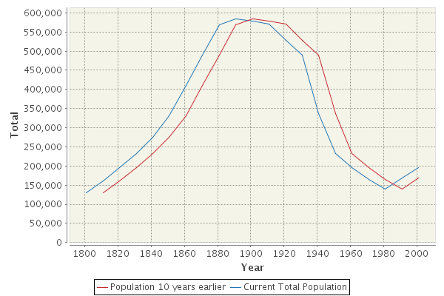
% male population in social economic class 4 & 5 (Semi -skilled and unskilled manual labour) | 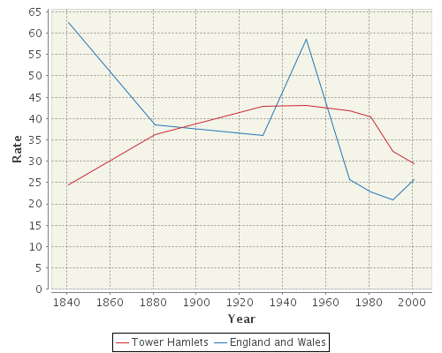
% of total working population employed in manufacturing industry | 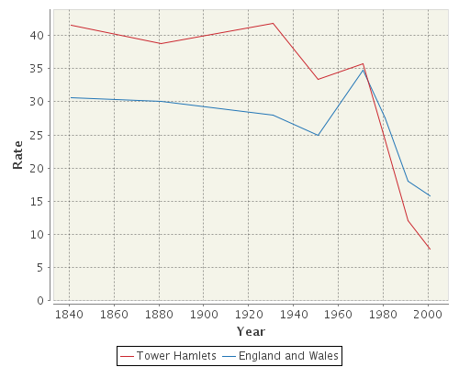
% Male unemployment | 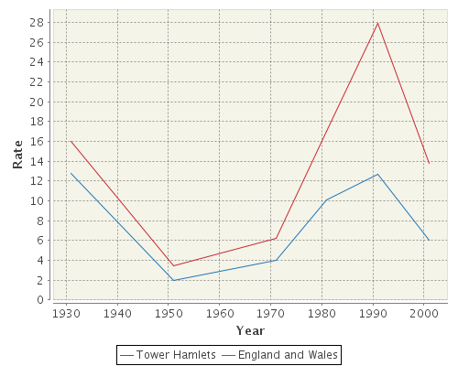
% of adult population with a degree level qualification | 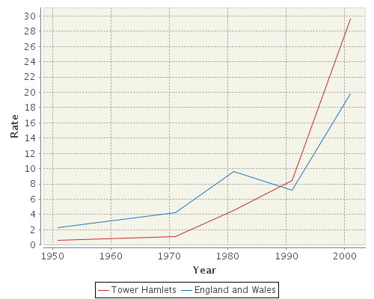

Activity
- For each graph make a prediction of where the line will be for 2010 and 2017 for Tower Hamlets and give reasons for your predictions.

- What can these graphs tell us about Tower Hamlets as a changing place?

- Is life in Tower Hamlets getting better? What other realistic data and indicators would help you to answer this question?

