Using Data for Tower Hamlets: Household Income
Source: Household income in Tower Hamlets, Insights from the 2013 CACI Paycheck data
The median household income in Tower Hamlets has increased above the 30K a year milestone. The median annual household income currently stands at £30,800 which was above the 2012 median of £29,550.8 The Tower Hamlets median household income is higher than the GB median income but still £900 below the London median household income.

Map 1: Median Household income by Output area in Tower Hamlets 2013 in £

Table 1: Median household income by ward and change between 2009 and 2013
(nb Millwall ward was renamed Canary wharf ward in 2014

Income Inequality in Tower Hamlets: Key facts taken from the Fairness Commission report of 2013 subtitled ‘Is Tower Hamlets rich or poor?’
Over a tenth of working residents earn in excess of £100,000 a year, compared to only 2% for London as a whole.
The median income in Tower Hamlets is broadly in line with the London median. Yet 50% of households have an annual income of below £50,000 and over 20% an income of just £15,000 a year or less. Nearly half of the borough’s residents are claiming some kind of benefit.12% of households earn around £60,000 a year and 3.7% of households earn around £100,000 a year. The borough has proportionally more people earning over £85,000 a year than the London average

The missing middle
One of characteristics of household income in Tower Hamlets is the lack of any clear ‘middle’ between rich and poor. This is evidenced by the fact that Tower Hamlets has a much higher proportion of both low earners and high earners than the rest of London, but proportionally less medium earners. Half of the 30,000 residents who work in the borough are in the three highest occupational sectors, with no change in the last decade. Low ranking sales and elementary roles have increased over this period, with no corresponding increase in middle-ranking roles.

This is noted in the Local Economic Assessment of 2010:
As Tower Hamlets changes and modernises its employment base it remains a place of extremes. Notable by its relative absence, by comparison with the London average, is what might be called the middle or intermediate range of skills, employment prospects and jobs. This ‘missing middle’ effect is linked to the particular pattern of housing tenure and the pricing of accommodation, and its interface with household incomes and wealth. The very wealthy and the very poor predominate in Tower Hamlets, with little bridging them economically or socially. At its worst, this represents a kind of bi-polar world in which two distinct groups are separated as much by psychological or cultural space as by physical or spatial barriers.

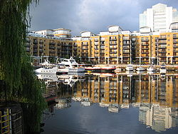 | 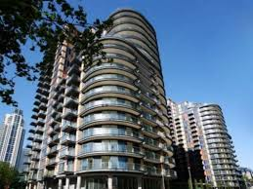 | 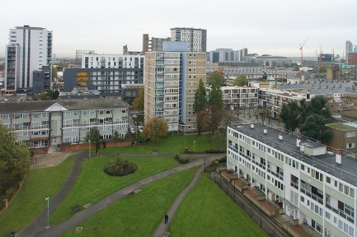 | 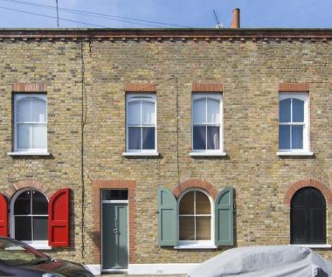
Housing in St Katharine Dock | Housing in Canary Wharf area  (Millwall ward) | Lansbury Estate | Bow west

Activity

- Describe the changes shown by the map and the table

- Suggest reasons to account for these changes

- What additional data would be useful to help with your analysis?

For teachers- Some suggested answers to activity

- Describe the changes shown by the map and the table
- Data for the last 5 years shows that the median household income in most wards has increased, often above the London and Great Britain average.
- Tower Hamlets has increased in median wealth by 9.2% in this period compared to just 5.1% increase in London and just 3.7% in GB as a whole.
- The median income for Tower Hamlets remains lower than the median income for the whole of London.
- Broadly speaking there is little change in location of where the poorest and richest areas are within Tower Hamlets. The poorest areas remain in the east and centre of the borough. The richest areas remain nearest the banks of the Thames, in the Canary Wharf area of the isle of dogs and in the areas nearest to the city of London to the west of the borough
- The data also indicates that lower income wards have been catching up to some extent with the high income wards.
- The strongest increase took place in East India & Lansbury (15.4%), Whitechapel, (15.2%), Shadwell, (15.2%), Weavers (14.1%) and Millwall (12.7%). Changes in those areas are significantly above TH, London and GB average increases.

- Suggest reasons to account for these changes

- The strongest increase in income the east and centre areas of TH relates to new housing developments in these locations which have attracted new higher income residents
- Remaining and existing residents may have also seen an increase in household income
- The lowest increase, even below London average, took place in Limehouse, St Katherine’s & Wapping and Blackwell and Cubitt Town and this reflects the fact that these areas were gentrifies many years ago and the existing population is not greatly changing now in terms of demographics/ social status.
- The 2012 Olympics had a role to play in improving job opportunities and incomes in the TH area around the 2012 period which will be reflected in these figures
- In the main changing income reflects changing people now living in the area rather than improved opportunities for the old residents

- What additional data would be useful to help with your analysis?

- Population mobility: We can’t tell who has benefitted from these changes. Only that the postcodes had richer people living there in 2013 compared to 2009. If we had data on population flux this would help us separate existing residents from recent incomers
- Demographic structure : we would expect older people to earn more money so knowing the age of the population would enable us to make better comparisons
- Household size: A household of one person earning above 50k would be experiencing v different levels of well -being to a household of 6 people on an income of below £20K
- Indicators reflecting other aspects of well -being apart from just wealth such as health or deprivation.

Sources:
http://www.towerhamlets.gov.uk/Documents/One-TH/Part-I-Poverty,-debt,-and-unemployment.pdf
http://www.towerhamlets.gov.uk/Documents/Borough_statistics/Income_poverty_and_welfare/Research-Briefing-2013-04-Household-Income-final.pdf

