Template for Preparation of One-Page Papers for DMRN
Given-name Family-name (Surname)^{*1} and Given-name Family-name (Surname)^{†2}

¹Department/Research Institute, University, Country, email@presenting.author
²Department/Research Institute, University, Country
Abstract— This document is a template for Microsoft Word for the submission of a one-page paper to DMRN.
Index Terms— One, two, three, four, five

Headings
This template provides authors with most of the formatting specifications needed for preparing electronic versions of their papers. A brief abstract (containing text only) must also be entered in the above 'Abstract' headed text box.
Headings may be used as required. Please adopt the Small-Caps heading style. References may be included if necessary as may figures. But the overall paper (including references and figures) cannot exceed the one page limit. Do not change the margins, column widths, font sizes or line spacing to squeeze more text into the page. Use italics for emphasis; do not underline.

Others
Define abbreviations and acronyms the first time they are used in the text, even after they have been defined in the abstract. Do not use abbreviations in the title or heads unless they are unavoidable. Use either SI (MKS) or CGS as primary units. (SI units are encouraged.)
You will need to determine whether or not your equation should be typed using either the Times New Roman or the Symbol font (please no other font). To create multileveled equations, it may be necessary to treat the equation as a graphic. Equation numbers, within parentheses, are to position flush right, as in (1), using a right tab stop. Italicize Roman symbols for quantities and variables, but not Greek symbols. Use a long dash rather than a hyphen for a minus sign.
       
Note that the equation is centered using a center tab stop. Be sure that the symbols in your equation have been defined before or immediately following the equation.

Figure captions should be below the figures; table heads should appear above the tables. Insert figures and tables after they are cited in the text. Use the abbreviation “Fig. 1”, even at the beginning of a sentence.
Figure Labels: Use 8 point Times New Roman for Figure labels. Use words rather than symbols or abbreviations when writing Figure axis labels to avoid confusing the reader. If including units in the label, present them within parentheses. Do not label axes only with units. In the example, write “Magnetization (A/m)”, not just “A/m”. Do not label axes with a ratio of quantities and units. For example, write “Temperature (K)”, not “Temperature/K.”
- Table Type Styles
Table Head
Table column subhead | Subhead | Subhead
More table copy

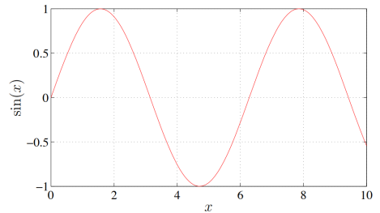
- Example of a figure with experimental results.

References
List and number all bibliographical references at the end of the paper. The references should be numbered in order of appearance in the document. When referring to them in the text, type the corresponding reference number in square brackets as shown at the end of this sentence [1, 2].

Acknowledgment
The preferred spelling of “acknowledgment” is without an “e” after the “g”. Avoid “One of us (R. B. G.) thanks”; try “R. B. G. thanks”. Put sponsor acknowledgments in the footnote.

References
- C. Jones, A. Smith, and E. Roberts, “A sample paper in conference proceedings,” in Proc. IEEE ICASSP, vol. II, 2003, pp. 803–806.
- E. Williams,Fourier Acoustics: Sound Radiation and Nearfield Acous-tic Holography. London, UK: Academic Press, 1999.
- https://www.qmul.ac.uk/dmrn/dmrn15/.

________________________ *Research supported by ABC Foundation. †Thanks to XYZ agency for funding.

