Disability and Dyslexia Service (DDS)

Advice for teaching students on the Autistic Spectrum

What is Autism?
Autism (also known as Autistic Spectrum Conditions) refers to a lifelong developmental disability that affects the way a person communicates and relates to people around them.

‘Autism is a “dynamic disability”. What this means is capacity and functioning are not concrete and may fluctuate dependent on factors such as environment, cognition, executive function, processing capacity, Interoception/exteroception, neuro-fatigue, anxiety, communication differences, burnout and sensory overwhelm.

This means Autistics may be capable of a task one day, but unable to perform the task at another.’

Credits: Neurodiversally Unbroken, 2021.

Talking about Autism
The most important thing to remember is that many autistic people see their autism as a fundamental part of who they are, so it’s important to use positive language. Ask them how they would prefer to be described. This preference should take precedence over the recommendations outlined on the National Autistic Society website:
https://www.autism.org.uk/what-we-do/help-and-support/how-to-talk-about-autism

Co-Editor, Co-Publisher, Co-Viewer

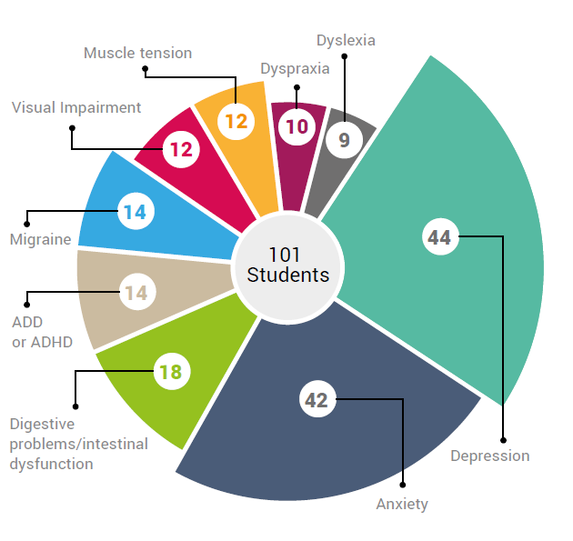
Classifications
Figure 1 Pie chart showing possible co-morbidities alongside autism
DSM 5(2013) and ICD 11 (2019)
Autism is classified under both Neurodevelopment Disorders and Behavioural, Mental Disorders. Often co-morbidities are presented, such as anxiety, depression, and gastro -intestinal issues.

Credit: Best practice guides from Autism&uni are available to download from http://www.autism-uni.org/bestpractice/
Figure 2: a glass of water

The Anxiety Glass (fight or flight)
Throughout the day/week/month, various things/events can contribute towards a build-up of anxiety, which may result in the autistic student experiencing an explosion: frustration, aggressive panic attack (melt down: fight) or implosion: may not seem themselves, struggles to engage/communicate, become mute, focusing on basic function (shut down: flight).
Being mindful of how you communicate and the environment you create can help to support a student’s emotional regulation and engagement at Queen Mary.
How the autistic student interprets and experiences the world around them, differs from each individual on the autistic spectrum. For more information you, visit the DDS Autism webpage. https://dds.qmul.ac.uk/asd/

Strengths and Interests
Identify and allow the students to build on existing strengths, interests and coping mechanisms that respects both their difficulties and their ambitions.

How to support Social Communication:
- identify how the individual prefers to communicate (face to face, in writing/use of visual aids)
- be consistent with your communication
- email the student prior to the scheduled meeting, outlining what will be discussed/questions asked/who will be present in the meeting (clear expectations)
- be specific with what you are saying or asking (anticipate that misinterpretations may occur)
- use the person’s name to ensure they know you are speaking to them
- limit verbal instructions given at one time (up to 4/5 points) and allow time for information to be processed
- provide something to refer to after verbal input, e.g. written list
- enlist the support of a specialist (disability advisers, mental health advisers)

Self-regulation and Mutual Regulation
Recognising triggers and having a bank of strategies to self-regulate is important for the autistic student. Some may have a bank of strategies already in place (self-regulation), while others may need support (mutual regulation).
Pre-emptive planning can really help to mitigate against triggers that might lead to a meltdown /shut down. For more information you, visit the DDS Autism webpage. https://dds.qmul.ac.uk/asd/

Mental Health Strategies
Self-Care | Social and Peer Support | Therapeutic Activities
Awareness | Friends | Relaxation / Mindfulness
Mood diaries | Family | Nature
Talking / Communicating | Support groups/specialists | Physical Exercise

Rigidity and Repetitiveness (difficulty with managing changes) – People on the autistic spectrum are often perceived to be inflexible with their thoughts/behaviours: unfamiliar situations; new transitions; concepts of danger, planning for the future; special interests, however, if the correct supports are in place, adapting to change is manageable:

- provide as much notice about upcoming changes as possible
- ensure communication channels are open (between the school, student, SSO etc)
- clear expectations / structure: provide timetable / schedules; send reminders; include dates and times; first -then/ today -tomorrow/ this week – next week etc
- encourage generalising skills learned in one area to another
- consistency of approach across all supporters (DA, SSO, mentors, tutors etc)

Differences that may be experienced by people on the autistic spectrum:
- Social Communication - e.g. difficulty making small talk; literal understanding of spoken language; lack of understanding of body language; lack of cognitive empathy
- Social Relationships – e.g. unfamiliar with /don’t pick up on unwritten social rules; may say inappropriate things; avoid eye contact; find group environments very uncomfortable
- Sensory Processing –sensitivities to lights/sounds/textures/tastes/smells that evoke physical responses, such as racing heart, nausea, fatigue and may trigger other conditions (migraines)

Other Considerations
The following are some possible challenges, though this list is not exhaustive. Students on the autistic spectrum may face difficulty with:
- Anxiety using video/audio conferencing in front of their teaching staff and/or peers. Many autistic students have told DDS they dislike speaking on the phone and feel uncomfortable posting comments to online forums/discussion boards where their peers can see their comments;
- Existing general anxiety is likely to be heightened when experiencing change/something new (including people), making it harder to concentrate on learning;
- Increased isolation (e.g. may not have many networks of friends for support or social communication);
- May get ‘lost’ in reading about other things, e.g. a specific topic of interest, at the expense of wider teaching material.

Additional guidance on teaching autistic students can be found at:
- http://www.dds.qmul.ac.uk/asd/
- http://www.dds.qmul.ac.uk/staffinfo/
- Best practice guides from Autism&uni are available to download from http://www.autism-uni.org/bestpractice/

For more information or specific queries, please contact Samia Imran or Huong Hoang-Wilson in the Disability and Dyslexia Service on dds@qmul.ac.uk .

Huong Hoang-Wilson

Disability Adviser (Mental Health & Autism)

Disability and Dyslexia Service

July 2022

