ULTRASOUND MEASUREMENT OF QUADRICEPS RECTUS FEMORIS CROSS-SECTIONAL AREA

Machine
Sonosite M-Turbo 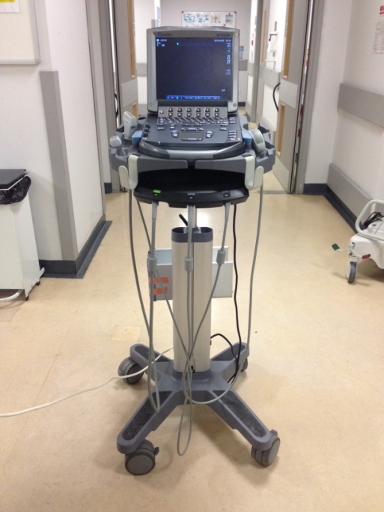

Useful links
User Manual
http://www.sonosite.com/downloads/M-Turbo_UG_P07662.pdf
Instruction Manual
http://www.youtube.com/watch?v=7xay5MFDgaY
Tutorial 1: System Overview
http://www.youtube.com/watch?v=ahZhsPU8isw
Tutorial 2: Screen Layout
http://www.youtube.com/watch?v=HNRPRrMlg80
Tutorial 3: How to Perform and Exam
http://www.youtube.com/watch?v=S-wojEALpW8
Tutorial 4: View, Save, Export Images/Clips http://www.youtube.com/watch?v=ZWCKKi5sQ3Q

Equipment required
- Ultrasound gel (Aquasonic)
- Tape measure (single use preferable for patient assessment; if not available, use a non-fabric tape measure that can be wiped clean with a sterilising wipe after use)
- Pen for marking measurement distance (indelible ink if planning to leave measurement mark intact after assessment)
- Tegaderm dressing (if planning to leave measurement mark intact after assessment)
- USB stick (unencrypted, for transfer of images from US machine to secure computer)
- Conversion chart (to facilitate calculation of 3/5 or 2/3 measurement distances)

Procedure
- Subject position
Maintain same position on each assessment occasion. Subjects should be semi-supine (likely between 30° and 45° trunk flexion for ICU patients in reality), midline and neutral, ensuring legs are not rotated. Pillows may be required to support. On the ICU, if necessary liaise with nursing staff to assist with repositioning of patient in advance e.g. sliding up the bed. A pillow can also be used to support under the knee for comfort and to avoid hyperextension. As standard, the right leg is always measured unless there is a clinical reason to preclude this. Access is required to the whole of the right thigh.

- Measurement position
- Palpate the anterior superior iliac spine (ASIS) – this is the bony prominence on the front of the hips. Note depending on subject body habitus, you may need to palpate more deeply on some than others, especially in the patient population.
- Measure from the ASIS to the superior patellar border (SPB, again, this will be more palpable in some patients that others).
- Mark a point 3/5 distance from the ASIS to the SPB. This is where a conversion chart of distances is useful for ease and speed. From experience the thigh ‘length’ tends to be between 40 and 50cm, so calculating 3/5 of each value between 35 and 55cm should cover most possibilities.
- If the measurement mark is to be used again after assessment in patients, use an indelible marker, and cover with a Tegaderm dressing afterwards (informing the nursing staff of this and advising for the dressing not to be removed). For additional reference, make a note of the ‘thigh length’ distance in the Case Report Form, in case this dressing is removed between assessment times. If the mark is not to be used again after assessment, any pen can be used and the mark removed with an alcowipe afterwards.

- Setting up the US machine
- Ensure the machine is plugged in with a power supply (there is an internal battery but not sure the reliable duration so always better to have mains source where possible), checking the power cable is securely in the machine.
- Turn on the machine using the Power switch and wait for the machine to load. When it is ready, the image acquisition screen will appear i.e. blank screen ready to take images.
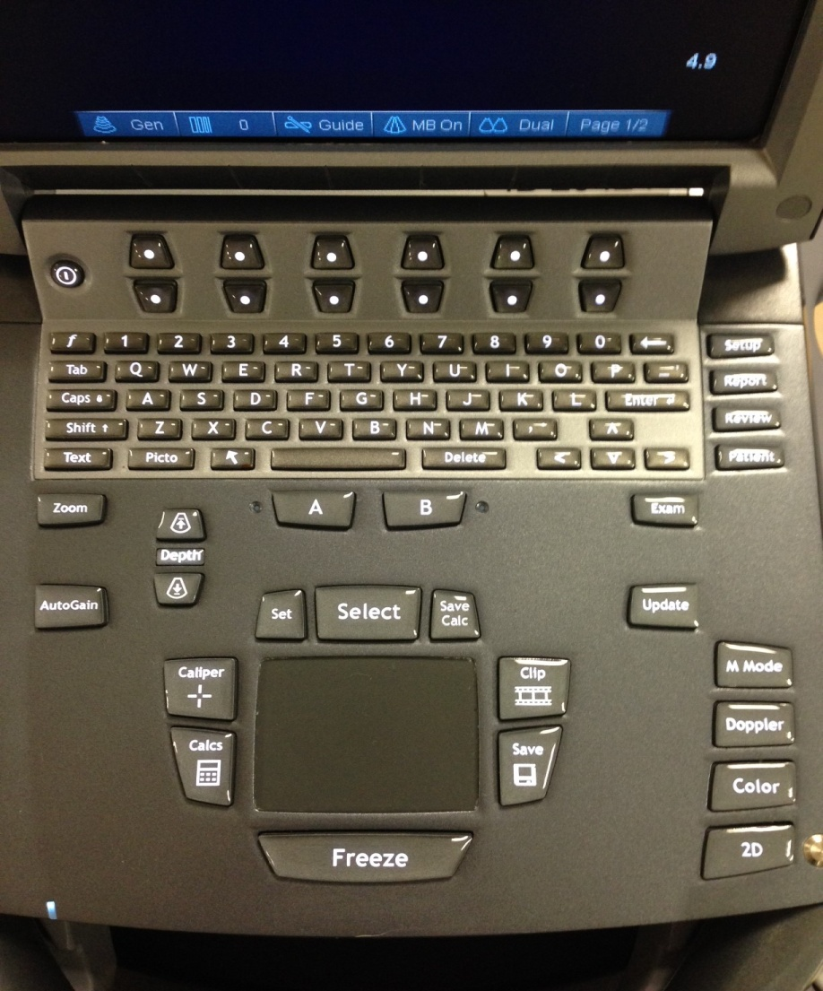
POWER

- Check that the curvilinear probe (transducer) is ready to use. This should already be connected to the machine, but will be indicated as ‘in use’ by a corresponding green light where the cable attaches into the machine. The straight probe can also be used: it gives good quality images providing the full extent of the RF can be visualised.

- Starting the assessment
- Each subject requires an individual folder to be created to store their images for a particular assessment. In the study, each patient will have a file of scans for Days 1, 7, 10, and ICU discharge.
- To start an assessment, press Patient (see image). The following Patient Information screen will appear. Information only needs to be inserted into the ‘Last’ box (see Section 8. Labelling, below).

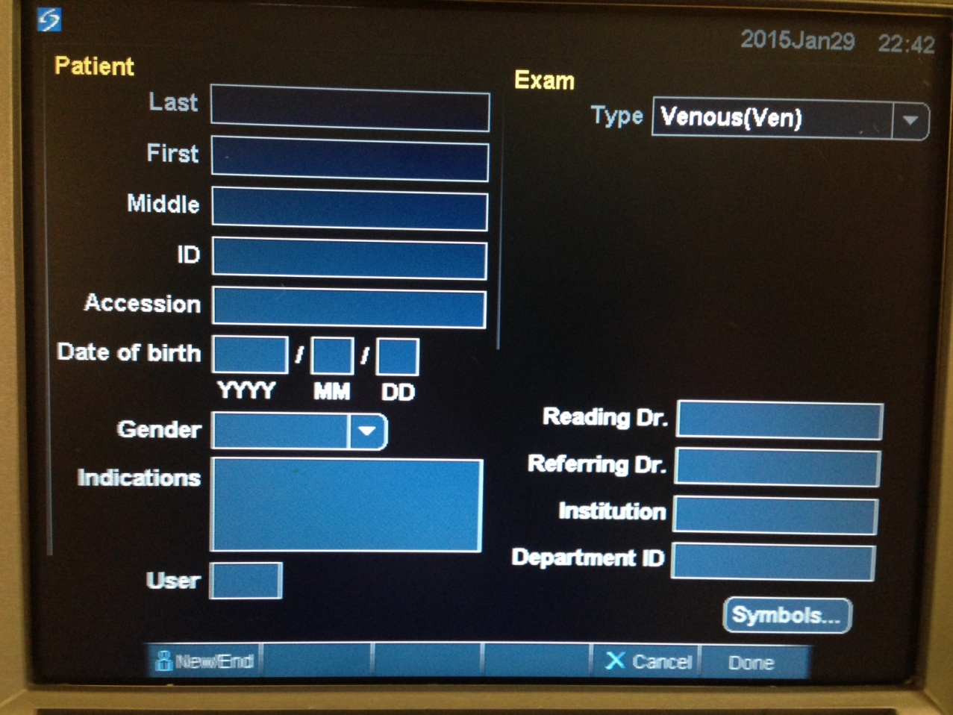

- Once this is completed, click on ‘Done’ and the screen will return to the imaging screen. However you will notice at the top of the screen that your label will appear. This label will appear on every different image, and is the ‘reference’ label for that patient’s particular assessment. Note you will still have to individually label each image with the image number etc.

- Image acquisition
- Ensure the subject’s leg is fully relaxed (not a problem of the patient is sedated, but to be aware of scanning a patient whose sedation is weaning, then may need to choose a different time if unable to acquire adequate images due to movement etc).
- Place a liberal quantity of US gel over the measurement mark, to maximise visualisation and minimise distortion of the images, especially important as using the curvilinear probe to make sure the edges are ‘filled in’ with gel. Using the curvilinear probe, place this along the superior border of the thigh, perpendicular to the long axis. Use the border of the femur bone to orient the image. See the enclosed image for an example of RF_{CSA} from a healthy subject.
- In subjects who are awake and able to follow instructions, contraction manoeuvres of the quadriceps (knee extension, instruct the patient to push the knee down into the bed) can be performed to facilitate identification of RF as you will see the muscle changing shape as is contracts and relaxes.
- Ensure that the superior border of the thigh remains curved in the image i.e. there is no excess pressure from pushing down too hard with the probe that will distort the underlying muscle. The probe should ‘float’ on the gel layer. Due to individual differences in muscle architecture, not all individuals’ muscles will be in the middle of the thigh i.e. if the leg is well positioned in neutral, you may find that you are more medial/lateral on the thigh to visualise RF.
- Ensure the entire border of RF can be visualised in the image as clearly as possible. Notes on settings:
  - The depth (how near/far away the image appears on the screen) should be at 5.6cm, adjusted using the Depth buttons (see image).
  - The gain (how bright the image appears on the screen) should be set using the Autogain button (see image). Note, whilst the gain is changeable using the dial indicated (see image), there does not appear to be any way of obtaining a numerical value for each level for the purposes of standardisation between images. Hence, we have decided to use the Autogain setting for this purpose. Essentially, there is no need to change any gain settings from the appearance of the image when it first appears.
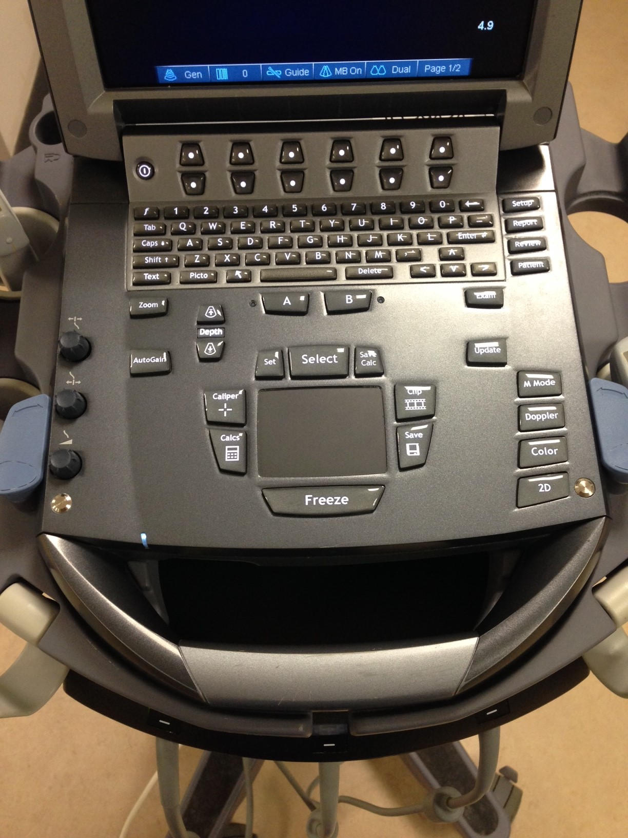
GAIN DIAL
CALIPER BUTTON
AUTOGAIN BUTTON

- Whilst viewing the screen to acquire your image, check that you do not inadvertently move the probe off of the measurement mark. Also check that you maintain the probe perpendicular to the thigh, and avoid holding it at an angle that will also cause distortion to the image.
- Once you are satisfied with your image, press Freeze.
- A caliper marker is required on all images for offline analysis, This is a distance noted on the image at the time of acquisition; it can be of any distance, but needs to be marked away from where RF appears on the screen (see image above). Press Caliper once to mark one end of the caliper line, then move the cursor to another point and press Select to mark the end of the line.
- Press Text to add labelling to the image. This is the individual label for that particular image and will include a reference as to the subject, the operator (if applicable), the day of measurement, and the number of the measurement (see Section 8. Labelling, below).
- Press Save to store the image. The machine beeps when it is has stored an image. If you have any doubt as to whether you have saved an image, or didn’t hear the beep, then re-save, as duplicate images can be deleted at the later analysis stage.
- Press Freeze again to unfreeze the image, and repeat the process.

For the purposes of analysis to determine RF_{CSA}, the average of three consecutive images within 10% are taken. Ideally, this would be within 5% to increase accuracy and to establish the effect of an intervention. I would also recommend taking extra images for reference, especially if the patient has been particularly complex to scan, and whilst gaining experience. It won’t take that long and any excess images can be stored but not used in analysis.

- Ending the assessment
- Once you have acquired all the images needed, with the screen in image acquisition mode i.e. unfrozen, press Patient again. This will return you to the patient data screen.
- Click on ‘New/End’ and this will ‘end’ the assessment of that subject. You will see that the details are removed from the ‘Last name’ box ready for a new patient. The patient’s file has been stored ready to be downloaded when ready.

It is important to ‘Start’ and ‘End’ each patient assessment to avoid muddling the images of multiple patients, on different occasions, and to facilitate file storage.

- Downloading files
- To export patient files to a USB storage device, go to Review. This will bring up a list of all patient files stored in the internal archive of the machine. You will see all the files under the labels assigned to each subject’s assessment. Check the box next to each file that you wish to download.
- Insert an unencrypted USB stick. Select Exp.USB on-screen, and select the USB storage device from the list that appear (likely only your one). Select Export, and wait at least 10seconds until the USB stick has ceased flashing before removing. The screen will return to normal once exporting has finished. Note there is no Export USB function as there is on a computer.
- Transfer onto a secure computer in the normal way, and delete from the unencrypted USB.

- Labelling

File name: UK01 XXXX D1 (eg, study pt XXXX at RLH, day 1)

Individual image name: GB01-XXXX D1 A RF1

Where GB01 = site number
XXXX = PIN
D1 = Day 1 assessment (D7, D10...and so forth)
Individual Scanner code = eg, A, B, C etc
RF1 = rectus femoris image 1 (2, 3....and so forth)

