g
Adult Critical Care Unit
STANDARD OPERATING PROCEDURE

TITLE | Ultrasound Rectus Femoris
VERSION | 1
DATE | September 17th 2019
AUTHOR | D Bear & A McNelly
APPROVED BY | Dr Zudin Puthucheary
APPROVAL DATE

REVIEW BY DATE | September 17th 2020

Standard Operating Procedure – Ultrasound Quadriceps (Rectus Femoris) Version 1
Scope and Purpose
This standard operating procedure (SOP) version applies to training of investigators as part of the ‘Alternative Substrates in the Critically Ill Subject’ Trial (ASICS).

Ultrasound scans of the leg are performed to measure the cross-sectional area of rectus femoris muscle (RF_{CSA}) as the primary outcome.

Training of additional local site study investigators (in advance of commencing study participant data acquisition) should be conducted on healthy volunteers.

Equipment:
I) Ultrasound scanner (make and model site dependent). For this trial the make and model being
used is the GE Logiq-e.
- Ultrasound gel (Aquasonic)
- Tape measure (single use preferable for patient assessment; if not available, use a non-fabric tape measure that can be wiped clean with a sterilising wipe after use)
- Pen for marking measurement distance (indelible ink if planning to leave measurement mark intact after assessment, eyeliner works well for reliability scanning where the mark needs to be removed between participants)
- Tegaderm dressing (if planning to leave measurement mark intact after assessment)
- USB stick (unencrypted, for transfer of images from US machine to secure computer)
- Conversion chart (to facilitate calculation of 2/3 measurement distance)

Procedure:
NOTES: All screenshots are for example only and each individual make and model of machine will vary. All instructions are given in principle for guidance only; all ultrasound imaging machines should be used according to manufacturer’s recommended guidelines which should be checked before use, and specific functions may vary from the notes below. This method for acquiring ultrasound images of RF_{CSA} is based on that reported by Seymour et al ².

Subject position
- Maintain the same position on each assessment occasion.
- Subjects should be semi-supine (likely between 30° and 45° trunk flexion), midline and neutral, ensuring legs are not rotated. Pillows may be required to support.
- Liaise with nursing staff to assist with repositioning of patient in advance as required.
- A pillow can also be used to support under the knee for comfort and to avoid hyperextension.
As standard, the right leg is always measured unless there is a clinical reason to preclude this.
- Access is required to the whole of the right thigh.

Measurement position
- Palpate the anterior superior iliac spine (ASIS) – this is the bony prominence on the front of the hips. Note depending on subject body habitus, you may need to palpate more deeply on some than others.
- Measure from the ASIS to the superior patellar border (SPB); again, this will be more palpable in some patients that others (See image below).
- Mark a point 2/3 distance from the ASIS to the SPB. This is where a conversion chart of distances is useful for ease and speed. If the mark is not to be used again after assessment, any pen can be used and the mark removed with a sterile wipe afterwards.
An eyeliner pencil also works well (See image below)
iv) Make a note of the ‘thigh length’ distance in the Case Report Form, in case this dressing is removed between assessment times.
v) If the measurement mark is to be used again after assessment in patients, use an indelible marker, and cover with a Tegaderm dressing afterwards (informing the nursing staff of this and advising for the dressing not to be removed. The Tegaderm can be labelled with the date and study name).

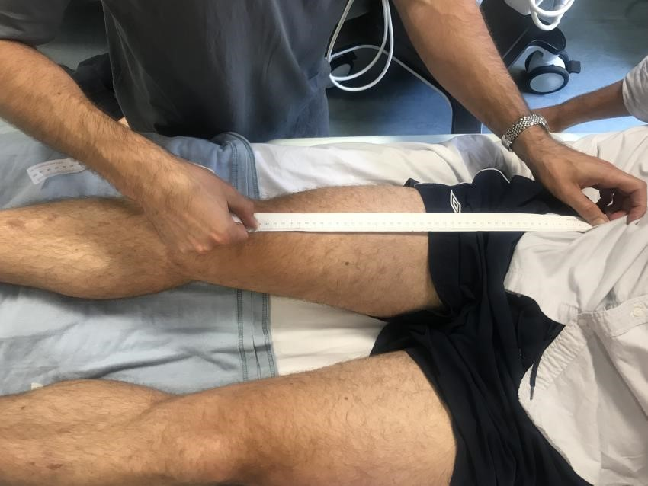

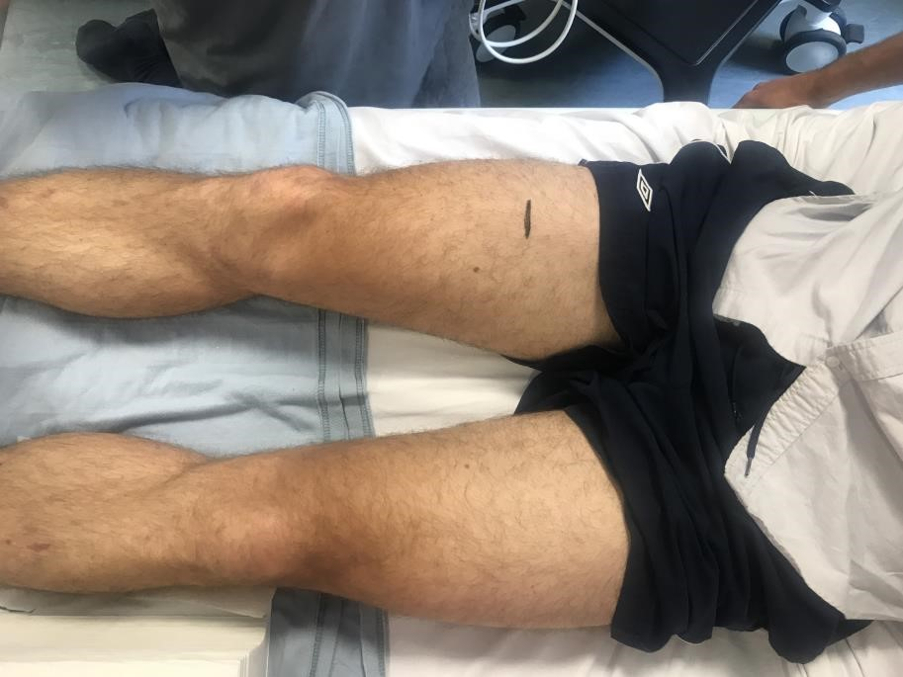

Setting up the US machine
- Ensure the machine is plugged in with a power supply (there is only 40 minutes of battery time on this particular machine), checking the power cable is securely in the machine.
- Turn on the machine using the Power switch and wait for the machine to load. When it is ready, a login screen will appear. There is no password, simply press ‘enter’
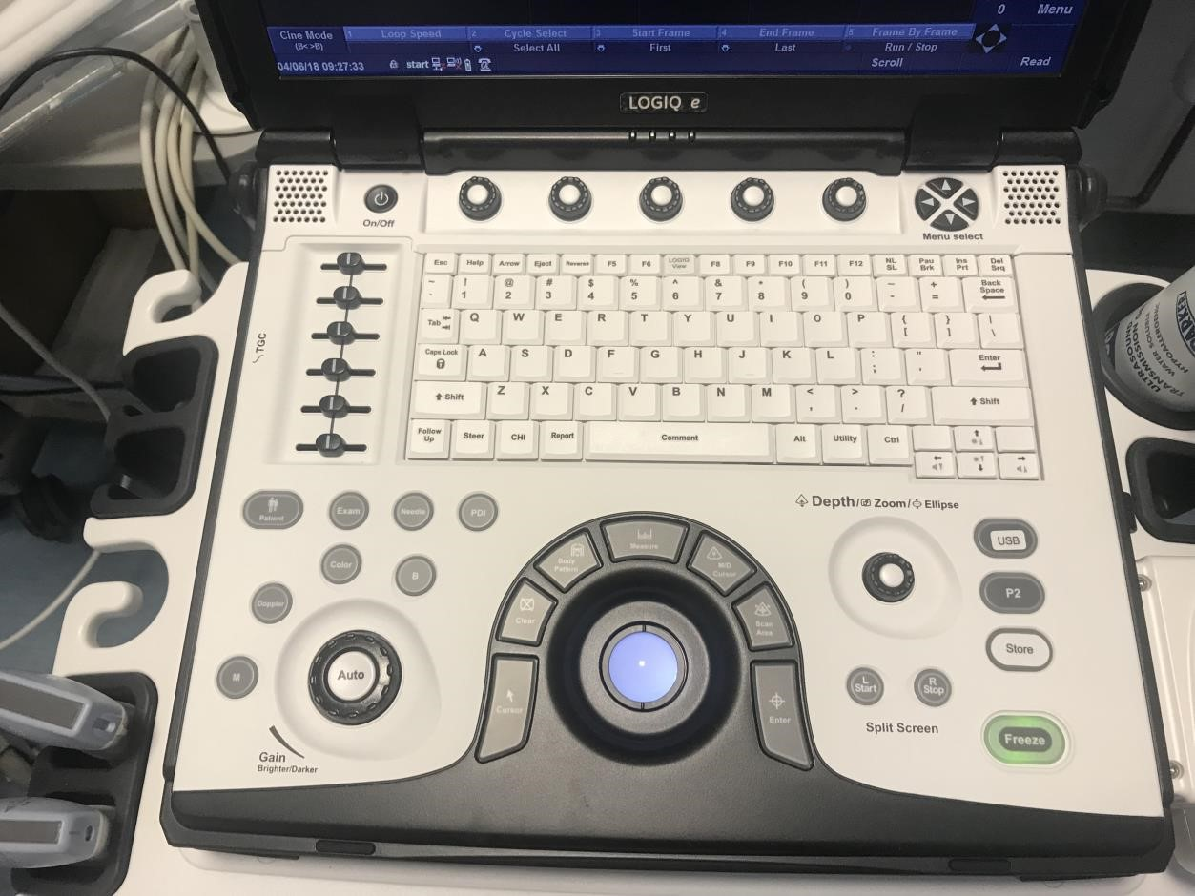

POWER

PPATIENT

B

Starting the assessment
- Each subject requires an individual folder to be created to store their images for a
particular assessment. In the study, each patient will have a file of scans for Days 1, 7, 10, ICU discharge, hospital discharge and 3-months post-hospital discharge.
ii) Log on: Operator: ADM; Password AAA65 + enter. Add patient’s ID. Change CAPS LOCK if it doesn’t work
iii) To start an assessment, press the ‘Patient’ key (see image above).
The Patient Information screen will appear as per below image. A patient ID must be entered in order for the system to store images. This ID will appear on every different image, and is the ‘reference’ label for that patient’s particular assessment. Note you will still have to individually label each image with the image number etc.
Once entered, you patient information will appear in the ‘Patient View’ box at the bottom of the screen. This is where you can access you scans later.
- Once this is completed, press the ‘B’ key to access the imaging screen (see above image).

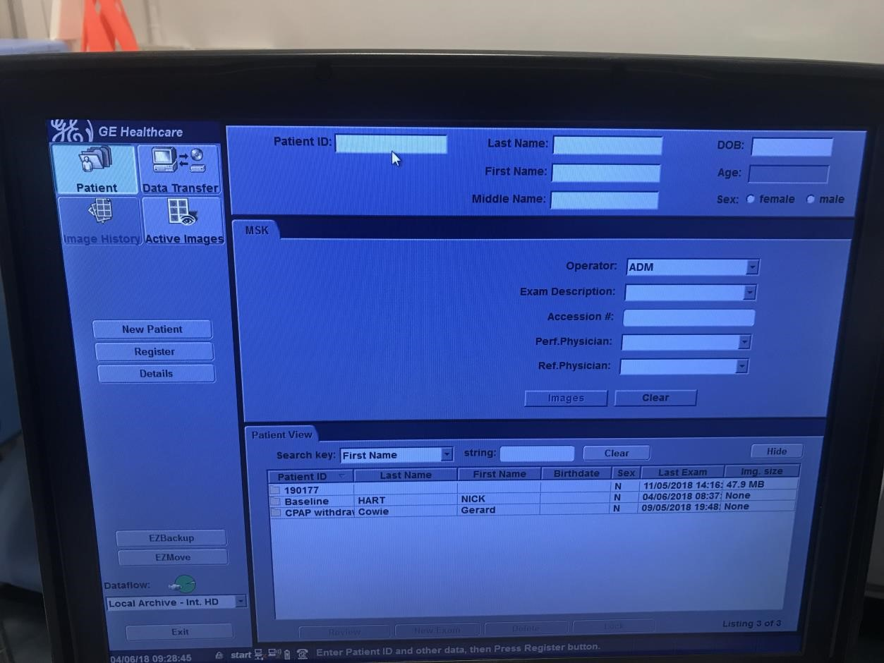

PATIENT ID

PATIENT VIEW

Image acquisition
- The setting will be pre-set for MSK image acquisition.
- Check that the probe setting is correct (eg. 9L or 12L). If you wish to change the probe, flick the tab on RHS to disconnect and then reconnect probes. This can be done anytime using the ‘exam’ key (see image below). Small linear probe = small parts; curvilinear probe for large RF = Abdomen
- Ensure the subject’s leg is fully relaxed.
- Place a liberal quantity of US gel over the measurement mark, to maximise visualisation and minimise distortion of the image. Place the transducer along the superior border of the thigh, perpendicular to the long axis.
- In subjects who are awake and able to follow instructions, contraction-relaxation manoeuvres of the quadriceps can be performed to facilitate identification of RF. If this is not possible, press the probe down to visualise the femur and orientate the scanner to different parts of the quadriceps muscle.
- Avoid applying excess pressure with the transducer that will distort the appearance of the underlying muscle. The probe should ‘sit’ on the aqueous gel layer. Where possible, centralise the appearance of the RF muscle in the image.
- Ensure the entire border of RF can be visualised in the image as clearly as possible.
Visualisation of the femur is a useful landmark. Notes on settings:
  - The depth (how near/far away the image appears on the screen) can be adjusted using the Depth dial (see image). Standard use of 4cms
  - The gain (how bright the image appears on the screen) can be adjusted using the gain dial (see image); standardising this across multiple machines does not appear possible. Standard use of 40.
  - Settings for depth and gain should remain constant within each patient across the timepoints assessed, and be recorded on the case report form.
- Whilst viewing the screen to acquire your image, check that you do not inadvertently move the transducer from the measurement mark. Also check that you maintain the probe perpendicular to the thigh, and avoid holding it at an angle that will also cause distortion to the image.
- Once you are satisfied with your image, press Freeze.
- A caliper marker is required on all images for offline analysis. This is a distance noted on the image at the time of acquisition; it can be of any distance, but needs to be marked away from where RF appears on the screen. Press the ‘Calc’ key once and the ‘enter’ to mark one end of the caliper line, then move the cursor to another point and press ‘enter’ to mark the end of the line.
- OMIT THIS MEASUREMENT [If you are undertaking online analysis of RFcsa, press the ‘Measure’ key twice to obtain the cross-sectional cursor. You can then use the track ball to draw around the border of the muscle. Once completed, press ‘Enter’ and your measurement will show (see image below).]
- Press the ‘Comment’ key (space bar) to add labelling to the image. This is the individual label for that particular image and will include a reference as to the subject, the operator (if applicable), the day of measurement, and the number of the measurement (eg. 001 D1 A 1 ie, patient 1, day 1, operator A, image 1).
- OPERATOR CODES: A=Tim Martin; B=Filipa Santos; C=Maria Gonzales; D=Angela McNelly; E=Ryan Haines; F=Zudin Puthucheary
- Press the ‘P1’ key to save the image to the device. Pressing ‘P3’ will store the images
directly to USB.
- Press ‘Freeze’ again to unfreeze the image, and repeat the process.
- Take a minimum of 3 images – PREFERABLY 4-6 especially if a study patient has been particularly complex to scan and visualisation difficult; when determining RF_{CSA}, the average of three consecutive images within 10% are taken.

GAIN DIAL

DEPTH DIAL

CALCULATE

ENTER

FREEZE

COMMENT

P3

P1

EXAM

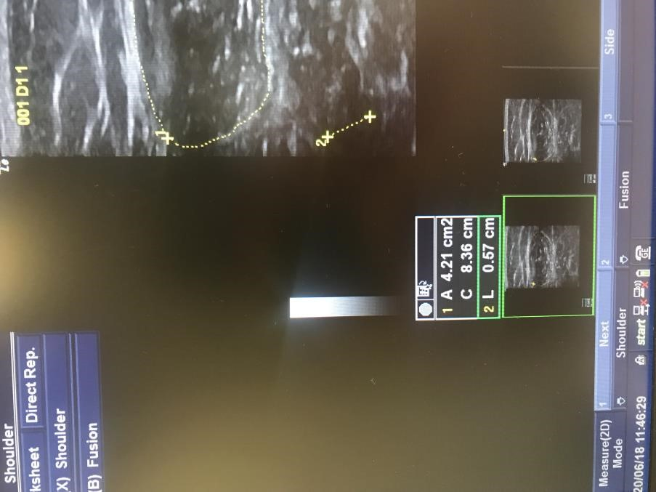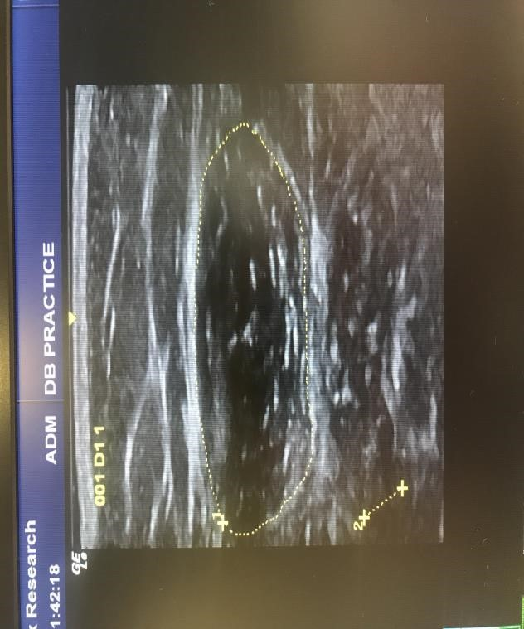

CALIPER

CROSS
-
SECTIO
N
AL
MEASU
RE
M
ENT

CROSS
-
SECTIO
N
NAL
MEASU
RE
M
REMENT

RESULT

Ending the assessment
- Once you have acquired all the images needed, with the screen in image acquisition mode
i.e. unfrozen, press ‘Patient’ again. This will return you to the patient data screen.

It is important to ‘Start’ and ‘End’ each patient assessment to ensure images are filed correctly on the machine, to avoid confusion across the different dates of assessment and to facilitate downloading the files.

Downloading files
- To export patient files to a USB storage device, go to Patient. This will bring up a list of all
patient files stored in the internal archive of the machine. You will see all the files under the labels assigned to each subject’s assessment.
- Insert an unencrypted USB stick. Select the images that you wish to export and select ‘Send to’. Follow the links to USB.
- Transfer onto a secure computer in the normal way, and delete from the unencrypted USB.

References:
- Shrout PE, Fleiss JL. Intraclass correlations: Uses in assessing rater reliability. Psychol Bull 1979;86(2):420-28.
- Seymour JM, Ward K, Sidhu PS, et al. Ultrasound measurement of rectus femoris cross-sectional area and the relationship with quadriceps strength in COPD. Thorax 2009;64(5):418-23. doi:
10.1136/thx.2008.103986

