A Statistical Analysis Proposal: Validity of ROX index for Nasal High Flow Therapy in Critical Care Patients, including those with hypercapnic respiratory failure
Raquel D’ Espiney¹*, Alex Robbins²*, Joe Vincent¹, Vladimir Macavei¹, J F Martin - Lazaro¹ and Yize Wan².

Intensive Care Unit, Newham University Hospital. London, UK.
Adult Critical Care Unit, Royal London Hospital, London, UK.
*Co-authors contributed equally to this study

Introduction
Nasal high flow therapy (NHFT) has been shown to be an effective respiratory support in patients with hypoxaemic respiratory failure¹. A ROX index (ROXI=[SpO₂/FiO₂]/RR), defined as the ratio of SpO2/FIO2 to respiratory rate, can predict the risk of failure. Patients who had a ROX index ≥4.88 after 2, 6 and 12 hours of HFNC therapy were less likely to be intubated, even after adjusting for potential covariates. However, studies of NHFT and the predictive ability of the ROX index have thus far frequently excluded those with hypercapnic respiratory failure, patients who represent a significant proportion of ICU admissions for ventilatory support.
Clinical outcomes for patients treated with NHFT for hypercapnic respiratory failure are less well understood as research to date has frequently excluded hypercapnic patients. However, there is growing evidence that suggests NHFT could be beneficial in patients with Type II respiratory failure.

Objectives
This retrospective observational cohort study aimed to validate the diagnostic accuracy of the ROX index for determining HFNC outcomes in those with Type 1 and Type 2 respiratory failure. Our objectives were:
- To demonstrate that a ROX index >4.88 is a predictive of HFNT success in those with type 1 respiratory failure and type 2 respiratory failure
- To examine the ROX index values for those in Type 1 and 2 respiratory failure and investigate if the optimum predictive cut off values are significantly different between the 2 groups
- To use the ROX index to define a population of patients with Type 2 respiratory failure who benefit from HFNT and are unlikely to fail this treatment
- For those that fail HFNT in either group we will report the time to failure and test for significant difference

Outcomes
The primary outcome is the failure of HFNT as demonstrated by escalation to non invasive ventilation, mechanical ventilation or death.
Secondary outcomes are the time to failure of HFNT and survival to discharge from ICU.

Methods
This was a retrospective cohort study which included all patients admitted to Newham Intensive Care Unit and treated with Nasal high flow therapy for either hypoxaemic (Type 1 respiratory failure) or hypercapnic (Type 2 respiratory failure) during a one year period during 2019. Type 1 failure is defined by a PaO₂ of <8 kPa with a normal or low PaCO₂. Type 2 failure is defined by a PaO₂ of <8 kPa and a PaCO₂ of >6 kPa².
Baseline demographic data including age, sex, comorbidities, reason for admission to intensive care, pre admission observations, pre initiation arterial blood gas results will be recorded. Respiratory observations will be recorded at 2, 6, 12 hours. Outcomes will be defined as failure of HFNT, demonstrated by either escalation to Non invasive ventilation, mechanical ventilation or death.
For type 1 respiratory failure patients with subsequent arterial blood gases that demonstrate they have developed type 2 respiratory failure we will analyse them as members of the type 1 group throughout as this was the indication the HFNT was initially commenced for and developing type 2 failure is likely to represent failure of HFNT as a therapy for this patient.
Data will be held in Excel (Microsoft Excel) and analysed in R (R Core Team). We will compare baseline variables between those admitted and treated with HFNT in Type 1 Respiratory failure and those admitted and treated for Type 2 respiratory failure. We will also compare baseline respiratory variables at 2, 6 and 12 hours.
ROX Index validity will be assessed before the therapy (ROX0), at 2h (ROX2), at 6h (ROX6) and 12h (ROX12) two groups will be analysed those with type 1 and type 2 respiratory failure, this will then be subdivided into those successfully managed with HNFT and those who fail therapy, defined as escalation to Non invasive ventilation, mechanical ventilation or death.
Quantitative variables will be expressed as median (interquartile range) and categorical variables will be expressed as frequency (percentage). Continuous variables will be compared using the Student t test or U-Mann Whitney test. Differences in categorical variables will be assessed with Chi square or Fisher exact test.
Multiple imputation will be used to estimate data for missing fields and this will be used for the main analysis³. However, as we are seeking to demonstrate that there is no difference in the outcomes for HFNT applied to Type 1 and 2 respiratory failure an overly conservative model with excessive imputed data may miss significant differences. Given this we will additionally handle data missingness with a pairwise deletion strategy which will be valid if missing data is missing at random.
We will compare the ability of a ROX score to predict the success or failure of HFNT in those with T1RF and T2RF by calculating AUROC values, we will use the previously validated cut off of 4.88.
We will undertake a uni- and multivariate Cox regression to describe the HR of having an ROX >4.88 to treatment failure as defined above. We will separate analysis by type of respiratory failure and in multivariate analysis include baseline demographics such as age, sex, comorbidities. We will also perform parametric testing on those that fail HFNT and demonstrate if there is a significant difference in the time to treatment failure between those with type 1 and type 2 respiratory failure.
We will then calculate the optimum cut off from our data set by AUROCs for ROX at different interval and then use these to repeat comparisons.
Given the expected low number of type 2 respiratory failure patients and to account for some patients who may develop both type 1 and type 2 respiratory failure during the same admission episode or progress from type 1 to type 2 respiratory failure we will add a sensitivity analysis to the Cox multivariate regression to give context to our results.

Table 1. Baseline characteristics
 | T1RF | T2RF
Age
Gender
Comorbidities
Apache score
Table 2. Respiratory Variables a 2,6,12 hours post initiation
 |  |  | T1RF |  | T2RF
 |  | RR
2 Hours |  | sO2
 |  | FiO2
 |  | ROX
 |  | RR
6 Hours |  | sO2
 |  | FiO2
 |  | ROX
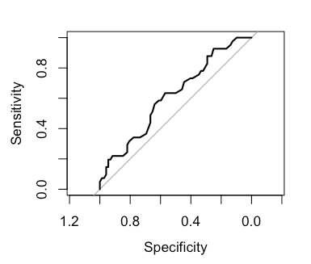
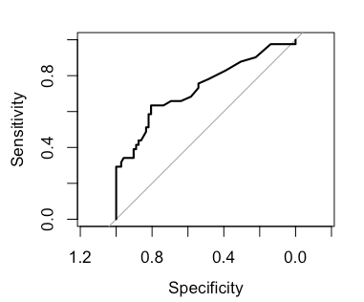
Figure 1. Receiver Operated Curves for ROX index and outcome in HFNT of T1RF and T2RF

Bibliography
1. Roca O, Caralt B, Messika J, et al. An index combining respiratory rate and oxygenation to predict outcome of nasal high-flow therapy. Am J Respir Crit Care Med [Internet] American Thoracic Society; 2019 [cited 2020 Jul 2]; 199: 1368–76 Available from: https://www.atsjournals.org/doi/10.1164/rccm.201803-0589OC
2. Baudouin S, Turner L, Blumenthal S, et al. Non-invasive ventilation in acute respiratory failure: British thoracic society standards of care committee [Internet]. Thorax. BMJ Publishing Group Ltd; 2002 [cited 2020 Jun 27]. p. 192–211 Available from: https://thorax.bmj.com/content/57/3/192
3. Sterne JAC, White IR, Carlin JB, et al. Multiple imputation for missing data in epidemiological and clinical research: Potential and pitfalls [Internet]. BMJ. British Medical Journal Publishing Group; 2009 [cited 2020 Jun 27]. p. 157–60 Available from: https://www.bmj.com/content/338/bmj.b2393

