Chronic disease within the NHS surgical population:
An epidemiological study statistical analysis plan

Alexander J Fowler^{1,2}, John Prowle¹, RM Pearse¹, David Cromwell²

- Queen Mary University of London, London, UK
- Royal College of Surgeons of England, London, UK

Introduction
More than 5 million surgical procedures are performed in the National Health Service (NHS) each year, with 49,000 deaths within 30 days.¹ Some specialities, such as cardiac, colorectal and vascular surgery collect detailed data describing their patients but these audits leave most surgical activity unaccounted for.^{2,3} A high-risk sub-group of around 250,000 patients are concealed within this large surgical population, and account for four out of five deaths after surgery.⁴ These patients are thought to be at increased risk by virtue of existing chronic diseases, advanced age and the magnitude of the required surgery.

The age of the surgical population is increasing more rapidly than the age of the general population.⁵ Advancing age is associated with the development of chronic diseases such as heart failure, chronic kidney disease and dementia.⁶ While certain chronic diseases are associated with reduced survival after surgical procedures, the detailed association between chronic disease and outcomes are unclear in a broad surgical cohort. Existing aggregate scores such as the Charlson co-morbidity index may attribute similar scores to different conditions with very different survival patterns.⁷ For example, both metastatic solid cancers and rheumatological disorders score one point but metastatic disease has far higher risk of death.

At present, the prevalence of different chronic diseases amongst patients undergoing surgery, and the association between these diseases and survival after surgery is unclear. The aim of this study will be to describe the chronic diseases most commonly suffered by the surgical population in the England, and the association between these diseases and subsequent outcomes after surgery.

Study objectives
Hypothesis
Amongst patients undergoing surgery in the NHS, different chronic diseases are associated with different rates of death after surgery.

Primary objective
- To describe the rate of 90 day death associated with different chronic diseases amongst patients undergoing surgery

Secondary objectives
- To determine the most frequent chronic diseases suffered by patients undergoing surgery
- To describe the change in prevalence of different chronic diseases with age
- To describe other relevant outcomes amongst patients with different chronic diseases including length of hospital stay, death within two years, hospital re-admission and number of days spent in a hospital bed in the year after surgery.

Primary outcome
- Death within 90-days of index surgical procedure

Secondary outcomes
- Length of hospital following index surgical procedure, reported in whole days
- Death within two years of index surgical procedure
- Rate of re-admission to hospital within one year of index surgical procedure
- Total number of days spent in hospital within one year of index surgical procedure, expressed as a proportion of days alive

Study population
All patients undergoing surgery in England between 1st January 2005 – 31st December 2015 in a National Health Service hospital will be considered for inclusion.

Data sources
- Hospital Episode Statistics, NHS England (2005-2016)
- Office for National Statistics death registry data (2005-2018)

Definition of surgery
Adult patients who meet a prior definition based on Office of Population Censuses and Surveys intervention and procedure codes (OPCS version 4.7) will be included.¹ This definition selects procedures typically performed in an operating theatre, or requiring general/regional anaesthesia. This definition of surgery was developed using three-character OPCS codes (e.g. L91; Other vein related operations).

Each three-character OPCS code has a further layer of information with a fourth character (e.g. L91.1; Open insertion of central venous catheter). Administrative data sets are coded according to the four-character OPCS codes. The two hundred commonest procedures performed will be reviewed by two researchers acting independently to ensure all four-character codes are relevant. The initial search will include all patients meeting the three-character definition and will be further refined to the four-character definition. Any codes excluded will be listed in a supplementary appendix.

Inclusion criteria
Patients aged greater than 18 years on date of admission, where the admission date was between 1st January 2005 and 1st January 2015 will be considered for inclusion. Patients will be included if they undergo a procedure meeting the refined definition of surgery. A flow of patient selection steps is outlined in figure 1. Where patients have multiple procedures over the period studied, only their first will be included.

Exclusion criteria
All organ retrieval operations will be excluded from analysis (identified by OPCS version 4.7: X45, X46).

Variables
The admission category will be defined by a combination of patient class (inpatient or day) and type of admission (emergency, elective) into three groups: elective inpatient, elective day and emergency inpatient. Age at time of surgery will be defined as the age in whole years at the start of the index hospital admission. Procedure grouping will be based on anatomical location of index procedure, divided into 21 categories.

A two-year look back file will capture diagnostic codes relevant to chronic diseases. Mappings have been developed to combine multiple International Classification of Disease version 10 codes ICD-10 codes) into disease specific domains.^{7,9} ICD-10 codes will be mapped to Charlson co-morbidity index domains (‘Charlson domains’) according to the Royal College of Surgeons Charlson mapping.⁷ This mapping was developed specifically to describe co-morbidity burden amongst surgical patients in the NHS. In this analysis, the Charlson co-morbidity index score (CCI) will be calculated as the sum of all fourteen Charlson domains. Where the CCI is greater than or equal to six, the score will be normalised to six.

A look-forward file will capture subsequent hospital re-admission within one year. A patient will be considered re-admitted to hospital if they have a record within the admitted patient care data set with a length of stay >0 days. Bed days will be calculated by summing the number of days spent as an inpatient in an NHS hospital in England in the year after surgery. To account for the competing endpoint of death, the number of bed days will be expressed as a proportion of days alive. For example if someone dies within 30 days of surgery and spends 15 days of those in hospital, their bed days proportion would be 0.5. If someone dies after 3 days and spends all those days in hospital, their proportion would be 1.

Deprivation will be determined by patient level index of multiple deprivation 2010 rank (IMD2010). This is based on the lower super-output area (LSOA) in which an individual resides, each LSOA describes a geographic area that includes around 1500 homes. IMD2010 combines a number of different social deprivation measures to rank each LSOA from the most deprived to the least deprived across England. Patients will be divided according to the IMD2010 rank of their LSOA into quintiles from 1 (most deprived quintile) to 5 (least deprived quintile).

Statistical considerations
Sample size
No sample size analysis has been performed. The number of patients meeting the above inclusion criteria will determine the sample size of this prospectively designed analysis of registry data study. Based on prior work, it is anticipated around ~30 million unique patients will be included.

Missing data
Where data are missing for patient demographic information (e.g. age or gender), process information (e.g. type of admission and patient category), or outcome variables (e.g. length of stay) and the proportion of cases with missing data is <1%, then records will be removed by case-wise deletion. A supplementary table will be provided summarising the characteristics of removed records.

Where the rate of missing data exceeds 1%, the pattern of the missing-ness will be assessed, and multiple imputation with chained equations considered. Ethnicity is poorly recorded in HES, with around 10% of records having a missing ethnicity code. Missing ethnicity will be handled as its own category. Records with implausible outcomes, such as a negative length of stay, will be manually reviewed for removal. All analyses will be completed using R (version 3.6.1, R Core Team, Vienna).

Patient characteristics
Characteristics of patients in each admission category (elective inpatient, elective day-case, emergency inpatient) will be presented. This will include the mean (with standard deviation) and median (with interquartile range) of age, frequency of different sexes, CCI, distribution of deprivation in quintiles, and the most commonly performed procedures (as per example table 1).

Frequency of chronic diseases
To describe the frequency of different chronic diseases amongst patients undergoing surgery, the number of patients suffering from each disease will be presented (example table 2), subdivided by admission category.

Change in chronic disease frequency with age
To determine how chronic disease frequency alters with age in the surgical population, the proportion of patients suffering each disease at each age will be presented as in example figure 2. A supplementary table will include the number of patients of each age with each disease.

Association between chronic diseases and outcomes
To identify the association between different chronic diseases and patient relevant outcomes, a table will be presented outlining the number of patients dying within 90-days, 2-years, length of stay, the rate of hospital re-admission and bed days spent in hospital in the year after surgery, as in example table 3. To adjust for the effect of age on outcomes for individual chronic diseases, a univariate analysis will be performed adding age as an interaction term and an odds ratio for death will be presented as in table 3. To demonstrate how the association between different chronic diseases interacts with age, the rate of 90-day death will be plotted against age with a line for each chronic disease (as in example figure 3). A Kaplan-Meier survival curve will be plotted for each chronic disease for survival out to two years.

Prototypical procedures
Above analyses will include all surgical patients. To explore if the association between different chronic diseases and subsequent outcomes persist in common surgical settings, the relationship between each chronic disease and outcomes will be presented as in example table 3 for specific procedures. Each row of the table will be divided into one of four surgical procedures (codes defining these procedures are present in Appendix B):
- Cataract surgery (very low risk procedure)
- Total hip replacement (low risk procedure)
- Coronary artery bypass graft (moderate risk procedure)
- Colorectal cancer resection (high risk procedure)

Risk is based on aggregated 90-day mortality for the above procedures.

References
1. Abbott TEF, Fowler AJ, Dobbs TD, Harrison EM, Gillies MA, Pearse RM. Frequency of surgical treatment and related hospital procedures in the UK: a national ecological study using hospital episode statistics. Br J Anaesth 2017; 119: 249–57
2. Bridgewater B, Grayson AD, Brooks N, et al. Has the publication of cardiac surgery outcome data been associated with changes in practice in northwest England: an analysis of 25,730 patients undergoing CABG surgery under 30 surgeons over eight years. Heart 2007; 93: 744–8
3. VSQIP. NATIONAL VASCULAR REGISTRY 2016 Annual Report. 2016;
4. Pearse RM, Harrison D a, James P, et al. Identification and characterisation of the high-risk surgical population in the United Kingdom. Crit Care 2006; 10: R81
5. Fowler AJ, Abbott TEF, Prowle J, Pearse RM. Age of patients undergoing surgery. Br J Surg England; 2019; 106: 1012–8
6. Kuan V, Denaxas S, Gonzalez-Izquierdo A, et al. A chronological map of 308 physical and mental health conditions from 4 million individuals in the English National Health Service. Lancet Digit Heal England; 2019; 1: e63–77
7. Armitage JN, Van Der Meulen JH. Identifying co-morbidity in surgical patients using administrative data with the Royal College of Surgeons Charlson Score. Br J Surg 2010; 97: 772–81
8. Quan H, Sundararajan V, Halfon P, et al. Coding algorithms for defining comorbidities in ICD-9-CM and ICD-10 administrative data. Med Care United States; 2005; 43: 1130–9
9. Brandes U, Delling D, Gaertler M, et al. On Modularity Clustering. IEEE Trans Knowl Data Eng 2008; 20: 172–88

Sample tables and figures

 | Elective inpatient |  |  | Elective daycase |  | Emergency
Age
Mean (SD)
Median (IQR)
Sex
Female
Male
Specialty
Orthopaedics
Hepatopancreatobiliary
Upper gastrointestinal
Lower gastrointestinal
Cardiac
Thoracic
Gynaecology
Plastics
Breast
Endocrine
Vascular
Urology and kidney
Head and neck
Other
Chronic diseases
Myocardial infarction
Diabetes mellitus
Chronic lung disease
Chronic kidney disease
Dementia
Congestive cardiac failure
Peripheral vascular disease
Cerebrovascular disease
Metastatic solid cancer
Cancer
Hemi/paraplegia
HIV
Rheumatological
Stroke
Liver disease
CCI (median [IQR])
Year
2005-2010
2010-2015
Table 1a. Characteristics of included patients undergoing surgery subdivided according to different acuity, Charlson co-morbidity index score; SD, standard deviation; IQR, interquartile range.

Charlson co-morbidity index domains |  | Elective inpatient | Elective day case | Emergency | All patients
 | MI
 | CCF
 | PVD
 | CVD
 | Dementia
 | COPD
 | Liver disease
 | Rheumatological
 | Diabetes
 | Hemi/Para
 | Renal disease
 | Malignancy
 | Metastatic solid
 | HIV
Table 2. The frequency of different chronic diseases as captured by the Charlson co-morbidity index across elective inpatient, elective day and emergency surgery. Charlson co-morbidity index mapped according to Royal College of Surgeons Charlson score. Numbers are presented as % (number with diseases/total number of operations). HIV; Human immunodeficiency virus. COPD; Chronic obstructive

Charlson co-morbidity index domains |  | 90-day death | 2-year death | Length of stay |  | Bed days |  | Readmission | Odds ratio
 |  |  |  | Mean (sd) | Median (iqr) | Mean (sd) | Median (iqr)
 | MI
 | CCF
 | PVD
 | CVD
 | Dementia
 | COPD
 | Liver disease
 | Rheumatological
 | Diabetes
 | Hemi/Para
 | Renal disease
 | Malignancy
 | Metastatic solid
 | HIV

Example table 3. Outcomes associated with different chronic disease conditions as captured by the Charlson co-morbidity index. Charlson co-morbidity index mapped according to Royal College of Surgeons Charlson score. HIV; Human immunodeficiency virus. COPD; Chronic obstructive pulmonary disease. sd; standard deviation. iqr; interquartile range. Bed days is the number of days spent in hospital over the year after date of index admission, expressed as a proportion of days spent alive. 90-day death is the total number of deaths within 90 days. Readmission is the count of patients re-admitted at any time point in the year after surgery. Odds ratio for the death at 90 days associated with each chronic disease corrected for age.

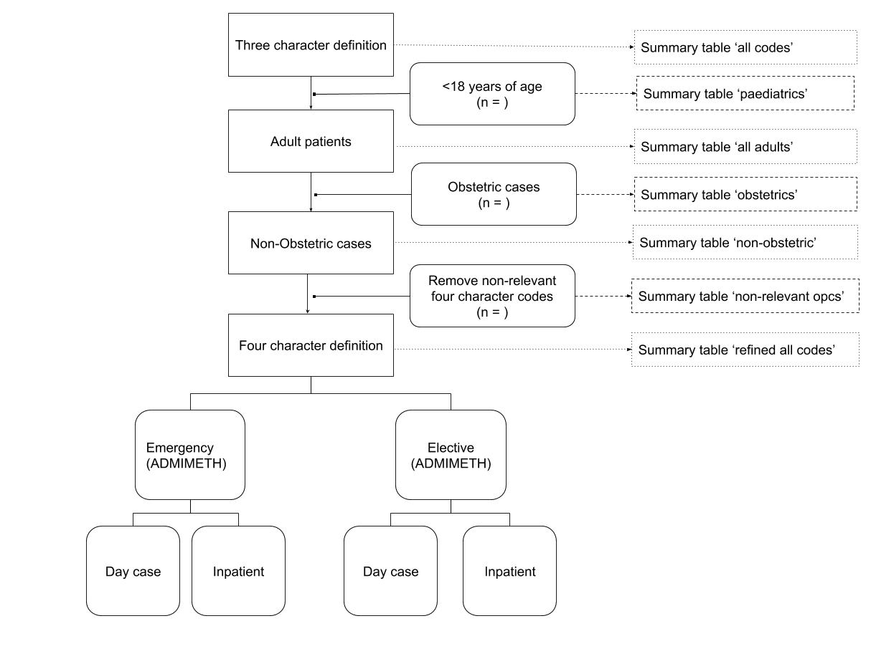
Example Figure 1. Flow diagram of patient selection. Reasons for exclusion are provided on the right-hand side and final study population includes those undergoing a surgical procedure meeting a previously defined categorisation of surgery. ADMIMETH; Admission method.
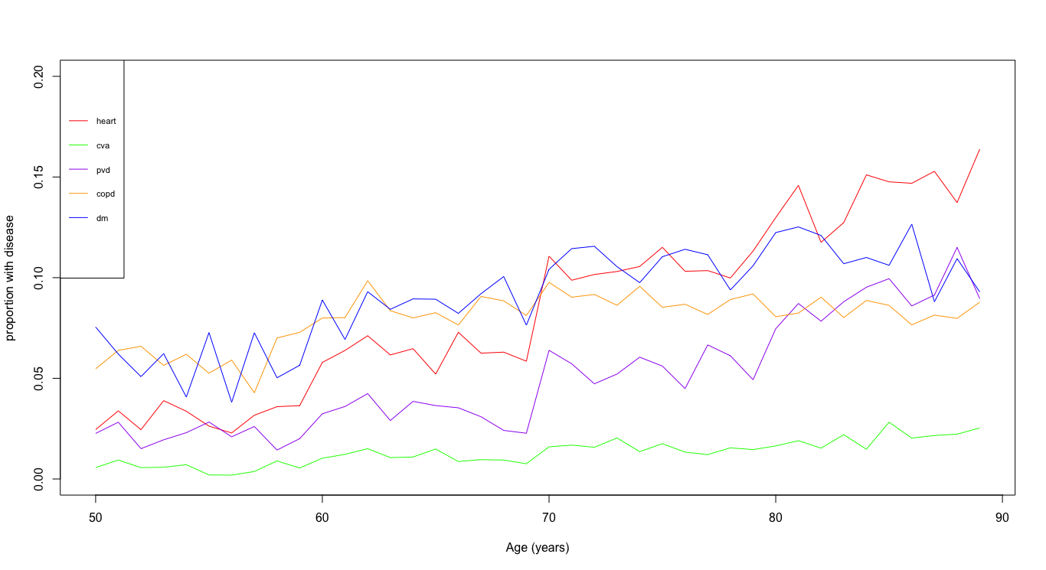
Example figure 2. Proportion of patients of different ages undergoing surgery with different chronic diseases. Proportion is the number suffering that disease divided by the total number of persons undergoing surgery with that disease.
Example figure 3. Rate of death associated with different chronic disease conditions as age increases. Each colour indicates a different disease. Y axis would be proportion dead at 90 days, or perhaps we could do it as ‘proportion of days alive spent in a hospital bed’.
APPENDIX A: OPCS 4 CODES DEFINING SURGERY
A13 | K78 | T57 | G61 | M61 | D12 | P25 | A42 | K29 | V31
A14 | L31 | T59 | G63 | M62 | D13 | P29 | A43 | K30 | V32
A33 | L35 | T60 | G67 | M72 | D14 | P32 | A44 | K31 | V33
A59 | L39 | T62 | G68 | M73 | D15 | Q02 | A45 | K32 | V34
A60 | L43 | T64 | G69 | M75 | D16 | Q05 | A47 | K33 | V35
A61 | L47 | T65 | G70 | N05 | D17 | Q09 | A48 | K34 | V36
A62 | L54 | T67 | G71 | N06 | D20 | Q10 | A49 | K36 | V37
A63 | L63 | T68 | G72 | N26 | D22 | Q11 | A51 | K37 | V38
A64 | L66 | T69 | G73 | O05 | D23 | Q16 | A57 | K38 | V39
A65 | L71 | T70 | G74 | O06 | D24 | Q17 | B01 | K40 | V40
A66 | L73 | T71 | G76 | O07 | D26 | Q19 | B02 | K41 | V41
A67 | L76 | T72 | G78 | O08 | D28 | Q20 | B04 | K42 | V42
A68 | L82 | T74 | G82 | O09 | E02 | Q26 | B06 | K43 | V43
A69 | L83 | T79 | H01 | O10 | E03 | Q27 | B08 | K44 | V44
A70 | L84 | T80 | H02 | O15 | E04 | Q28 | B09 | K45 | V45
A73 | L85 | T83 | H03 | O17 | E05 | Q29 | B10 | K46 | V46
A75 | L86 | T86 | H04 | O18 | E07 | Q30 | B12 | K47 | V48
A76 | L87 | T87 | H05 | O20 | E08 | Q31 | B14 | K48 | V49
A77 | L88 | T88 | H06 | O21 | E09 | Q32 | B16 | K52 | V52
A78 | L89 | T91 | H07 | O22 | E10 | Q34 | B17 | K53 | V54
A79 | L91 | T92 | H08 | O23 | E11 | Q35 | B18 | K54 | V56
A81 | L93 | T96 | H09 | O24 | E14 | Q36 | B20 | K55 | V57
A84 | L94 | T97 | H10 | O25 | E15 | Q37 | B22 | K56 | V58
B30 | L96 | T98 | H11 | O26 | E16 | Q38 | B23 | K57 | V60
B31 | L97 | V21 | H12 | O27 | E17 | Q39 | B25 | K66 | V61
B33 | L98 | V47 | H13 | O29 | E20 | Q41 | B27 | K67 | V66
B34 | L99 | V62 | H14 | P05 | E24 | Q49 | B28 | K69 | V67
B35 | M09 | V63 | H15 | P17 | E27 | Q50 | B29 | K71 | V68
B36 | M10 | W01 | H16 | P18 | E34 | Q51 | B38 | L01 | W05
B37 | M13 | W02 | H17 | P20 | E35 | Q52 | B39 | L02 | W06
B40 | M15 | W03 | H19 | P31 | E38 | Q54 | C01 | L03 | W08
C02 | M16 | W04 | H29 | Q01 | E48 | Q56 | C05 | L04 | W09
C03 | M19 | W07 | H30 | Q07 | E50 | R01 | D10 | L05 | W10
C06 | M26 | W11 | H33 | Q08 | E63 | R02 | D19 | L06 | W15
C08 | M27 | W12 | H34 | Q22 | F01 | R04 | E01 | L07 | W16
C09 | M28 | W13 | H35 | Q23 | F02 | R05 | E12 | L08 | W17
C10 | M29 | W14 | H36 | Q24 | F03 | R07 | E13 | L09 | W18
C11 | M32 | W26 | H40 | Q25 | F04 | R08 | E19 | L10 | W19
C12 | M33 | W29 | H41 | Q43 | F05 | R10 | E21 | L12 | W20
C13 | M38 | W31 | H46 | Q44 | F06 | R12 | E23 | L13 | W21
C14 | M39 | W32 | H47 | Q45 | F09 | R17 | E28 | L16 | W22
C15 | M41 | W33 | H49 | Q47 | F11 | R18 | E29 | L18 | W23
C16 | M42 | W34 | H62 | S17 | F18 | R28 | E30 | L19 | W24
C17 | M43 | W59 | J01 | S18 | F24 | R29 | E31 | L20 | W25
C18 | M44 | W68 | J02 | S19 | F26 | R30 | E33 | L21 | W27
C19 | M48 | W69 | J03 | S20 | F29 | R34 | E39 | L22 | W28
C20 | M49 | W70 | J04 | S54 | F30 | S01 | E40 | L23 | W30
C22 | M53 | W71 | J05 | S55 | F32 | S02 | E41 | L25 | W37
C24 | M54 | W72 | J07 | T01 | F34 | S03 | E42 | L26 | W38
C25 | M55 | W73 | J08 | T02 | F36 | S04 | E43 | L27 | W39
C26 | M56 | W74 | J16 | T03 | F40 | S05 | E44 | L28 | W40
C27 | M58 | W75 | J18 | T05 | F42 | S06 | E46 | L29 | W41
C29 | M60 | W76 | J19 | T07 | F44 | S10 | E47 | L30 | W42
C31 | M64 | W77 | J20 | T08 | F45 | S11 | E52 | L33 | W43
C32 | M65 | W78 | J21 | T09 | F46 | S21 | E53 | L34 | W44
C33 | M66 | W79 | J23 | T10 | F48 | S22 | E54 | L37 | W45
C34 | M67 | W81 | J27 | T14 | F50 | S23 | E55 | L38 | W46
C35 | M68 | W82 | J28 | T15 | F51 | S24 | E57 | L41 | W47
C37 | M70 | W83 | J29 | T16 | F52 | S25 | E59 | L42 | W48
C39 | M71 | W84 | J30 | T17 | F53 | S26 | E61 | L45 | W49
C40 | M76 | W85 | J31 | T28 | F58 | S27 | E62 | L46 | W50
C41 | M79 | W86 | J32 | T30 | G14 | S28 | F22 | L48 | W51
C43 | M81 | W87 | J33 | T33 | G17 | S30 | F23 | L49 | W52
C44 | M83 | W88 | J37 | T34 | G75 | S31 | F28 | L50 | W53
C45 | M86 | W89 | J52 | T36 | H42 | S33 | F38 | L51 | W54
C46 | N01 | W91 | J54 | T37 | H44 | S34 | F39 | L52 | W55
C47 | N03 | W92 | J55 | T38 | H48 | S35 | G01 | L53 | W56
C49 | N07 | W99 | J56 | T39 | H50 | S36 | G02 | L56 | W57
C51 | N08 | X11 | J57 | T41 | H51 | S37 | G03 | L57 | W58
C52 | N09 | X12 | J58 | T50 | H52 | S38 | G04 | L58 | W60
C53 | N10 | X27 | J59 | T51 | H53 | S39 | G05 | L59 | W61
C54 | N11 | X46 | J60 | T52 | H54 | S40 | G06 | L60 | W62
C55 | N13 | X53 | J61 | T53 | H55 | S41 | G07 | L62 | W63
C57 | N15 | X55 | J62 | T56 | H56 | S42 | G08 | L65 | W64
C59 | N17 | A01 | J63 | T76 | H57 | S47 | G09 | L67 | W65
C60 | N18 | A02 | J65 | T77 | H58 | S48 | G10 | L68 | W67
C61 | N19 | A03 | J68 | T85 | H59 | S49 | G11 | L69 | W80
C62 | N20 | A04 | J69 | T89 | H60 | S56 | G13 | L70 | W93
C64 | N22 | A05 | J70 | T94 | H66 | S57 | G21 | L74 | W94
C65 | N24 | A07 | J72 | V01 | J06 | S60 | G23 | L75 | W95
C66 | N27 | A08 | K01 | V03 | J10 | S62 | G24 | L77 | W96
C67 | N28 | A09 | K02 | V04 | J11 | S64 | G25 | L79 | W97
C69 | N29 | A10 | K04 | V05 | J12 | S66 | G27 | L80 | W98
C71 | N30 | A11 | K05 | V06 | J13 | S68 | G28 | L81 | X01
C72 | N32 | A12 | K06 | V07 | J15 | S70 | G29 | L90 | X02
C73 | N34 | A16 | K07 | V08 | J24 | T11 | G30 | M01 | X03
C74 | O01 | A17 | K08 | V09 | J25 | T12 | G31 | M02 | X05
C75 | O02 | A18 | K09 | V10 | J26 | T13 | G32 | M03 | X07
C77 | O03 | A20 | K10 | V11 | J34 | T19 | G33 | M04 | X08
C79 | O04 | A22 | K11 | V13 | J35 | T20 | G34 | M05 | X09
C80 | O19 | A24 | K12 | V14 | J36 | T21 | G35 | M06 | X10
C81 | P01 | A25 | K13 | V15 | J49 | T22 | G36 | M08 | X14
C82 | P03 | A26 | K14 | V16 | J73 | T23 | G38 | M17 | X15
C83 | P06 | A27 | K15 | V17 | J77 | T24 | G40 | M18 | X17
C84 | P07 | A28 | K17 | V19 | K16 | T25 | G41 | M20 | X19
C85 | P09 | A29 | K18 | V20 | K35 | T26 | G48 | M21 | X20
C86 | P11 | A30 | K19 | V22 | K59 | T27 | G49 | M22 | X21
C88 | P13 | A31 | K20 | V23 | K60 | T29 | G50 | M23 | X22
C89 | P14 | A32 | K22 | V24 | K62 | T31 | G51 | M25 | X23
D01 | P15 | A34 | K23 | V25 | K64 | T42 | G52 | M34 | X24
D02 | P19 | A36 | K24 | V26 | K65 | T43 | G53 | M35 | X25
D03 | P21 | A38 | K25 | V27 | K68 | T45 | G57 | M36 | X45
D04 | P22 | A39 | K26 | V28 | K75 | T48 | G58 | M37
D06 | P23 | A40 | K27 | V29 | K76 | T54 | G59 | M51
D08 | P24 | A41 | K28 | V30 | K77 | T55 | G60 | M52

APPENDIX B: CODES DEFINING PROTOTYPICAL PROCEDURES
Coronary artery bypass grafting procedure | Code
Saphenous vein graft replacement of coronary artery | K40
Allograft replacement of coronary artery | K42
Prosthetic replacement of coronary artery | K43
Other replacement of coronary artery | K44
Connection of thoracic artery to coronary artery | K45
Other bypass of coronary artery | K46
Repair of coronary artery | K47
Other open operations on coronary artery | K48
Colorectal cancer resection | Code
Excision of ileum | G69
Open extirpation of lesion of ileum | G70
Bypass of ileum | G71
Other connection of ileum | G72
Intra-abdominal manipulation of ileum | G76
Other open operations on ileum | G78
Other operations on ileum | G82
Total excision of colon and rectum | H04
Total excision of colon | H05
Extended excision of right hemicolon | H06
Other excision of right hemicolon | H07
Excision of transverse colon | H08
Excision of left hemicolon | H09
Excision of sigmoid colon | H10
Other excision of colon | H11
Extirpation of lesion of colon | H12
Bypass of colon | H13
Exteriorisation of caecum | H14
Other exteriorisation of colon | H15
Incision of colon | H16
Intra-abdominal manipulation of colon | H17
Open endoscopic operations on colon | H18
Other open operations on colon | H19
Subtotal excision of colon | H29
Other operations on colon | H30
Excision of rectum | H33
Open extirpation of lesion of rectum | H34
Other operations on rectum | H46
Excision of anus | H47
Excision of lesion of anus | H48
Other operations on bowel | H62
Excision of bile duct | J27
Extirpation of lesion of bile duct | J28
Clearance of pelvis | X14
Major joint replacement procedure | Code
Total prosthetic replacement of hip joint using cement | W37
Total prosthetic replacement of hip joint not using cement | W38
Other total prosthetic replacement of hip joint | W39
Total prosthetic replacement of knee joint using cement | W40
Total prosthetic replacement of knee joint not using cement | W41
Total prosthetic replacement of other joint using cement | W43
Total prosthetic replacement of other joint not using cement | W44
Other total prosthetic replacement of other joint | W45
Prosthetic replacement of head of femur using cement | W46
Prosthetic replacement of head of femur not using cement | W47
Other prosthetic replacement of head of femur | W48
Prosthetic replacement of articulation of other bone using cement | W52
Prosthetic replacement of articulation of other bone not using cement | W53
Hybrid prosthetic replacement of hip joint using cemented acetabular component | W93
Hybrid prosthetic replacement of hip joint using cemented femoral component | W94
Hybrid prosthetic replacement of hip joint using cement | W95
Cataract procedures
Prosthesis of lens | C75

