The Chinese Stockmarket Bubble

Richard Taffler*, Angel (Xijuan) Bellotti and Lin Tian

v.2.2
Draft submitted for reading at the BFWG meeting 16-17 December 2013

ABSTRACT

Between June 2005 and October 2007, when it peaked, the Chinese stockmarket rose five-fold becoming, for a short time, the third largest stockmarket in the world; it then went into freefall losing 70% of its value over the following year. This paper seeks to provide an original explanation for this speculative asset-pricing bubble. In particular, it explicitly considers the emotional dimensions of Chinese investor behavior at this time and some of the unconscious processes that might be driving individual investment decisions including the potential role fantasy might play. Such issues are not directly explored in conventional economic theories of asset-pricing bubbles. Comparisons between the dot.com bubble of only a few years previously, and with the current Chinese real-estate bubble, are also drawn.

*Corresponding author: Richard Taffler, Finance Group, Warwick Business School, University of Warwick, Scarman Road, Warwickshire CV4 7AL. E-mail: Richard.Taffler@wbs.ac.uk; tel: +44 (0) 2476524153

1. Introduction

Although most developing stockmarkets have been subject to asset pricing bubbles in the last five years, the Chinese bubble was the most extreme. In just over two years from July 2005 to its high in October 2007, the Shanghai Stock Exchange Composite Index (SSEI) increased no less than five-fold with a rise of 60% alone in the last three months before it peaked. The market then imploded, going into freefall losing 70% of its value over the following year. This dramatic trajectory portrayed in figure 1 bears a remarkable resemblance to that of the Dow Jones Internet Index during dot.com mania only a few years previously. Figure 2 highlights this. At its peak, the nominal market capitalization of the Chinese stockmarket placed it as the third largest in the world, even larger, temporarily, than that of Japan, and with average P/E ratio of 73 compared with under 20 for the S&P (Yao and Luo, 2009).

How can we make sense of a stockmarket bubble of such a magnitude occurring in one of the world’s largest economies, and taking place over such a short period of time? In this paper we suggest conventional explanations of such speculative bubbles in terms of herding behavior, information cascades and the “greater fool theory”, which can be modeled in economic theory in “rational” terms (e.g., Shiller, 2005, pp. 159-160; Hirshliefer and Teoh, 2003), need to be augmented by explanations that take into account investor “irrationality”. Specifically, we argue that, as Yao and Luo (2009) point out, if we want to understand the Chinese stockmarket bubble then we need to look for answers principally in terms of the investment psychology of Chinese investors. In particular, Yao and Luo view the economic psychological factors of ‘greed’, ‘envy’, and ‘speculation’ as inflating the bubble, and ‘fear’, ‘lack of confidence’, and ‘disappointment’ as explaining its bursting. In this paper we adopt a more formal psychological perspective which has also led to valuable insights into the understanding of the recent parallel internet bubble (e.g., Taffler and Tuckett, 2005; Tuckett and Taffler, 2008). Specifically, we draw on the insights of a new area in behavioral finance known as emotional finance. This seeks to explain some of the unconscious processes driving individual investment decisions, and market behaviors. We suggest that acknowledging the role of unconscious fantasy in all human activity can help us explore aspects of investor behavior that cannot be explained using more conventional approaches. In particular, here, this can help us make sense of the drivers of the Chinese stockmarket bubble, and its different stages as it unfolded.

In the next section we summarize some of the underlying theory we draw on, and introduce the concept of the “phantastic object” as a description of the (unconscious) emotional meaning Chinese stocks seemed to have represented for investors. Section 3 describes the different stages of the path-dependent emotional trajectory of asset pricing bubbles, and this is then tested against what actually happened between 2005 and 2008 in Chinese financial markets in section 4. Based on the results of this critical discourse analysis the paper concludes that we need formally to take account of how the unconscious needs, fantasies and fears of investors can drive their behavior, and the predictable and potentially destructive both short-term and longer-term consequences when market environments allow, and implicitly encourage, these to be freely acted out, as in China most recently.

2. Emotional finance and stockmarket activity

Emotional finance is a new area in behavioral finance which draws on the rich insights of the psychoanalytic understanding of the human mind to help explain how people’s emotions and feelings may drive their investment activity. In contrast to neoclassical economic theory, and related finance perspectives including cognitive behavioral finance, emotional finance accords the unconscious a key role in determining the way individuals make financial decisions. Drawing on the understanding of group psychology, inter alia of Bion (1952, 1970), it also views markets as large groups prone to be swayed by unconscious and often debilitating group processes.

Taffler and Tuckett (2010) seek to develop a coherent theoretical framework for this new perspective on the workings of financial markets and it is useful, briefly, to describe some of these ideas to provide an appropriate lens through which to view the Chinese stockmarket bubble. The starting point in seeking to understand investment behavior, these authors argue, is to recognize that, on one level, investment activity is only loosely about seeking to maximize financial returns, as conventionally conceived, and that it has a much deeper meaning in unconscious psychic reality. Freud (1911) views feelings as essentially of two types, pleasurable (exciting) or unpleasurable (painful, anxiety-generating or loss-provoking). Life is viewed as a continuing unconscious struggle between the pleasure principle, and the ability to acknowledge reality, the reality principle, however painful this may be (Freud, 1908). We deal with this unconscious conflict through splitting the good and bad feelings, with the former attributes exaggerated (or idealized), and the latter, which we do not want to “know” or acknowledge, we deny or repress and render unconscious (Moore and Fine, 1990). Psychoanalysis views what has been made unconscious as becoming more, not less, influential as a result. Such unrecognized emotions or phantasies are the principal components of unconscious mental life, and thus key drivers of human judgment. In fact, Klein (1935, p. 290) suggests that the whole of an individual’s psychic life is dominated by phantasies originating in the earliest stages of emotional development.

On this basis, investing in stocks takes on an emotional meaning. Investment is an activity that generates conflicting and highly charged feelings, both conscious and unconscious. It is inherently exciting, and thus pleasurable, but also uncertain and potentially painful if losses arise. The investment process is likewise anxiety-generating because outcomes are largely outside the control of the investor, and thus unpredictable, however much this awareness is conventionally repressed.

States of mind

Another important insight of emotional finance, we believe, that can contribute to the understanding of asset pricing bubbles, and investor behavior more generally, relates to the states of mind in which investment judgments are made. Klein (1935) describes two basic alternating mental states. Adapting these ideas for our purposes, we can distinguish between the depressive state of mind (D), and the paranoid schizoid (PS) state of mind. In the D state of mind people see the world essentially as it is, complex with good and bad characteristics. In the PS state of mind financial actors are operating in a black and white world where the psychic pain of dealing with undesirable reality is avoided by mentally separating good and bad feelings which are now disowned. As will be recognized there is a constant tension between judgments grounded in reality, made in a D state of mind, and the more phantastical judgments made in a PS state of mind.

The process of investing is both exciting and uncertain, and requires the investor to enter into a necessarily ambivalent emotional relationship, whether conscious or not, with a stock or other asset that can easily let him down. The investment decision can be made in a depressive state of mind, with an awareness of the reality of the inherent unpredictability, and potential for both upside and downside, or in a paranoid schizoid state of mind. In asset pricing bubbles, such as the Chinese stockmarket bubble, the paranoid schizoid state of mind we argue tends to dominate among investors with doubt being split off, and the assets unconsciously idealized as prices shoot up. When the bubble bursts these investments now become all bad and hated with others (the government, markets, advisors, the media etc.) blamed for the resulting pain of the collapse of the original unrealistic fantasies, and financial losses resulting.

The phantastic object
In some sense all investment activity includes the investor’s unconscious belief that any investment can be represented both as exceptionally exciting and transformational in unconscious psychic reality. The term “phantastic object” is used to convey this important idea. “(A) phantastic object is a mental representation of something (or someone, or an idea) that fulfils the individual’s deepest and earliest desires to have exactly what they want, and exactly when they want it. Possession of such phantastic objects allows people unconsciously to feel omnipotent like Aladdin whose lamp could summon a genie…” (Taffler and Tuckett, 2010). As Tuckett and Taffler (2008, p. 396) point out, phantastic objects are both alluring and transformational: “…(they) appear to break the usual rules of life and turn aspects of ‘normal’ reality on its head.” As will be recognized, asset pricing bubbles reflect the metamorphosing of ‘real’ assets into exciting, highly fulfilling and magical fantasies in the minds of investors caught up in them. The concept of the phantastic object reflects just this process.

Markets as groups
A final potential contribution of psychoanalytic theory to the understanding of financial markets in general, and asset pricing bubbles in particular, relates to the relationship between the individual investor and the market, which represents one large group with its own set of group dynamic behaviors. In the case of an asset pricing bubble anxiety is split off from the excitement, and underlying reality is suspended. In such settings, market participants are essentially behaving as a “basic assumption group” (Bion, 1952) showing the same strong belief in the phantastic object, and operating in a paranoid schizoid state of mind which blocks any attempt to think clearly or independently. The purpose of the group (or market) then becomes to provide comfort to the group members (investors) through the unconscious defenses the group as a whole adopts against anxiety, and what its members don’t want to know. In this way, continued wishful thinking and the good exciting (pleasurable) feelings can be promoted. This can easily lead to “herding” or positive feedback trading reflecting the appearance of unconscious wish-fulfilling fantasy initially being self-fulfilling., In the next section we describe the emotional trajectory asset pricing bubbles seem to follow, and then test this model against what happened during the Chinese stockmarket bubble in an attempt to understand how and why it happened.

3. The emotional trajectory of asset pricing bubbles

Kindleberger and Aliber (2005, p.25) define an asset pricing bubble as “an upward price movement over an extended period of 15-40 months that then implodes”. That such bubbles or ‘manias’ constitute an essentially emotional process is highlighted by the language conventionally used to describe them (Taffler and Tuckett, 2008). Based on a general model of financial crises originating with Hyman Minsky, Kindleberger and Aliber (2005, pp. 21-28) characterize a 3-stage model for asset pricing bubbles in terms of the path-dependent process of: initial “displacement” or some exogenous shock, “boom” and “euphoria”, and then “revulsion” or “panic”. However, a more formal reading of such bubbles would tend to distinguish both between euphoria and boom, and panic and revulsion because the former psychologically leads to the latter. As such, we work with a 5-phase model in our subsequent analysis though noting that although these phases are presented sequentially for exposition purposes, there is inevitably some overlap as the psychic drama of the bubble unfolds. The underlying research question then pertains to whether the nature of this emotionally-driven path-dependent trajectory we hypothesize can similarly help us answer the questions of why the Chinese stockmarket bubble, and how, and its rapid inflation and subsequent implosion as in the parallel case of the equally dramatic dot.com mania only a few years earlier (Taffler and Tuckett, 2005). Is this psychoanalytically-informed model consistent with the way Chinese stocks were being treated and valued by investors between 2005 and 2008, and what were the consequences?

Representing Kindleberger and Aliber’s (2005) anatomy of an asset pricing bubble more formally in emotional finance terms we term the beginning phase of “displacement” or exogenous shock as “emerging to view”, when Chinese stocks began to be perceived as transformational phantastic objects in the minds of investors. Next, once these unconscious mental images are established in this way, we predict a headlong and compulsive craze among investors to acquire more of such assets at almost any price helped by observing how other investors have profited so well from their speculative activity, inter alia, assisted by the media. This we term the “rush to possess” phase.

Following these two stages we predict a crucial third stage with Chinese stock prices continuing to boom, and departing even further from fundamental value, despite increasing evidence that such stock valuations are clearly unrealistic and unsustainable. We argue, however, that normal investment criteria are no longer salient when applied to phantastic objects. This is due to the specific ways investors, operating in a paranoid schizoid state of mind, unconsciously collude as a basic assumption group to maintain their joint idealized wish-fulfilling phantasy against the external challenges of material reality. This is the phase of “psychic defense”. Ultimately, however, such exciting phantasies are unsustainable, however pleasurable and emotionally satisfying; external reality can not be held at bay forever. The emotional logic underpinning the extreme stock valuations is no longer maintainable and the stockmarket bubble implodes. Feelings of shame associated with the now conscious awareness of having been caught up in such an unconscious wish-fulfilling phantasy are now paramount, together with the pain of loss. This is felt both emotionally, in terms of what the phantastic object represented in psychic reality, and the pain of having to give it up, as well as the resulting financial loss. Investors now seek to liquidate their investments as fast as possible. This is the “panic” phase.

Fifth and finally, after the dramatic collapse in stockmarket valuations, we predict feelings of embarrassment, shame, guilt and loss will continue to predominate in markets. Investors will be wary of further involvement in the market that has let them down so badly, leading to potentially adverse consequences for rational asset pricing over quite a significant period of time subsequently. Those caught up in the bubble will look for other parties to blame for being seduced by the wish-fulfilling (infantile) phantasy of being able unconsciously to have what you want when you want it, and in this way deny active participation in the bubble fantasy, and the inevitable unwanted and very painful consequences.

Investors and other associated parties need formally to acknowledge their responsibility for, and involvement in, the asset pricing bubble as it evolved, and the phantasies they sought to act out. They also need to face loss which is painful. If not, the search for a new phantastic object will only serve to replace the old with similar market consequences repeated in due course. This final phase has the potential for “learning from experience” or not as the case may be.

4. The” pathology” of the Chinese stockmarket bubble – an emotional journey
Background
The Shanghai Stock Exchange and Shenzhen Stock Exchange were both founded only at the end of 1990 by the Chinese Government in an attempt to provide an environment where new capital could be raised, and both local and foreign investors could trade stock. However, their development has lagged significantly behind China’s economic reforms. By mid-2005 the Shanghai Stock Exchange Composite Index had been hovering not much above the 1000 mark for almost 4 years after collapsing from its previous high of over 2200 in 2000. In contrast, Chinese GDP had been growing at an annual rate of 8-10%, and the stockmarkets of the other three main developing economies, Brazil, Russia and India, had all been booming. Commentators attributed the poor investment performance of Chinese equity markets as largely due to the state share overhang with typically 70% of equity by market value being non-tradable, and general lack of government interest in the capital markets. “This has stymied the development of proper capital markets and a real equity culture, which would help wean China off its dependence on bank lending. At some point someone will have to pay to fix all this, it is likely to be the tax payer.” The lack of linkage between China’s capital markets and economic progress was a continuing paradox.

The “emerging to view” phase
It is difficult to identify exactly when an asset pricing bubble takes off, and this is equally true in the case of the Chinese stockmarket bubble. What seemed to constitute the awakening of awareness of the potential opportunities offered by the Chinese stockmarket towards the end of 2005 appeared to be made up of a combination of different things. Government policy towards the capital markets had clearly changed; there was now obvious commitment to market reforms, which it started implementing towards the end of 2005. These included, in particular, encouraging firms to change their ownership structure, as well as allowing them to raise new capital on the Chinese stock exchanges, and sent a strong positive message about a revitalized investment environment. At the end of September the government also officially launched a compensation fund which was designed to protect investors who had money in failed brokerage houses. However, this was viewed by fund managers more to be used to prop up the market if it were to fall.

The Chinese government also signaled its interest in opening up Chinese local stockmarkets internationally by significantly increasing the quota allocated to overseas investors (known as QFIIs – qualified foreign institutional investors) allowing them to trade on the Shanghai Bourse, from $4bn to $10bn. As the Wall Street Journal commented “…expanding the limits on QFII money is China’s latest effort to boost foreign investment in its stockmarkets.” Another signal of a new zeitgeist in China’s equity markets was the high profile first IPO of one of China’s large banks, China Construction Bank, floated on the Hong Kong Stock Exchange on 20 October 2005 raising $9.2bn. Other large flotations were set to follow. The Chinese stockmarket now appeared to be “absolutely different”, and had the potential to provide an appropriate environment in which the unconscious search for the phantastic object, to which emotional finance teaches us investors can be readily prone, looked as if it might be realized. In fact, by the end of 2005 there had been a 16% rise in the SSEI Index, and there was a renewed sense of optimism about its fate in the Chinese calendar year of the dog (2006), “man’s best friend”. Analysts were now predicting there would be a sustained recovery in asset prices. There was a common view that the government’s market reforms were definitely a turning point, and had removed the uncertainty hanging over the mainland stockmarkets for a long time: “All these policies are boosting investors’ confidence in the market.” Concurrent with this the SSEI started to take off, and by the beginning of April had passed the key level of 1300 points, the ceiling most analysts had set for the year, and succeeded in staying above it. The powerful rally offered hope to investors, and there was even a Feng Shui Index which projected investors in China would enjoy a relatively sustained run-up in 2006. By May the Chinese stockmarket had soared to a level more than 50% higher than a year previously, and in that month the Bank of China also listed on the Hong Kong Stock Exchange raising $9.7bn, the world’s largest public share offering in the previous 6 years. Other large listings were clearly due to follow, including in due course on the local stockmarkets, and, in fact, the Bank of China soon conducted a $2.5bn IPO on the Shanghai bourse with shares rising 23% on its trading debut.

The soaring market index demonstrated how successful the government’s changed attitude to the capital markets, and its market reforms were. Investors appeared to view government reforms as likely to lead to a continuing increase in share values, and that the stockmarket’s longer-term trend would reflect better the continuing growth in GDP.

Together with extensive media coverage and hype the mutual fund industry launched a range of equity funds attractively packaged and enticingly marketed. QFIIs fought each other for stakes in the increased quota of $10bn, allowing them to invest directly in China’s Class A (local market) shares, viewing this as an opportunity to join in and share the profits generated by the remarkable growth in the Chinese economy. The usual cover story for an asset bubble taking off that “this time it is different” (Kindleberger and Aliber, 2005) was that the capital markets had completely changed. The excitement conveyed by the financial media and websites stimulated the desire of Chinese investors to invest in the stockmarket after its more than five years of stagnation. Everyone wanted a stake, and the government would ensure there was no downside risk. The fantasy associated with investing in the Chinese stockmarket took on the nature of a “one-way bet”.

The “rush to possess” phase
The run of high profile IPOs of large state-owned enterprises gathered pace increasing investor excitement levels. In October 2006, the China Construction Bank raised a further $11bn, and in the same month the Industrial and Commercial Bank of China (ICBC), the nation’s largest lender, launched dual listings in Hong Kong and Shanghai raising $21bn. This was the world’s largest IPO in the history of capital markets, and meant that ICBC had surpassed Japan’s Mitsubishi UFJ to become the world’s fifth largest bank. By December 2006 the domestic market value of ICBC was $250bn, representing more than 20% of the total market capitalization of the Shanghai Stock Exchange at that time (Yao and Luo, 2009).

By November 2006 the SSEI exceded its level in 2000, representing an increase of 74% since the beginning of the year, and was double its 8-year low in July the previous year. Investing was a brand new fashion and the “only way” to pass time. Commentators reported how college students, office workers, retirees, and even a pregnant woman in suede boots, all jostled into the brokerage houses eager to buy stocks or mutual funds, and wanting to buy them now. One mutual fund even raised $5bn in a single day. In Shanghai one of the most popular local television programs was “Stockmarket Today”. Everyone seemed to want a stock tip with a simple goal “want to get rich”. “When I go to the beauty salon even the girls who give me a manicure are talking about stocks!” reported a consultant in Shanghai who was worrying that inexperienced buyers could be cheated. “They asked me ‘what should I invest in?’, they say they are doing research”. Direct parallels with the manic excitement experienced in a similar phase of the dot.com bubble will be noted (Cassidy, 2002; Taffler and Tuckett, 2005). As well as investing in stocks, Chinese investors put large sums of money into the country’s mutual funds (1280 in number at the end of 2006). Contributing to this capital migration were investors with bank deposits earning negative real interest rates looking for a more lucrative berth. China was the world’s fastest growing mutual fund market. Investors preferred brand new funds, in particular those with units of 1 yuan net asset value being perceived as “cheap”. In November 2006 alone new mutual fund accounts opened amounted to 6.7m in number, compared with only 4.3m new yuan denominated (Shanghai and Shenzhen Stock Exchange A-Share) stock accounts.

There was enormous pressure to join in the carnival. The excitement was intense in all walks of life, and it was very difficult to resist basic assumption group thinking. Not investing would make one feel eccentric and ostracized. The perceived promise was that if you wanted to be rich you only had to put money into stocks or mutual funds, and since everyone else appeared to be getting rich with no effort in this way, it was very painful to sit on the sidelines, even if, on one level, you recognized this manic excitement for what it was, and knew it could not last. With the continuing opening of new mutual funds, and the regulatory requirement on fund managers to put at least 60% of the capital received into the market within 10 days, the market was equally pushed higher by the resulting strong capital inflows. Mutual funds sold themselves on the basis of their sophistication and company research expertise, as well as their specialized professionals. However, many Chinese investors appeared to view mutual funds as a substitute for stocks buying and selling them like individual stocks when they underperformed in the short-term. This led to a series of highly successful fund launches often followed a few months later by equally dramatic withdrawals of money. Returns had to be certain and quick; Chinese investors wanted these now!

Keeping the boom booming: the phase of “psychic defense”
The dramatic returns delivered by the Chinese stockmarket in 2006, more than doubling, were already creating concerns of a potential bubble as early as January 2007, with many important public figures issuing warnings about the bubble, and that investors should be concerned about the risk. During the same period concerns also emerged about China’s neighbors including the bubble in Vietnam where stocks appeared singularly overvalued, and the Philippines and Indonesia where stocks appeared to be peaking. According to a survey by the Chinese Securities Journal at the beginning of 2007 about 70% of Chinese investors said they had made profits in 2006 with losers accounting for only for 16% of interviewees. Most people who bought stocks made (a lot of) money; why would anyone want to spoil the party?

Figure 3 plots the number of mentions in the financial media covered by Factiva of the keyword “bubble” in association with “China/Chinese” and “stockmarket” overlaid on the Shanghai Stock Exchange Index trajectory. As can be seen there were a large number of articles already warning of the bubble by the first quarter of 2007. Needless to say, however, this volume of warnings was dismissed by investors. IPOs were dramatically increasing in value on day one, and shareholder accounts continuing to multiply at a phenomenal rate. By April 2007 there were no fewer than 90 million equity trading accounts. In February 2007 the Vice-Chairman of the National People’s Congress, China’s highest legislative body, said 70% of domestically-traded companies were worthless and should be delisted. “We must force bad children out.” He also criticized investors swept up in the bull market. “Some people’s brains are obviously starting to get hot.” Not long after in April the Vice-Chairman of the Social Security Fund told a JP Morgan investment conference in Beijing “This market seems to defy gravity, it’s got to come down at some point. We can’t risk that, especially given the nature of our fund.” Even Alan Greenspan, the then Chairman of the Federal Reserve, warned that China’s stockmarket was heading for a crash and that “there is going to be a dramatic contraction as some point”. However, investors paid little heed to this and other warnings. The pipeline for new listings remained packed. On February 5 China’s Industrial Bank went public in Shanghai, and its shares closed up 39%. Investors in a paranoid schizoid state of mind, supported by basic assumption group modality, appeared to split off and repress any idea that they might get hurt, and from this perspective China’s bull market was almost like an unstoppable train, going faster and faster with all sorts of complicit arguments being made as to how this idealized and magical world could continue on forever.

Investors’ wishful thinking was confirmed time and time again. Money raised from Chinese IPOs eclipsed that raised in all other markets. Overriding all warnings, some even bet their houses on the stockmarket. The Chinese lunar New Year holiday in February 2007, also a stockmarket holiday, found the stockmarket being one of the major topics of discussion with people spending the week swapping stock tips. For investors in a frenzy any news was good news. When Tianjin Global Magnetic Cards failed to report quarterly earnings its stock jumped 137%. After Shanghai Haixin Group reported that its chief executive was under investigation for “irregular activities”, the company’s share price doubled over the following two months. Simply mentioning a stock on the TV news led to excited activity in its shares. “I don’t know how to choose a stock”, a 60 year old retiree commented, “…some companies’ names sound lucky to me so I choose to buy these stocks.” Interestingly, despite presumably being backed by more sophisticated analysis, institutions were also piling in, and very few analysts were betting against the market. “You can’t be a fundamental investor in China, you can only speculate. Fundamental investors make long-term cash projections. In China, there is not good information on corporate governance”, reported one major investor. “Purchasing stocks is not an investment, it is gambling”, a pharmaceutical company executive in Shanghai was interviewed as saying; “The only reason I stay here is I trust the government won’t let prices go straight down.”

Individual behavior was confirmed by collective behavior. Chinese investors were not the only optimists. Foreign investors were clamoring to buy into China’s stockmarket, and wanting to invest ahead of the Chinese, who were taking money out of their savings accounts, selling their apartments and houses, and even taking out bank loans to get in on the stock-buying frenzy.’ The Chinese government indirectly reassured overseas investors by suggesting it might allow greater foreign investment in Chinese stocks, up to 10% of the market, and would not impose capital gains taxes on their profits soon.

Interestingly, at the end of February 2007, the Chinese stockmarket had its largest one-day decline to then in a decade (nearly 9%) in line with US stock indices which had had their worst day since September 11 2001, contradicting the belief that the two markets, which were previously thought to have a very low correlation, were not connected. Nonetheless, like Chinese investors, foreign investors also denied what this might be suggesting, continuing to believe in the cover story., Needless to say, under the sway of the phantastic object, the market bounced back within a few days. The economy was still growing at a rate of nearly 10%, and the underlying economic fundamentals remained strong, so the common view seemed to be that “since the economy is doing well there is no doubt the stockmarket will continue to grow over the next year or two”. Although the stockmarket had previously fallen as the economy grew, now the continuing rapid growth in GDP was being viewed as promoting a bull market run well into the future. The cover story for the phantasy moved from the stockmarket reforms to continuing economic prosperity. Excitement was rampant. For many in China’s shareholding class stock picking was more an art than a science. Mr Lee, for instance, couldn’t resist a bargain: “I like stocks that cost no more than 8 renminbi ($1).” “I believe good codes will bring good luck”, said Mr Yuan, who spent most of his days in front of a trading screen at a Shanghai brokerage as a day trader. Indeed shares in Jilin Yatai (Group) Co., a cement company he bought, promptly tripled earning him about $50,000. This investment success Mr Yuan attributed to the two ‘8s’ in the stock’s numeric ticker symbol which he considered a lucky combination. In contrast, investors appeared to get nervous when they see the number ‘4’ since its pronunciation (si) can mean ‘death’. As additional proof of the destabilizing force of number 4, many pointed out that Chinese stocks began to “wobble” in early May, when the SSEI was trading around the 4000 level for the first time.

The Chinese authorities were unsure what to do to cool the market; they could act now to deflate the bubble or wait for the inevitable implosion. Other commentators were also increasingly warning about the impending bursting of the bubble with mentions of the bubble peaking in the financial media in the second quarter of 2007 as figure 3 highlights. In an attempt to calm the frenzy the Central Bank started to raise the interest rate, and reserve requirement ratio in small steps between March and December 2007. The Ministry of Finance also raised stamp duty on securities’ trades from 0.1% to 0.3% on May 30, 2007 leading to a fall of 6% in SSEI. However, less than two months later the market had recovered all its losses, with only a modest ripple around the world, serving to confirm to those who wished to believe it that: “China is a self-contained issue. It is not going to cause contagion in any normal sense of the word.” Three months later the Shanghai Stock Exchange Composite Index was no less than 20% higher than its position on May 29. Nothing seemed to be able to stop its rise. In April the World Bank raised its forecast for China’s economic growth in 2007, and emphasized that the nation’s economy did not appear to be overheating, nonetheless there were other concerns; the pork price was sky rocketing and food prices had jumped 15%. After the stream of continuing IPOs by August 2007 the Chinese stockmarket was now even larger in terms of market value than that of Japan. The listing of Shenhua Energy, China’s largest coal miner, on the Shanghai bourse at the beginning of October 2007, raising $8.9bn in new money, valued it at $172bn, making it the second most valuable mining group in the world. Almost 40 times oversubscribed it experienced a nearly doubling of its share price on its trading debut, and became the world’s largest IPO in 2007 to date. Very soon after, at the beginning of November, China’s largest oil and gas producer, PetroChina, became the first company in the world to be valued at more than $1,000bn, raising a similar amount of new money on the Shanghai Stock Exchange as Shenhua Energy, with its shares, 50 times oversubscribed, up 160% at the end of first day of trading. Its market capitalization was more than double the value of the second largest company in the world, ExonMobil, valued at just under $500bn. As the bubble reached its peak investors did not want to listen to any of the increasing number of siren voices.

Interestingly, soaring stockmarket prices were partly responsible for the announcement that the earnings of more than two thirds of the listed Chinese firms that published their results had increased by over 70% on average in the first half of 2007. However, around half of this growth was due to company investment gains on the stockmarket; it was not clear investors appreciated this.

Crucially, as the market continued to boom investors lost any vestige of risk aversion with even financial commentators seeming to give up on pointing out the acute risk of collapse in prices the Chinese stockmarket was facing. No one seemingly wanted to listen. In fact, as figure 3 shows, the number of media mentions of the bubble in Factiva fell to less than 20% of those in the previous three months between July and September 2007 despite the market rising by no less than 45% or 2½ times the rate of the previous quarter. Institutional investors were equally optimistic with 95% attributing the performance of the stockmarket to the government’s effective stockmarket reforms. Despite Alan Greenspan warning in February 2007 that the US economy might slip into recession by the end of the year, the beginnings of the sub-prime crisis, and the fall in the US market, the continuing rapid growth in the SSEI supported the “closed and safe stockmarket” fantasy, and the idea of the oxymoron of a “rational bubble”. The fantasy of the association between stockmarket reform, and the growing economy merged as did investors’ sense of external reality with unconscious wish fulfillment. The stockmarket was viewed as the mirror of the economy, and vice versa. In psychic reality the stockmarket was a phantastic object, and prices could never fall. By July 2007 institutional investors had increased their holdings to no less than 44% of China’s A shares. To foreign investors the Chinese stockmarket was the ideal investment to hedge the risks of the sub-prime crisis.

According to a survey in July 2007 60% of investors, both institutional and individual, also believed the stockmarket would continue to boom until the 2008 Olympic Games. According to another survey, 52% of Chinese investors were investing more than 40% of household assets into the stockmarket, while 15% had put more than 80% into it. Under the pressure of basic assumption group behavior, and investment fantasy associated with the phantastic object, the Shanghai Stock Exchange Composite Index peaked on October 16 at 6092; standing almost 6 times where it had been only two years previously. With Shanghai stocks then trading on a price/earnings ratio of more than 70, absurd valuations were being rationalized. Powerful cover stories were being used to deny reality. Not surprisingly this situation was not ultimately supportable and the market went into freefall.

The collapse: the panic phase
What actually burst the Chinese stockmarket bubble is arguable; there was not one particular event to which this can be attributed. Stock valuations were so unrealistic that not very much was needed, even though the market appeared resilient even to the actions of the Chinese government in an attempt to rein in market demand. One important component that appeared to trigger the bursting of the bubble seemed to be the deep concerns about the impact of the credit crunch in the US on East Asia. Perhaps stockmarkets were not disconnected after all? The Chinese government issued a report warning that a US recession could be “devastating” to China’s manufacturing sector towards the end of November 2007. Also, more generally, anxiety about how long prices could continue to rise could not be repressed any longer, despite wishful thinking among many key investors that China would not allow a stockmarket collapse until after the closing ceremony of the Beijing Olympics. Just a few days after the SSEI peaked, the Financial Times penned an article “China’s Bubble May Burst But The Impact Will Be Limited”. The International Herald Tribune also pointed out the high risk of the bubble bursting. Likewise Warren Buffet on October 24, after selling his entire stake in PetroChina and earning a seven-fold return in the process, urged investors to be cautious about the Chinese stockmarket: “We never buy stocks when we see prices soaring. We buy stocks because we are confident of the company’s growth.” At the end of October 2007 Alan Greenspan again said China’s stockmarket was a speculative bubble that would burst.

Nevertheless, at the beginning, investment bankers remained determinedly optimistic. “It will all bounce back in the second quarter” and “Asia is still booming”. Denials continued; investors did not want to know. The World Bank forecast an increase in growth rate for 2007, and a similar high figure for 2008, and viewed the consequences of a Chinese stockmarket “correction” to the wider economy as “likely to be fairly limited”.

However, the Shanghai Composite was down 21% from its peak by the end of November 2007 with weekly trading volumes falling from 17bn shares earlier in the year to 3.3bn. Mainland Chinese equities had attracted huge amounts of overseas interest on the basis not only because of the two-year surge in share prices, but also the belief that the Chinese stockmarket was largely insulated from what was happening in global markets. This was demonstrably no longer true, if this idealized belief ever was. Movements in the SSEI were now highly correlated with those of other world markets despite the denials of many commentators.

Chinese investors entered into an explicitly anxious state of mind and began to panic. Once they believed market prices were no longer supportable any news which reinforced these feelings would be amplified, leading to a stampede for the exit. By January 2008 only a quarter of investors had an optimistic view of the market, even though less than one in five had lost money in 2007, and the Olympic Games was no longer being viewed as holding up market prices. A range of other investors’ surveys in Chinese investment magazines also demonstrated this reversal of beliefs, with a large proportion of investors planning to reduce their exposure to the stockmarket. By the first quarter of 2008 the SSEI was 40% off its peak. The world’s best performing market had suddenly turned into one of the worst. Panic replaced euphoria among Chinese retail investors almost overnight. Reality was no longer as they wanted it to be. Institutions were racking up enormous losses; by June, 80% of institutional investors believed the SSEI would level out between 2500 and 3500 points. Dramatic market falls being made worse, it was argued, by panic among inexperienced portfolio managers who controlled around $360bn of local mutual funds. About three quarters of Chinese fund managers had spent less than 3 years doing the job. “Most of them have only bull market experience and they haven’t seen past bubbles bursting. They are seeing it for the first time and they are scared. They behave like super retail investors.”

Revulsion and blame
As the market continued to fall the inflation rate soared reaching 8.5% in April 2008, close to its highest level for 12 years. This pushed the People’s Bank of China into a corner. However, instead of increasing interest rates the Central Bank only raised the reserve requirement ratio modestly. Nonetheless, between June 3 and June 17 (a mere 10 trading days) the SSEI plunged a further 24%. Investors could no longer deny reality and turned to anger and blame. They began to question the nature of the phantastic object that the story of market reforms, and continuing IPOs, seemed to represent to them. An additional issue related to the inherent contradictions in the market. The “all good” market reforms allowed previously listed state-owned enterprises to convert their non-tradable shares into tradable ones. Together with the shares issued from the continuing spate of State Owned Enterprise (SOE) IPOs flooding the market, this led to a glut in new shares with limited demand, and one more reason given to rationalize the share price fall. In addition, there was further downward pressure on prices from the burden overhanging the market of the newly floated SOEs non-tradable shares waiting to be liberalized in the future. Investors seemed to be convinced, and holders of the newly unlocked A-shares sped to cash their holdings. Before the Olympic Games had opened many investors appeared to be holding on to their stocks expecting it would lift market sentiment, and lead to a significant rebound in share prices. When the Games began they started to unload Olympics-related stocks, again putting pressure on the market. The US sub-prime mortgage crisis and global inflation also dented investor confidence.

Excitement turned to blame with Chinese investors being in no doubt who was responsible – Beijing – with the state owning 70% of the equity of listed shares. In fact, a June 2008 poll conducted by Chinese television found more than 80% of those surveyed saying the government was at fault for their market losses. In their turn, fund managers, who claimed not to have acted “inappropriately” or “irresponsibly” as some investors had charged, blamed retail investors who “turned a blind eye to the risks” and “pumped more and more money into equity funds even when the market was overheated”. However, there was no evidence in any of the large number of media comments on the causes of the bubble that investors themselves blamed their own judgment or of being caught up in an investment fantasy.

Trading activity collapsed as investors pulled out of the market which was now stigmatized. Trust had broken down; fantasy and wishful thinking were replaced by revulsion. Although, as figure 1 shows, the SSEI subsequently had recovered somewhat from its lowest level in November 2008 by the end of 2009, as at the end of June 2010 it was still only up 40% from its trough, not very different from the 35% increase in the S&P 500 from its lowest point on 21st November 2008. Whereas the Chinese stockmarket might be far more volatile than developed markets, low levels of trading activity suggest that the fantasy had moved on.

Kindleberger and Aliber (2005) view real estate bubbles and stockmarket bubbles as mirror images of each other. The current boom in Chinese real estate prices seems to have taken the place of the stockmarket bubble. However, the authorities, in contrast, now appear to be making major efforts to rein these price increases in. During 2009 average prices for new homes rose 68% in Shanghai, 66% in Beijing, and 51% in Shenzen with the China Daily reported as noting that in terms of house prices as a proportion of incomes China was now the most expensive place in the world. Apartments were being treated as “stores of value, like gold”. Figure 4 plots the increase in the price of second-hand apartments in Shanghai between 2003 and the end of 2011 and despite the unreliability of such price series nonetheless the graph does highlight the dramatic rise in Chinese real estate prices over this period. Symptomatic of a bubble is its emotional dimension. The most-talked-about television program in China was a soap opera called Snail House offering the viewer sex, corruption and political intrigue. However, it was actually all about house prices and what people will do to buy an apartment. Needless to say the authorities took it off the air at the end of 2009.

5. Summary and conclusions

This paper sets out to explain the Chinese stockmarket bubble of 2006-2008 in terms of its emotional drivers. Traditional explanations of financial bubbles can make an important contribution to such understanding although economists tend to focus on theoretical and analytical models that may or may not actually fit the real world experience of asset-pricing bubbles (e.g., Hirshliefer and Teoh, 2003). However, by considering the role of the unconscious in investor behavior during this period we are able formally to recognize the powerful phantasies, and emotions unleashed in such situations. Our evidence suggests that taking this complementary perspective to that offered by more conventional economic models we can increase our understanding of such major economic events as asset-pricing bubbles. In our paper we demonstrate how their emotions seemed to be driving the decisions of Chinese market participants leading asset prices dramatically to depart from fundamental value. Adopting the path-dependent model of investor emotions of Taffler and Tuckett (2005), and Tuckett and Taffler (2008) based on the original Minsky taxonomy of bubble activity, we show that the unconscious search for what we describe as the phantastic object, which is continually present in all financial markets, can help explain the Chinese stockmarket bubble, and the different stages of its trajectory.

Driven by the quest for excitement described by Freud in terms of the pleasure principle, which is innate in all human beings, we demonstrate how initially a new idea actively promoted in the media that this time it’s different can trigger a move into states of euphoria and boom with investors denying reality as stock prices rocket. In a paranoid schizoid or split state of mind supported by the basic assumption group behavior of other investors, market participants unconsciously deny and repress reality to keep the party going. Warning voices are ignored in the acting out of the enormously exciting, and initially psychically rewarding, self-fulfilling unconscious infantile fantasy that you can have what you want when you want it. What is known as mania reigns. Eventually we show how after an increase of 500% in the stockmarket index in not much more than two years, and with stock prices representing a P/E ratio of no less than 73, it was no longer possible to deny the siren voices, and reality had to intrude. The magic was shown to be only sleight of hand. Prices collapsed, panic followed as investors realized they were in a reverie, and then blame of the government and the authorities. Certainly nothing to do with the investors themselves! Finally, we observe how investors are avoiding the market, and in its place appear to have found another phantastic object, in this case real estate, with the consequent on-going well-documented Chinese real estate bubble resulting.

In contrast to many economists who view bubbles as an underlying fact of life which cannot be explained, we argue that, in fact, asset pricing bubbles are perfectly explicable. This follows if, instead of looking for patterns of rational economic activity, we recognize that most financial decisions, as with most other decisions we make, are predominantly emotional in nature. Unconscious fantasies and drives very much determine our actual behavior.

Interestingly, the Chinese stockmarket trajectory between 2005 and 2008 mirrors exactly that of the Dow Jones Internet Index between 1998 and 2001, as illustrated in figure 2. Very similar parallels can also be drawn with the Japanese “bubble economy” between 1987 and 1990 generated by speculative fever in real estate and stocks (Okina, Shirakawa and Shiratsuka, 2001). As the New York Times points out, bubbles hurt!

We argue that only if we start to recognize the unconscious emotional drivers of investment activity, and the unconscious fantasies that markets can release, are economists and policymakers going to be able to understand the nature and morphology of financial bubbles in the future and take appropriate action.

References

Bae, K-H and W Wang (2009), What’s in a “China” name? A test of the investor sentiment hypothesis, working paper

Bion, WR (1952), “Group dynamics: A re-review”, The International Journal of Psychoanalysis, 33, 235-247.

Bion, WR (1961), Experiences in groups, London, Tavistock.

Bion, WR (1970), Attention and interpretation: A scientific approach to insight in psychoanalysis in groups, London Tavistock.

Cassidy, J (2002), Dot.con: the greatest story every told, London: Alan Lane/Penguin.

Freud, S (1908), Creative writers and daydreaming, Standard Edition 9, 141-153, London: Hogarth Press.

Freud, S (1911), Formulations regarding the principals of mental functioning, Standard Edition, 12, 213-226, London: Hogarth Press.

Kindleberger, CP and RZ Aliber (2005), Manias, panics and crashes, Basingstoke Hampshire: Pulgrave McMillan (5th ed).

Klein, M (1998), “Weaning” originally published in: John Rickman (Ed) On the bringing up of children, London: Kegan-Paul, reprinted in Melanie Klein, 1998, Love, guilt and reparation and other works, 290-305, London: Vintage.

Klein, M (1935), “A contribution to the psychogenesis of manic depressive states”, International Journal of Psychoanalysis, 16, 145-174.

Moore, BE and BD Fine (1990), Psychoanalytic terms and concepts, New Haven, Conn: Yale University Press.

Na, S and T Schneider (2010), The use of ‘lucky numbers’ in the pricing of Chinese A-share initial public offerings, working paper

Okina, K, M Shirakawa and S Shiratsuka (2001), “The asset price bubble and monetary policy; experience of Japan’s economy in the late 1980s and its lessons”, Monetary and Economic Studies, 19 (s-1), Institute for Monetary and Economic Studies, Bank of Japan, 2001, 395-450.

Shiller, R J (2005), Irrational Exuberance, 2nd ed., New Jersey: Princeton University Press.

Taffler, R J and D A Tuckett (2010), “Emotional finance: The role of the unconscious in financial decisions”, in K Baker and J Nofsinger, (eds.) Behavioral finance, Hoboken, NJ: John Wiley & Sons Inc.

Taffler, R J and D A Tuckett (2005), A psychoanalytic interpretation of dot.com stock valuations, working paper.

Tuckett, D A and R J Taffler (2008), “Phantastic objects and the financial market’s sense of reality, a psychoanalytic contribution to the understanding of stockmarket instability”, International Journal of Psychoanalysis, 89, 2, 389-412.

Yao, S and D Luo, (2009) “The economic psychology of stockmarket bubbles in China”, The World Economy, Vol. 32, 5, 667-691.

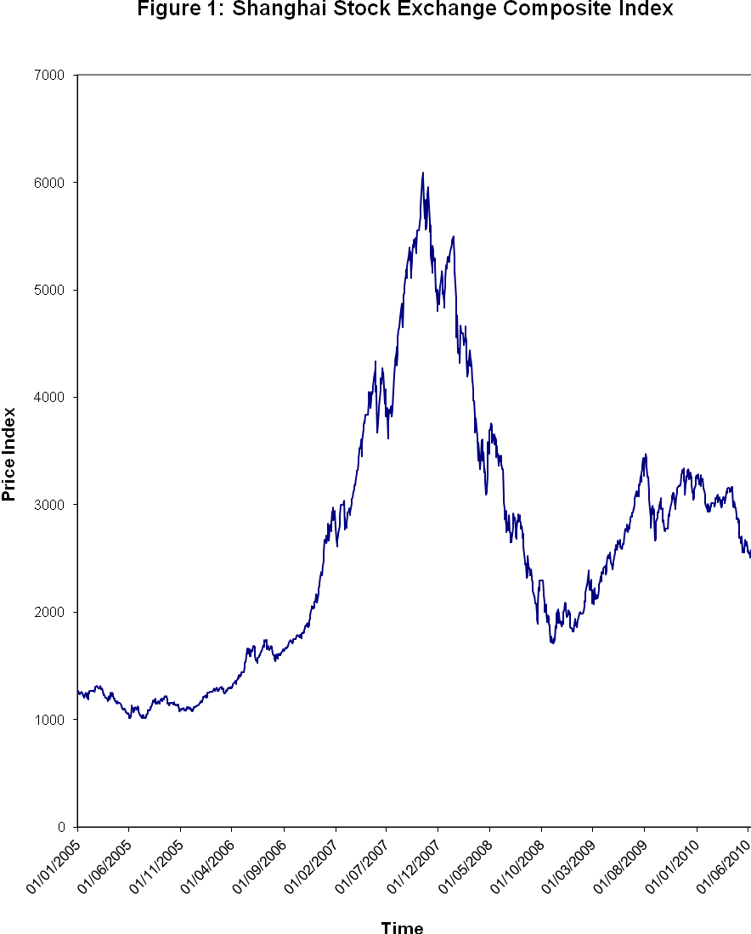

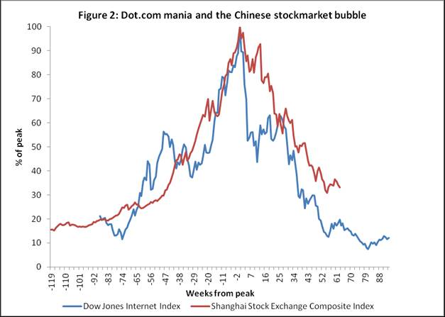

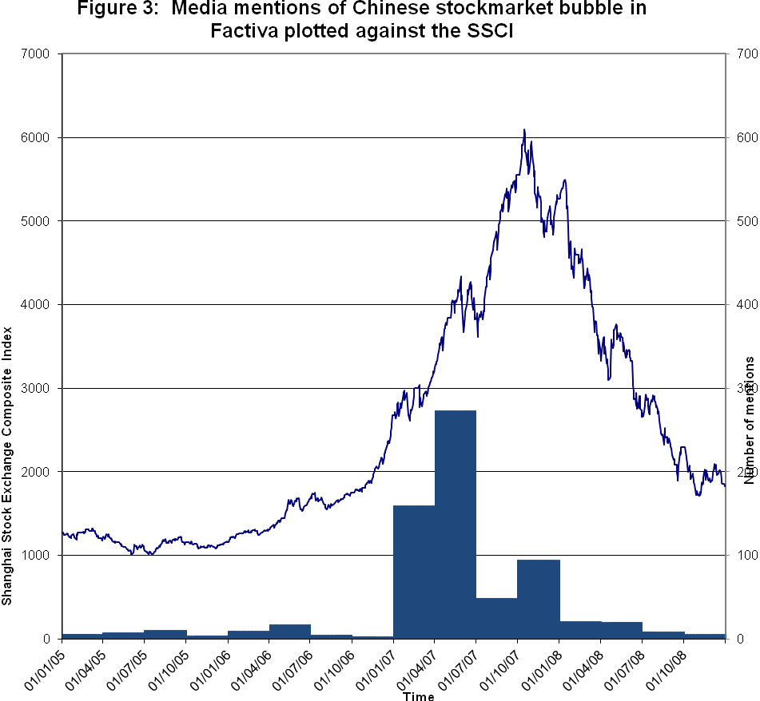
Figure4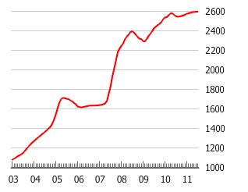

The SSEI stood at 1012 on July 11 2005, and climaxed at 6092 on October 16 2007. By November 4 2008, its lowest point, it was back down to 1708, the same level as 28 months earlier. Although being much more volatile, it has since largely moved in line with international capital markets.
Investors in the Chinese stockmarket lost about $3 trillion in the 13 months between October 2007 and November 2008 whereas investors in internet stocks only lost about a quarter of this sum when the dot.com bubble burst.
Whereas the term “psychoanalysis” usually brings to mind a method of clinical treatment, for our purposes it also provides a coherent set of ideas about the workings of the human psyche. Interestingly, modern research in neurobiology has started to confirm the key role of emotion and unconscious psychic processes in the way we relate to the world, and the formative role early infant relationships play in adult mental states (see the list of references in Taffler and Tuckett, 2010).
Who for example has not been aware, on one level, of falling in love with a stock or feeling “jilted” and angry when it doesn’t perform as one was expecting?
Schizoid refers to the splitting and projection process where the good or bad experiences are disowned and projected onto others who are either idealised or feared as a result. Paranoid refers to the outcome of the splitting when one feels unconsciously persecuted by the recipient of these bad feelings.
We view this as a fundamental contribution of emotional finance to the understanding of asset valuations in psychic terms.
The term is derived from two ideas (Tuckett and Taffler, 2008), the Freudian concept of object denotes the mental representation of something but not the actual thing itself. Phantasy or phantastic is a technical psychoanalytic term used to describe an individual’s unconscious beliefs and wishes, which it teaches are derived from the earliest stages of an infant’s mental development as referred to above.
Bion (1952) contrasts basic assumption groups with work groups whose members co-operate in the performance of a task, and act in a rational and constructive manner. Markets operating appropriately in allocating resources efficiently can be viewed as having work group characteristics.
Bion (1952; 1961) further discusses how basic assumption groups form to meet three different common purposes which oscillate: fight-flight, pairing off, and dependency. Interestingly, market behaviour in asset pricing bubbles appears to portray all three basic assumption group characteristics at different stages in their trajectory.
The use of the highly emotionally charged terms such as ‘greed’, ‘envy’ and ‘fear’ by Yao and Luo (2009) in their explanation of the cause of the Chinese stockmarket bubble mentioned in the Introduction to this paper will be noted here in this regard.
Or Torschlusspanik “door-shut panic” in German as investors crowd to get out before the door slams shut.
The current Chinese property bubble which has many direct parallels with the stockmarket bubble is a case in point. This is discussed later in the paper.
1² The SSEI’s low point of 1016, which it reached on June 2 2005, was its lowest level since February 1997.
During 2005 the Russian stockmarket more than doubled, and those in Brazil and India climbed by more than 50%, whereas that of China, the country with the world’s fastest growing economy, only grew by 16%.
Hangover cure? China’s stockmarkets, The Economist, 13 August 2005.
The Chinese Securities Regulatory Commission issued comprehensive rules in early September 2005 outlining how listed firms could float their non-tradable shares. Following this, several dozen companies unveiled plans for the overhaul of their ownership structure. By the end of 2005, 300 listed companies out of 1370 or so had announced plans on how to compensate their existing shareholders with freely tradable shares for the adverse impact on them of increasing the size of the free float.
Chinese fund could be used to prop up the market, Financial Times, 30 September 2005.
China to relax foreign quotas, The Wall Street Journal, 12 July 2005.
This bank among others, had previously been sanitised by the Chinese Government in taking over its massive non-performing loans.
Market insights: growing optimism in the Chinese stockmarket, Financial Times, 26 January 2006.
Stockmarket expected to see a bullish year, China Daily – Hong Kong edition, 24 January 2006.
Running with the bulls tests courage despite bitter memories of false dawns, Shanghai’s soaring stockmarket is winning over sceptics as foreigners lead the way, South China Morning Post, 17 April 2006.
Advice for investors in China: consider an 11-month vacation, The Wall Street Journal, 28 February 2006.
China bets on blue chip IPOs to lay strong market foundation, The Wall Street Journal Asia, 10 August 2006.
QFIIs less speculative than other institutional investors in China, Xinhua News Agency, 28 August 2006.
Chinese united by a common goal: a hot stock tip, New York Times, 30 January 2007.
Warning of bubble in China’s stockmarket, Financial Times, 30 January 2007.
Equity funds face Chinese wall, Financial Times, 6 April 2007.
Mutual feelings of over bullish stockmarket, Industry Updates, 8 January 2007
The China 20, Institutional Investor – International Edition, 22 October 2007.
Warning of bubble in China’s stockmarket, Financial Times, 30 January 2007.
On China: China’s loss is SE Asia’s gain, Financial Times, 2 February 2007.
Hot and cold – China’s stockmarket, The Economist, 10 February 2007.
Global overview: China overheating fears hit markets, The Financial Times, 19 April 2007.
Investors pay little heed to Greenspan, Bloomberg, 25 May 2007.
Hot and cold – China’s stockmarket, The Economist, 10 February 2007.
Bubble economics, Wall Street Journal Asia, 14 February 2007.
Market mania in China, Business Week, 19 March 2007.
Chinese bet their houses on share prices going through the roof – brisk trade at the pawn shops points to a streak of recklessness, Financial Times, 3 February 2007.
China’s other celebration: Stocks holiday respite could spark even more buying, The Wall Street Journal, 16 February 2007.
Where corruption is a buy signal millions of Chinese seek stocks amid “blind optimism”, International Herald Tribune, 17 February 2007.
Unworried investors buy again in Shanghai, International Herald Tribune,1 March 2007.
Bae and Wang (2009) show that Chinese firms listed on US stock exchanges that had “China” or “Chinese” in their company names significantly outperformed their counterparts without such specific identifiers during the Chinese stockmarket bubble with an annualized abnormal return of 123%.
China shrugs off losses as market swings back, New York Times, 1 March 2007.
Time to stop worrying and start investing, Financial Times, 6 March 2007.
Taking stock in China, The Wall Street Journal, 6 March 2007.
A rapid rebound: Chinese stocks set record, The New York Times, 22 March 2007.
Bae and Wang (2009) show that Chinese firms listed on US stock exchanges that had “China” or “Chinese” in their company names significantly outperformed their counterparts without such specific identifiers during the Chinese stockmarket bubble with an annualized abnormal return of 123%. Apparently similar irrational investor sentiment was present at that time even in US markets.
Na and Schneider (2010) in fact show how IPO prices set by issuers are 6x more likely to end in an 8 (sounding like the word meaning to become prosperous or rich), than in a 4.
Chinese investors crunching numbers are glad to see 8s, Wall Street Journal, 24 May 2007.
China’s stockmarket, Financial Times, 6 May 2007.
Markets relaxed on China’s stock plunge, Jeff Dyer and Richard Beales, Financial Times, 30 May 2007.
Blame money not pigs, Bloomberg, 15 August 2007.
Chinese stockmarket bigger than Japan’s, Financial Times, 27 August 2007.
Shenhua shares nearly double on debut, Richard McGregor, Financial Times, 9 October 2007.
PetroChina first to reach $1,000 cap, Jeff Dyer, Financial Times, 5 November 2007.
Boom in Chinese earnings draws warning, Financial Times, 27 August 2007.
Chinese investors in a stockmarket survey report, Xinhua News, 3 August 2007.
Growing debt crisis slams Asian markets, blurs outlook…how China continues to defy share slump; “rational bubble”, Wall Street Journal Asia, 20 August 2007.
Asia safe as houses: China’s growing consumer spending power should protect the region from the fall-out of the sub-prime crisis, South China Morning Post, 25 September 2007.
Chinese investors in the stockmarket survey report, Xinhua News, 3 October 2007.
China’s market mood swing, Time, 22 November 2007.
On Asia: how long can China remain in orbit?, Financial Times, 26 October 2007.
China’s bubble may burst but the impact will be limited, Financial Times, 17 October 2007.
The bubble risks in China OFF THE CHARTS, International Herald Tribune, 20 October 2007.
On Asia: how long can China remain in orbit?, Financial Times, 26 October 2007.
Greenspan says China stockmarket bubble may burst, Bloomberg, 30 October 2007.
Asia half full, Financial Times, 4 December 2007.
East Asia likely to surge on amid US slowdown, Financial Times, 16 November 2007.
The short view, Financial Times, 29 November 2007.
China’s parallel universe fades, Financial Times, 23 January 2008.
The second individual investors in securities market survey and analysis report, China Securities Journal, 1 April 2008 (in Chinese).
Chinese shares tumble on profit fears, Financial Times, 11 June 2008.
Supply demand relationship crucial in China stockmarket fall, Asia Pulse, 18 August 2008.
Stocks slide to lowest in 19 months, China Daily, 12 August 2008. (check reference)
Market slump deters investors in India and China, Financial Times, 11 April 2008.
Shanghai losses test pensioners’ faith, Financial Times, 20 June 2008.
Equity funds hit by crash, China Daily, 30 August 2008.
The China bubble, Gady Epstein, Forbes, Vol. 184, 12, 28 December 2009. Fears grow over China property bubble, Jamil Anderlini and Tom Mitchell, Financial Times, 11 March 2010.
Real estate: bid to put the brakes on excessive price gains, Robert Cookson, FT.com, 29 April 2010.
The soap opera of China’s housing boom, Jeff Dyer, Financial Times, 7 January 2010.
The soap opera of China’s housing boom, Jeff Dyer, Financial Times, 7 January 2010.
China’s property bubble is worse than it looks, Takatoshi Ito, Financial Times, 17 March 2010.
Take it from Japan: bubbles hurt, New York Times, 25 December 2005.

