We are inviting carers of people with COPD to take part in a research study called:
Identifying the best ways to deliver health care for people from ethnic minority groups living with chronic obstructive pulmonary disease (COPD) and other health conditions.
- Are you a care giving family member or friend to a person with COPD from an ethnic minority group?
- Have you been involved in a consultation using telephone, mobile phone, apps, video or website either with or on behalf of the person with COPD?

If yes to both questions, we would like to hear your views and experiences in a one-to-one interview.
We hope this study will help us to improve services for you to better support the person you care for with COPD & improve the experience of health care by remote delivery for people with COPD.

If you are interested in taking part in the study, please contact the study researcher:
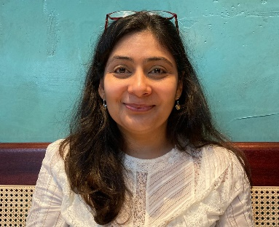
Study researcher: Dr Ratna Sohanpal
Contact details: Centre for Primary Care, Queen Mary University of London, 58 Turner Street, London, E1 2AB. ratna.sohanpal@nhs.net, 079 3929 6667
Please note: Speaking to us about the research study does not commit you to anything, we will be happy to answer questions and you can decide if taking part in the study is right for you.

