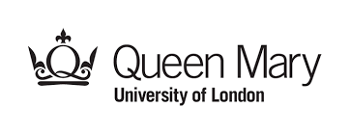

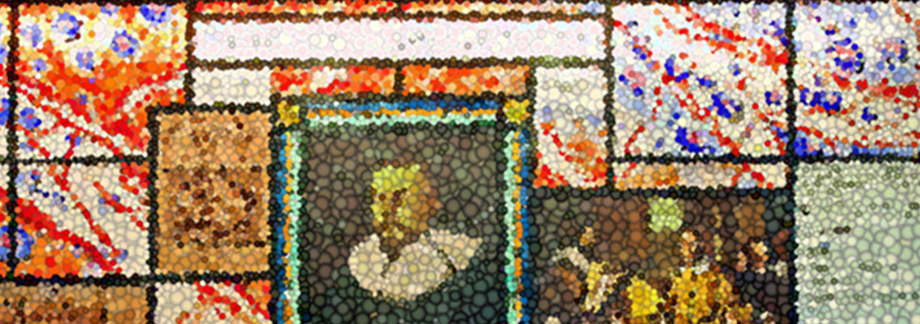

Short course in basic and Translational Cardioimmunology

PROGRAMME

DAY 1 - 26th February 2024 (Aim 1)

Basic principles of innate and adaptive immunity:
10.00 Welcome (Federica Marelli-Berg)

10:15 am-11:15 am
Cells and mechanisms of the innate immune system (Paula Longhi)
11:20 am- 12:15pm
Cells and mechanisms of the adaptive immune system (Federica Marelli-Berg) 45 minutes

Break

1pm-1:40pm
Macrophages and cardiac repair (Suchita Nadkarni) 30+10

1:45 pm- 2:15 pm
The immune response in the heart (Federica Marelli-Berg)
2:20 pm- 3:05 pm
Cardiac metabolism and inflammation (Dunja Aksentijevic)

Break

3:30pm-4pm
Placental inflammation and cardiac defects (Suchita Nadkarni)

4:05 pm- 4:45 pm
Immune senescence & inflammation (Sian Henson)

4:45 pm-5:15 pm panel discussion

DAY 2 - 27th February 2024 (Aim 2)

Inflammatory heart muscle diseases (Part one)

10 am-10:30 am
Diagnostic and prognostic challenges in inflammatory heart muscle disease (Saidi Mohiddin)

10:30- 11:15
Biomarkers in precision medicine: lessons from rheumatology
(Myles Lewis)

Break
11: 30 am– 12:10 pm
Cardiac inflammation in systemic inflammatory disorders (Jianmin Chen).

Break

1.00 pm- 1:40
Sarcoidosis (Thanos Bakalakos)

1.45 pm- 2:25
Myocarditis and Covid (Dan Harding)

2.30pm- 3.15 pm
Immunosuppression in heart muscle inflammation (Myles Lewis)

Break
3.30-4:00 pm
Panel discussion (all presenters)

DAY 3 – 28th February 2024 (Aim 3-4)

Inflammatory heart muscle diseases (Part two)

10am-10:45
Acute Myocarditis (Oliver Guttman)
10:55 am -11:25 pm
Inflammation and Arrythmias (Vishal Vyas)

11:30- 12.10pm
Inflammation in acute and chronic heart failure (Kostas Savvatis)

Break
1 pm-1:40 pm
Cardiac inflammation as a complication of chemotherapy/immune checkpoint inhibition in cancer (Charlotte Manisty)

1:50 pm-2:30 pm
Familial heart muscle diseases and inflammation (Alex Protonotarios)

2:30-3.10pm
The heart-brain axis (Egle Solito)

Break

3:15pm-3:45pm
Panel Discussion (all presenters)

Concluding remarks Federica Marelli-Berg

