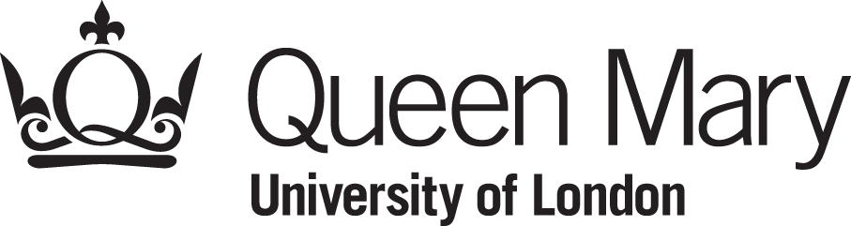

The Biennial Queen Mary Symposium
in American History

June 28, 2013
Arts 2, Room 3.20

09.45 -10.20: Coffee and Danish Pastries
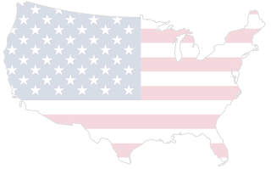
10.20-10.30: Head of School’s welcome: Prof. Miri Rubin (QMUL)

10.30-11.20: Keynote Address, Chair: Prof. Mark White (QMUL)

Speaker: Professor Richard Carwardine FBA, (President of Corpus Christi College, Oxford University)

The Fighting Parson: William Gannaway Brownlow and Conservative Unionism during the American Civil War

11.20-11.40: Break

11.40-13.10: Panel 1

Old Empire, New Empire: America and the World in the Nineteenth Century Chair: Dr. James Ellison (QMUL)

Dr. Matthew Karp (Princeton University)
The World the Slaveholders Craved: Empire, Slavery, and the U.S. Military in the 1850s

Dr. Jay Sexton (Oxford University)
U.S. Consolidation and Expansion: The Case of the Most Important 19th Century Company that You've Never Heard of

Dr. David Sim (University College London)
Preparations and Formulations: Walter LaFeber's The New Empire at 50

13.10-14.10: Buffet Lunch in the SCR

14.10-15.40: Panel 2

Performance and Power in America Chair: Dr. Jo Cohen (QMUL)

Dr. Kate Dossett (University of Leeds)
Women, Performance and Political Culture in the New Deal

Dr. Adam Smith (University College London)
Theatrical Politics and Political Theatre in Antebellum America

Dr. Joe Street (Northumbria University)
Huey P. Newton’s Stage: The Black Panther Party and Street Protest

15.40-16.00: Break for Coffee

16.00-17.30: Panel 3

The Politics of the Arts: Creativity and Liberalism in Twentieth Century America Chair: Dr. Mark Glancy (QMUL)

Dr. Harvey Cohen (Kings College London)
Warner Bros. and the musical Footlight Parade (1933): Supporting and Undermining the New Deal in 1933 Hollywood

Dr. J.E. Smyth (Warwick University)
The Un-American Western: High Noon (1952), Foreign Content, and the Body of the Cold Warrior

Karen Heath (Oxford University)
The Making of a Great Society: Art Politics in the 1960s

17.30-18.30: Reception in the Foyer of Arts 2

Canapés and Music

Please book via the Eventbrite link http://bit.ly/18c1eLO

