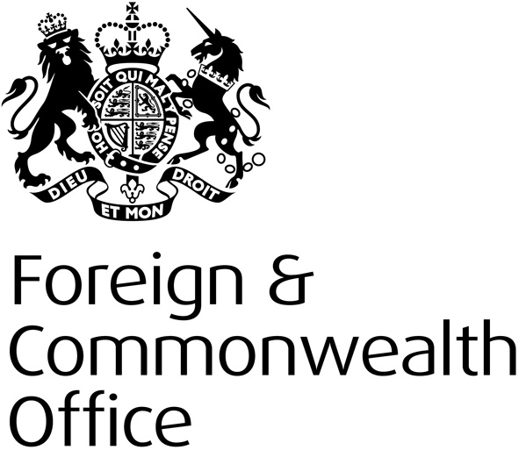
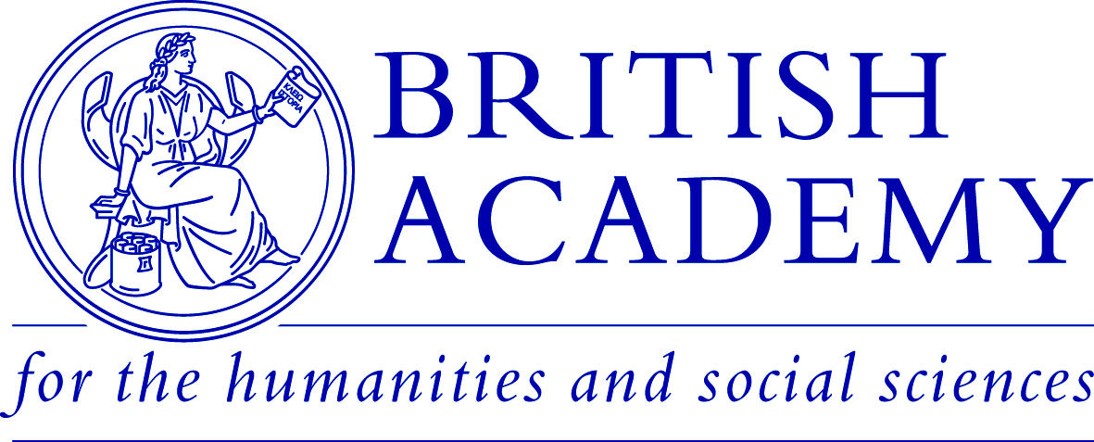

Contemporary Political History
in the Digital Age

Thursday 11th February 2016
1.30pm – 5.30pm
Venue: Foreign & Commonwealth Office
London

The transformation of politics in the era of the internet is a subject of endless debate and discussion, but what are its implications for political history and historians? How does the current ‘digital revolution’ compare to technological change in earlier periods, from the birth of radio and television to the arrival of the fax machine and photocopier? How are digital technologies changing the methodological and conceptual terrain of political history? And how should we preserve and analyse ‘born-digital’ sources, from central government emails to activist tweets? In short, if digital technologies have changed politics in our time, how are they changing political history?

This event will bring early-career and more established historians together with archivists, policymakers and digital specialists to consider these and other questions about the relationship between politics, digital technologies and the writing of history.

The event, hosted in partnership between the Mile End Institute at Queen Mary University of London and the Foreign and Commonwealth Office Historians, forms part of a wider programme of activity on the theme of Rethinking Contemporary British Political History, which is funded by a British Academy’s Rising Star Engagement Award held by Dr Helen McCarthy at Queen Mary University of London. For more information: http://mei.qmul.ac.uk/news/2015/152398.html

Please email Dr McCarthy to reserve your place (h.mccarthy@qmul.ac.uk), including a brief paragraph on your area of research and interest in digital politics.

As places are limited, priority may be given to advanced postgraduate research students and early-career researchers (defined as within 10 years of award of PhD) working on British political history, broadly-defined, since 1945. Scholars at other stages of their careers, and those working in related fields (eg archives, heritage, think-tanks) with relevant interests are, however, very welcome to apply.

Full or partial travel bursaries will be available to early-career scholars travelling from outside London. Please contact Dr McCarthy for more information.

Provisional Programme

1.30pm arrivals and registration

2pm: Welcome and introductory remarks from Dr Helen McCarthy, Senior Lecturer in British History at Queen Mary University of London, and Professor Patrick Salmon, Chief Historian, Foreign and Commonwealth Office

2.15pm – 3.40pm Panel One: Digital Politics and Government in Historical Perspective

Keynote speaker: Russell Davies, writer and strategist

Respondent: Dr James Ellison, Reader in International History, Queen Mary University of London

Chair: Dr Helen McCarthy

This panel will explore the ways in which digital technologies have changed and are changing the practices of democratic politics and government, and what implications this might have for historical narratives of British politics and political culture. Key questions to be addressed:

- What do we mean when we talk about the ‘digital state’ or ‘digital democracy’?
- Where have digital technologies made the greatest impact on political practices and identities? Where have they made the least?
- Have the effects of the digital ‘revolution’ been overstated? What can we learn from earlier technological revolutions, when seeking to document and evaluate the political consequences of present-day digital technologies?

3.40-4pm: Coffee break

4pm – 5.30pm: Digital Politics and the Practice of History

Speakers:

Dr Katrin Weller, Leibniz Institute for the Social Sciences

Dr James Baker, Lecturer in Digital History, University of Sussex

Professor Patrick Salmon, Chief Historian, Foreign and Commonwealth Office

Simon Demissie, Head, Modern Domestic Records, The National Archives

Chair: Dr Robert Saunders, Lecturer in Modern British History, Queen Mary University of London

This session will pick up themes from the previous panel but shift the focus on to the practical challenges of preserving, archiving and making accessible ‘born-digital’ sources alongside more conventional, paper-based sources. It will reflect upon the related question of how digitisation shapes the type of history it is possible to teach and write.

Questions to be addressed:

- Are digital technologies creating new kinds of ‘born-digital’ sources for political historians? How are they being captured, preserved and made available to researchers?
- Will such sources require historians to develop new methodologies or conceptual tools to analyse them? What can historians learn from other disciplines or approaches?
- How will the shift towards an increasing proportion of ‘born-digital’ sources shape the kinds of histories that get taught and written?

5.30 – 5.45pm: Final Reflections followed by reception

