Pubs within walking distance of Mile End Campus.

The Lord Tredegar, 50 Lichfield Rd, E3 5AL

This fine pub is named after the eccentric Welsh Lord responsible for building much of Bow in the late 1800s. The tap beers change regularly, and they try to support local breweries as much as possible. There is also a large, paved back garden for the summer.

The Coborn, 8 Coborn Rd, E3 2DA

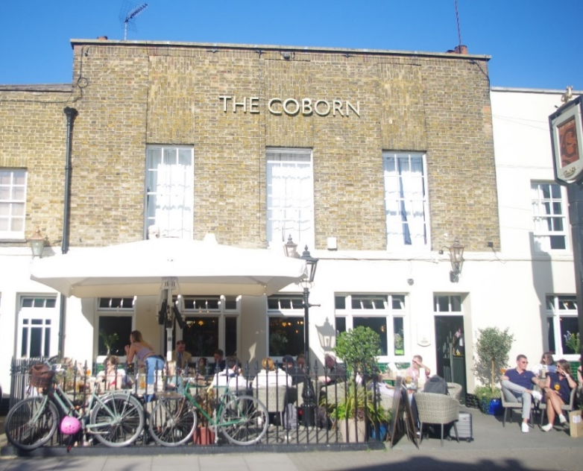
This is a light, airy and spacious foodie pub, decorated in rustic greys and greens. There is a Snug room for meetings. The Coborn got its name simply from the fact that it nestles in the middle of Coborn Road. However, reminders of Charles Coborn (born 1852 in Stepney and who adopted his name from Coborn Road), the famous music hall singer are dotted around the pub. There is a sunny garden and an Orangery with a skylight window.
Morgan Arms, 43 Morgan St, E3 5AA

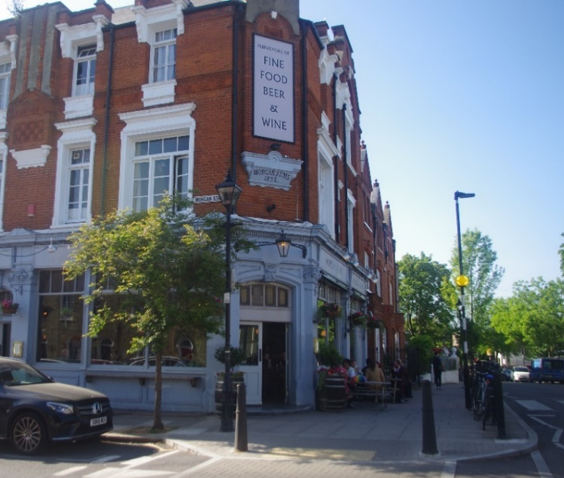
Just off the elegant Tredegar Square, the Morgan Arms gastro menu, generous portions, and lack of pretension makes this one of the top places to eat in the East End. This pub is unrecognisable from its days when the Kray twins frequented the pub! There is also a secret garden perfect for catching the afternoon sun.

Rusty Bike Pub, 588 Mile End Rd, E3 4PH
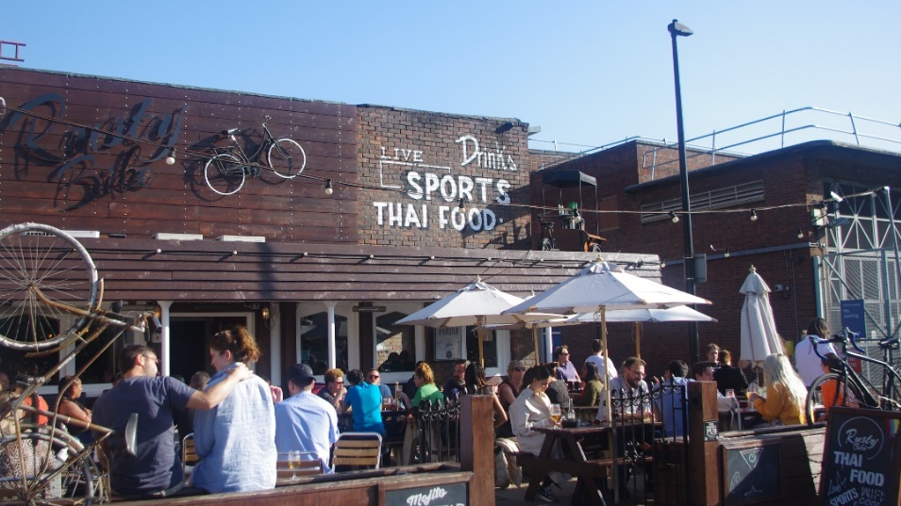
‘Thai Sports Bar’ located near Mile End Underground, the spacious Rusty Bike pub offers a friendly and relaxed environment. The light and airy interior has a rustic feel about it, with a modern twist.

Horn of Plenty, 36 Globe Rd, E1 4DU

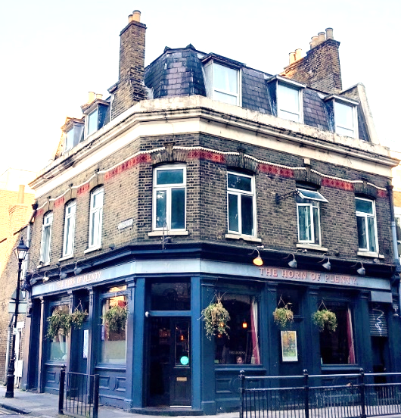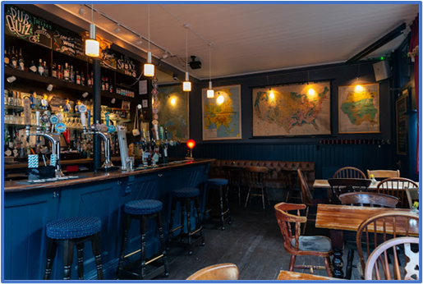
A small neighbourhood pub in the heart of Stepney Green, only one hundred yards from Stepney Green station. Voted the 'Best Pub in Whitechapel & Stepney' by Time Out London's ‘Love London Awards’ in 2015, 2016, and 2018. ‘Signature’ beers (6 on tap) from Walthamstow based brewery.

Half Moon (JD Wetherspoon), 213-223 Mile End Rd, E1 4AA

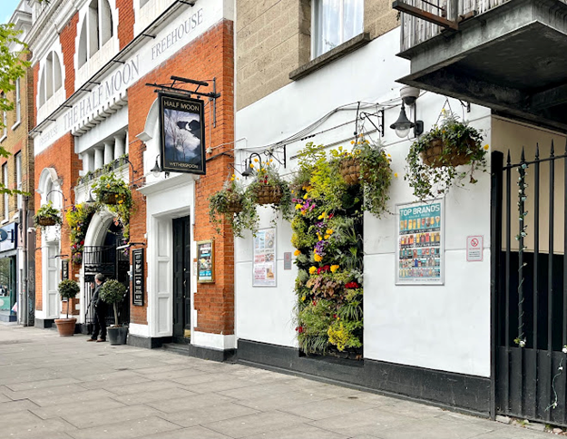
The former Methodist chapel, forming the front of these premises, was built in 1900. In 1977, the disused chapel, with its high octagonal ceiling, was taken over by the Half Moon Theatre Company, opening with a production of Robert Tressell’s the Ragged-Trousered Philanthropists. In 1985, the theatre expanded into a derelict site next door, yet closed in 1990. Several years later, it was converted into The Half Moon.
Pub Location Map.

